Faster commissioning with no power supply surprises
Automation Studio calculates I/O power requirements
The new Power Calculation function in Version 4.11 of B&R's Automation Studio engineering environment shows developers exactly where power supply modules are needed in the layout of their X20 I/O system. Easily optimizing the number and position of power supply modules early in the design phase makes machine commissioning faster and more predictable.
Automation Studio's hardware configuration analysis tool now includes an X20 Power Calculation function that evaluates the power balance of the I/O system. The amount of supplied power is compared against the required power, and the positions of undersupplied modules are highlighted. The feature can be enabled in existing projects by upgrading the hardware version of configured modules.

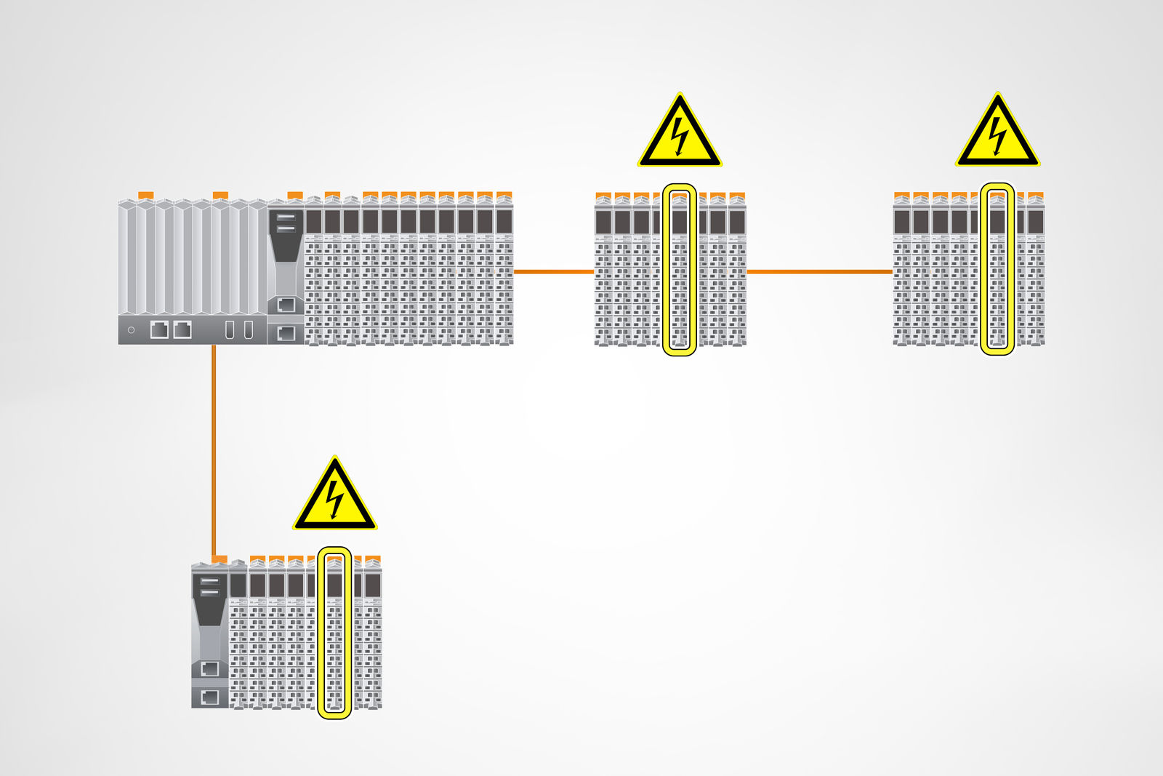
B&R Automation Studio makes commissioning faster and more predictable by highlighting where power supply modules are needed in the X20 I/O system.

About B&R
B&R, a division of ABB Group, is a global leader in industrial automation headquartered in Austria. B&R combines state-of-the-art technology with advanced engineering to provide customers in virtually every industry with complete solutions for machine and factory automation, motion control, HMI and integrated safety technology. With Industrial IoT communication standards including OPC UA, POWERLINK and openSAFETY as well as its Automation Studio software, B&R is constantly redefining the future of automation engineering. The innovative spirit that keeps B&R at the forefront of industrial automation is driven by a commitment to simplifying processes and exceeding customer expectations.
For more information, visit www.br-automation.com.

