ACOPOS P3 defies environmental influences
B&R servo drive now more resistant
The compact B&R servo drive is suitable for use in aggressive atmospheric environments and at temperatures as low as -25°C. The electronics of the ACOPOS P3 are protected from external influences by a special coating as standard, making the servo drive even more resistant.

The servo drive can now easily be used under extreme conditions like those faced by wind turbines. Applications in cold rooms or in very dusty environments such as the textile industry are also possible. Additional expensive special hardware is no longer required, which reduces costs.
Comprehensive testing
B&R conducts extensive environmental testing to ensure the reliable performance of its hardware. The tests are carried out in a fully accredited in-house testing laboratory and in certified external testing facilities in accordance with international standards and regulations.

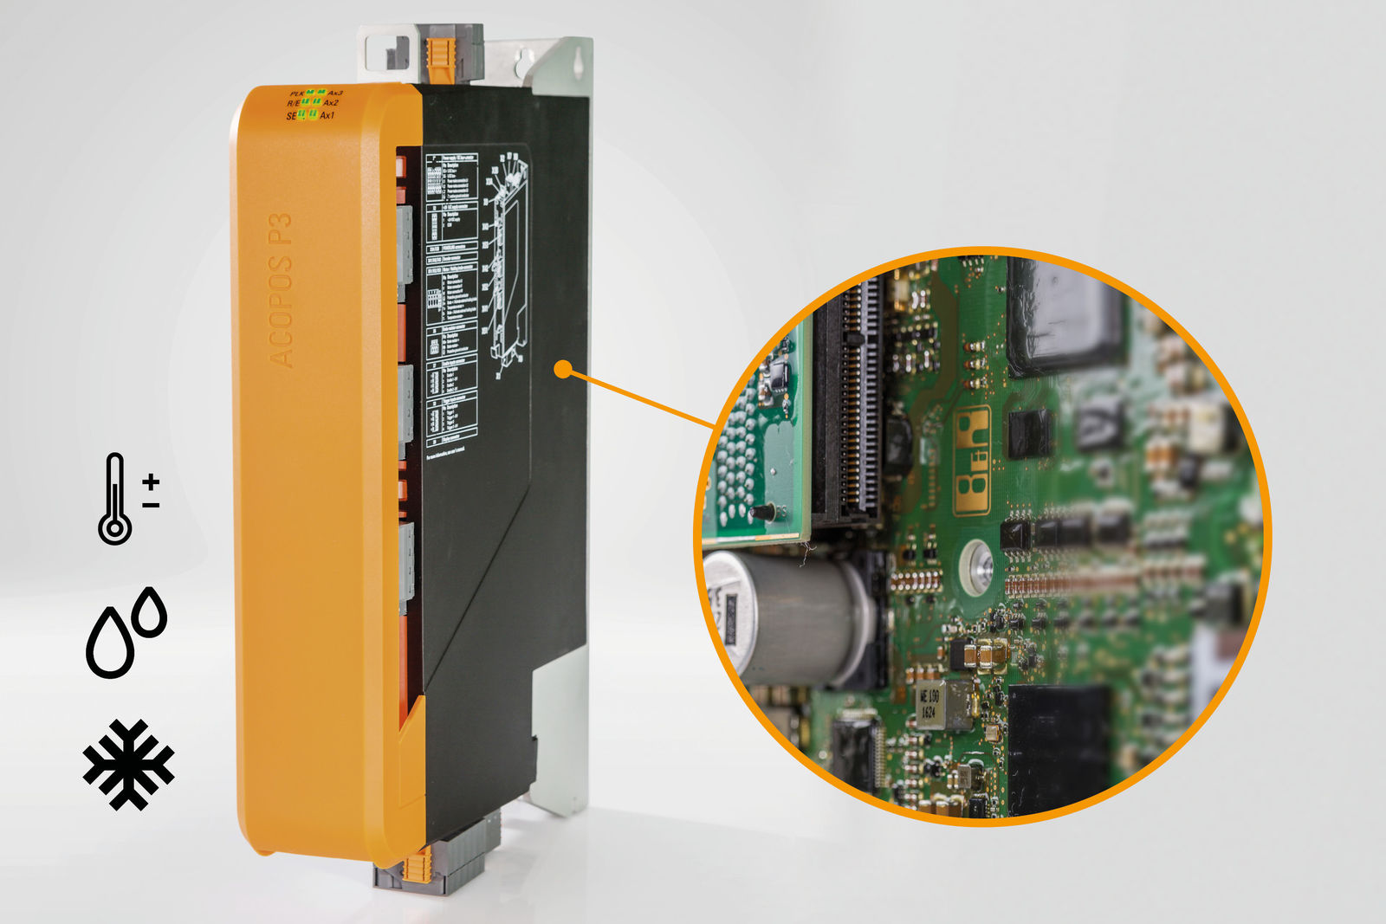
The electronics of the ACOPOS P3 are specially coated for use under aggressive atmospheric conditions and at temperatures as low as -25°C.

About B&R
B&R, a division of ABB Group, is a global leader in industrial automation headquartered in Austria. B&R combines state-of-the-art technology with advanced engineering to provide customers in virtually every industry with complete solutions for machine and factory automation, motion control, HMI and integrated safety technology. With Industrial IoT communication standards including OPC UA, POWERLINK and openSAFETY as well as its Automation Studio software, B&R is constantly redefining the future of automation engineering. The innovative spirit that keeps B&R at the forefront of industrial automation is driven by a commitment to simplifying processes and exceeding customer expectations.
For more information, visit www.br-automation.com.

