ACOPOS P3: At home anywhere in the world
B&R servo drives support all common power supply systems worldwide
B&R's ACOPOS P3 servo drive can be used in machines regardless of where they are deployed. Machine builders save the cost of building different variants of a machine for each country, because the ACOPOS P3 is compatible with all common power supply systems worldwide.

B&R's ACOPOS P3 servo drive now supports TN-S and TN-C-S systems with a grounded outer conductor as well as IT systems. That makes it possible to use the ACOPOS P3 in more applications than ever. It also enables OEMs to reduce the number of machine variants, since they no longer need isolation transformers or additional filters for use in different countries.
High performance in a compact design
With a power density of six amps per liter, the ACOPOS P3 is an extremely efficient servo drive able to control up to three axes. Safety functions in accordance with SIL 3 / PL e can also be integrated upon request.
It also delivers excellent dynamics and precision, with a minimum sampling time of just 50 µs for the entire controller cascade. All that performance is combined with a compact design. The ACOPOS P3 reduces the amount of space used in the control cabinet by up to 69%.

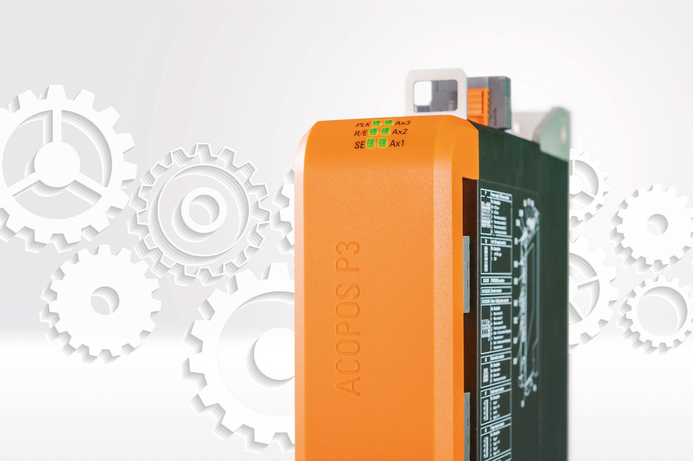
The B&R ACOPOS P3 servo drive is compatible with all common power supply systems worldwide.

About B&R
B&R, a division of ABB Group, is a global leader in industrial automation headquartered in Austria. B&R combines state-of-the-art technology with advanced engineering to provide customers in virtually every industry with complete solutions for machine and factory automation, motion control, HMI and integrated safety technology. With Industrial IoT communication standards including OPC UA, POWERLINK and openSAFETY as well as its Automation Studio software, B&R is constantly redefining the future of automation engineering. The innovative spirit that keeps B&R at the forefront of industrial automation is driven by a commitment to simplifying processes and exceeding customer expectations.
For more information, visit www.br-automation.com.

