ACOPOS 6D brings adaptive manufacturing to Hispack

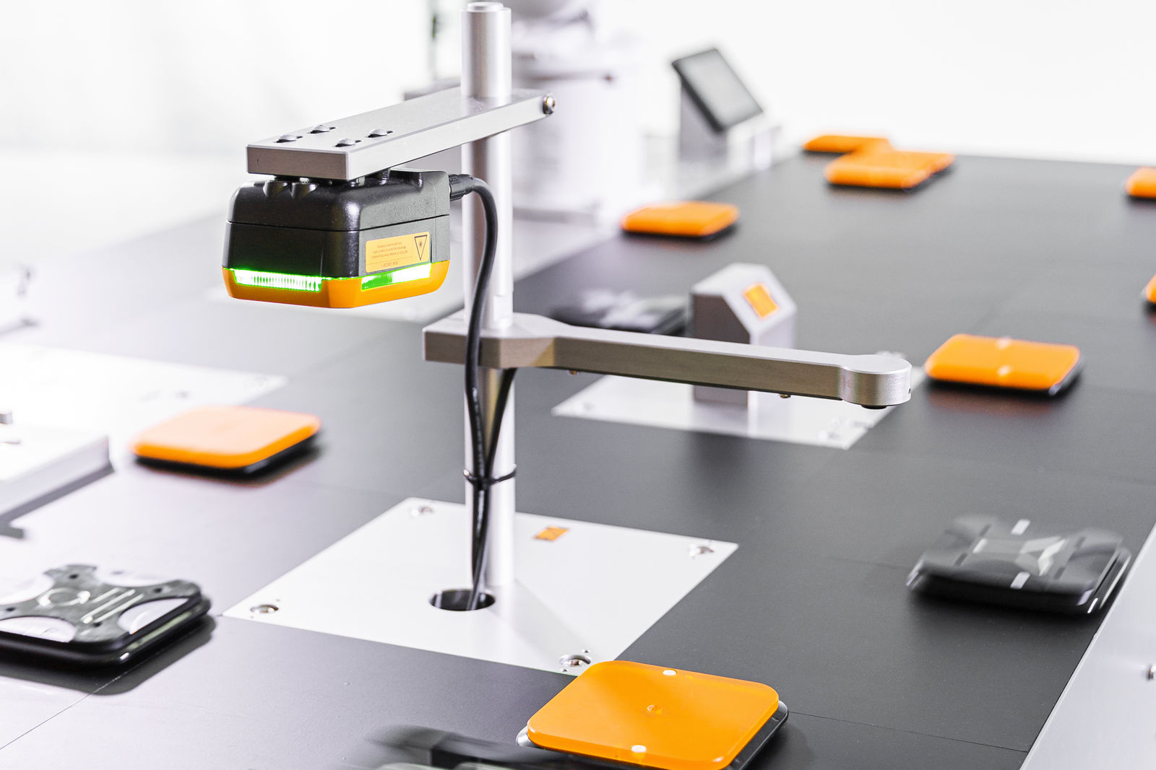
Example of an ACOPOS 6D transport system with an integrated machine vision.

B&R's disruptive technology for packaging machinery also at Hispack
The ACOPOS 6D, B&R's disruptive technology, will be on display at ABB's Hispack stand (H3-F184), an example of adaptive manufacturing for a medical vial filling and capping process with machine vision validation through a Smart camera that will position the shuttle at the two workstations. Finally, an ABB GoFaTM collaborative robot will pick up the vial and unload it in another work area.
ACOPOS 6D is the latest intelligent conveyor system from B&R that can be integrated into any machine and provides a significant increase in productivity by revealing a multidimensional processing space and blurring the boundaries between conveying and processing.
The modular motor segments are 240 x 240 millimetres in size and can be freely arranged in any shape. A wide variety of shuttle sizes carry payloads from 0.6 to 14 kilograms and reach speeds of up to 2 metres per second. They can move freely in two-dimensional space, rotate and tilt on three axes and offer precise levitation height control. Together, this gives them six degrees of freedom of motion control.
Ideal for hygienic areas
ACOPOS 6D shuttles levitate freely, without any contact or friction. As there is no abrasive wear, no maintenance of the parts is required. If a stainless steel cover is fitted over the motor segments, ACOPOS 6D offers IP69K protection, which is ideal for use in hygienic areas, clean rooms or for food and beverage production.
In addition, shuttle path planning is performed in a dedicated control, connected to the machine network via POWERLINK; this means that it does not affect the performance of the network or the machine control system. ACOPOS 6D is fully integrated into the B&R ecosystem.
ACOPOStrak also present
The stand will also have a robotic cell where you will see the perfect coordination between 2 delta robots: the IRB360, which is responsible for the collection of bottles and their grouping, and the IRB390, which is responsible for the collection and positioning of the groups of bottles, together with an ACOPOStrak.
ACOPOStrak is a revolution in adaptive manufacturing. This highly flexible transport system extends the economy of large-scale production to individual batches. Parts and products are transported quickly and flexibly from one processing station to another on independently controlled shuttles.
Hispack Unboxing
More details of B&R's participation at Hispack. Wlady Martino, Global Head of Packaging at B&R, will present "Enabling Operational Excellence at the End-of-Line" in the Hispack Unboxing room in Hall 3.
The adaptive machine improves manufacturers' production performance, including at the end of line. "The automation of these processes aims to continuously improve indicators as well as facilitate operations. We will see where the technology stands and what the future challenges will be," Martino comments.

