Think adaptive at SPS 2022
B&R unlocks key capabilities for today's manufacturing challenges
In times of rapidly shifting consumer behavior and unpredictable changes in markets and supply chains, manufacturing systems need to be more adaptive, open and sustainable than ever before. At this year's SPS trade show in Nuremberg (November 8-10), B&R is showcasing some of the ways it gives machine builders and manufacturers the power to not just weather these challenges, but to transform them into a competitive advantage.
In an inviting new booth design (Hall 7, Booth 206) B&R presents the latest advancements in key technologies – including mechatronic product transport, machine-centric robotics, integrated machine vision and simulation – which come together around its core portfolio to open up the capabilities urgently needed to master today's manufacturing challenges. Known as adaptive manufacturing, these capabilities make it possible to switch effortlessly between different products and packaging to dramatically increase productivity while simultaneously shrinking the footprint of machines and lines.
Advancing adaptivity
"Today's machines need the power to adapt," said B&R CEO Jörg Theis. "They need to change effortlessly between batches, get more output from a smaller footprint, and make highly customized products on demand – even ones that are yet to be invented." Among the latest developments making this possible is a new generation of ACOPOStrak shuttles that last longer, run smoother and bring positioning accuracy down to an impressive ±200 µm.
Visitors to the B&R booth can see how integration of delta robots from Codian in the B&R portfolio makes it quicker and more intuitive to implement high-speed pick-and-place applications. Simulation capabilities make it even easier to integrate Codian robots as a natural part of the B&R ecosystem. "The combination of robotics and other key technologies like machine vision and independent product transport gives machines the superpower of adaptability," says B&R Adaptive Ambassador Nicoletta Ghironi. "In other words: the power to run any batch with the efficiency and profitability of mass production."
Growing together
Also on display at the B&R booth are a variety of solutions that give teams more flexibility for collaborative and simulation-based development. Developers who are able to use their preferred tools and environments complete higher quality work faster and more easily. Training costs are reduced and innovation becomes quicker and leaner. "Like our products, our people are most effective when we work together seamlessly and communicate openly," says B&R CSO Luca Galluzzi. "It is when our people join their strengths that our innovative technology comes to life and creates real solutions to our customers' biggest challenges."
Highlighting the concept of innovation through collaboration, B&R announced a joint project with machine vision specialist MVTec and AI processor specialist HAILO to integrate sophisticated deep learning algorithms into B&R cameras. The first result of this collaboration is a new Deep OCR function that combines groundbreaking speed – up to 26 tera-operations per second – with exceptional usability.
Freedom through openness
The adaptive solutions on display at the B&R booth make it possible to produce highly customized products at smaller, decentralized production sites. Aiding manufacturers' efforts to re-shore and nearshore production, this helps reduce the cost and environmental impact of shipping while also making supply chains more resilient. Further resilience against supply chain disruptions comes from B&R's commitment to open connectivity and hardware-agnostic control. From the ability to run B&R control solutions on third-party hardware to a more complete array of fieldbus connectivity, with more freedom to choose the platforms, technologies, languages and tools that best suit their needs, B&R customers can easily meet new requirements and deploy cutting edge IIoT and AI-enhanced solutions with the teams and skills they already have.

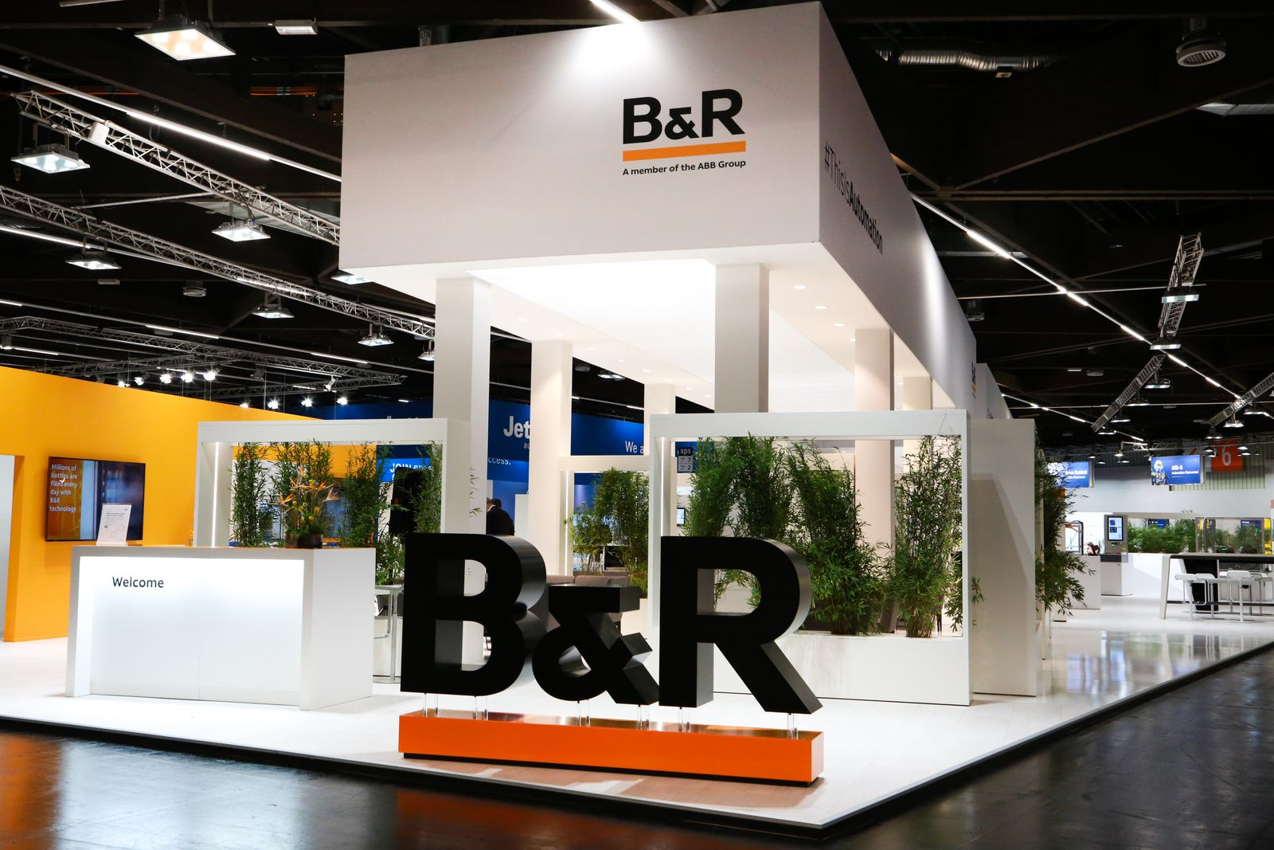
At its redesigned booth, B&R shows machine builders and manufacturers how to transform uncertain times and shifting consumer behavior into their competitive advantage.
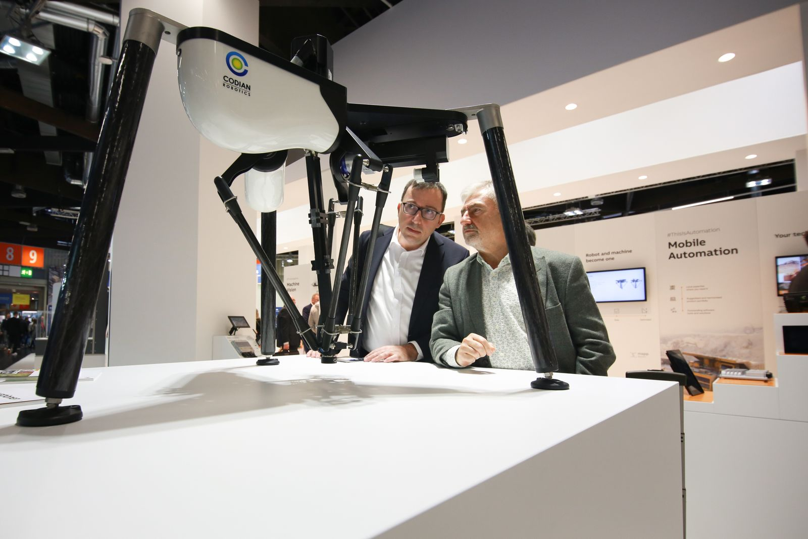
Visitors to the B&R booth see how integration of delta robots from Codian in the B&R portfolio makes it quicker and more intuitive to implement high-speed pick-and-place applications.
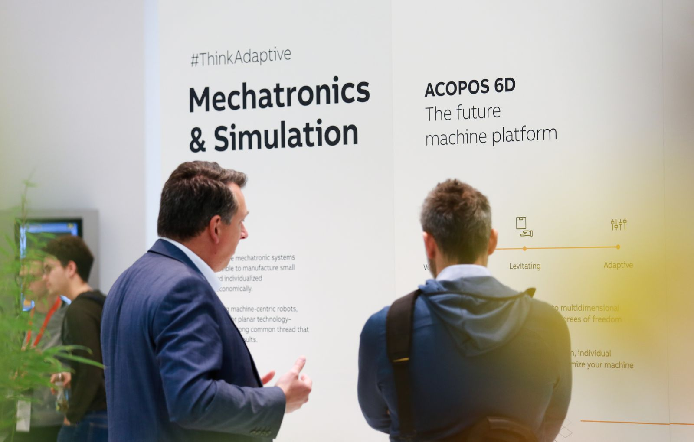
B&R challenges visitors to "think adaptive": Unprecedented flexibility requires a fundamental shift in thinking about how things are made, assembled and packaged.

About B&R
B&R, a division of ABB Group, is a global leader in industrial automation headquartered in Austria. B&R combines state-of-the-art technology with advanced engineering to provide customers in virtually every industry with complete solutions for machine and factory automation, motion control, HMI and integrated safety technology. With Industrial IoT communication standards including OPC UA, POWERLINK and openSAFETY as well as its Automation Studio software, B&R is constantly redefining the future of automation engineering. The innovative spirit that keeps B&R at the forefront of industrial automation is driven by a commitment to simplifying processes and exceeding customer expectations.
For more information, visit www.br-automation.com.

