Free choice of simulation tool
New function from B&R opens up more possibilities for exchanging models
B&R has added a new function to its Automation Studio development environment. With FMU Export, machine code can be exported and integrated as a PLC simulation into any simulation tool, allowing simulation experts to work in the familiar software ecosystem of their choice. This saves both valuable time and resources during interdisciplinary development.
All necessary data is automatically bundled into a Functional Mock-up Unit, or FMU. Because the exported FMU incorporates a standardized interface, there is no need to create a new interface for each tool. The only requirement on the tool side is support for the FMI 2.0 standard. FMI stands for Functional Mock-up Interface, an industry-independent standard for exchanging models between different modeling tools.
Data exchange in both directions
It was already possible to import machine models into Automation Studio using FMU Import. Now developers can also export their machine code to the simulation tool of their choice. Starting with Automation Studio 4.12, FMU Export is available to all Automation Studio users.

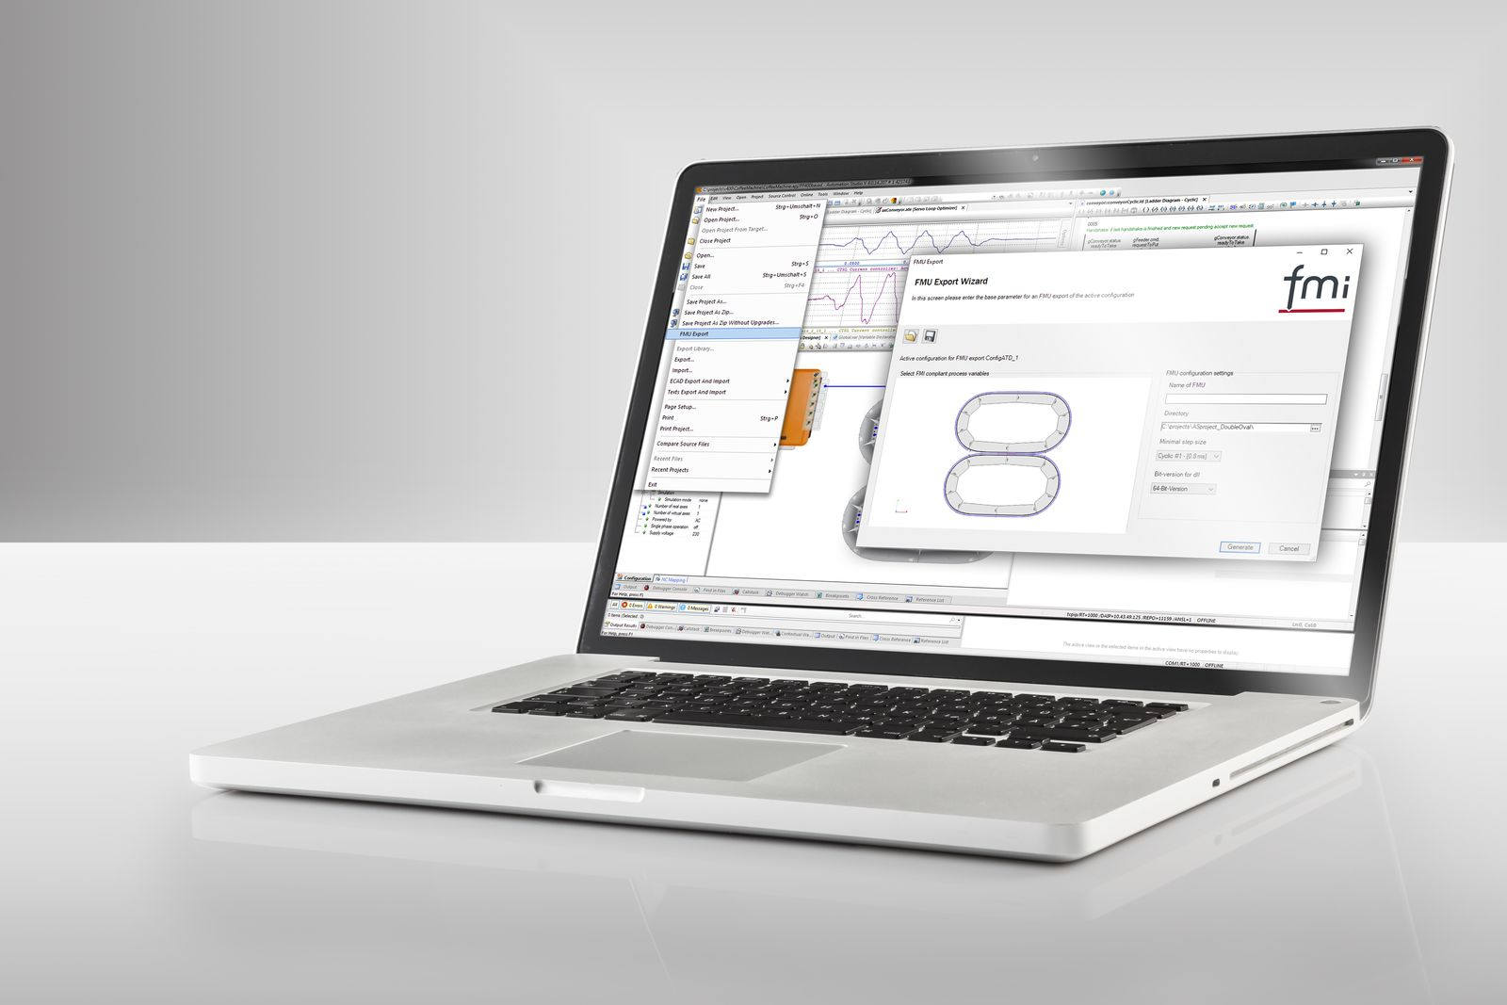
With FMU Export, B&R is expanding the range of functions of simulation tools.

About B&R
B&R, a division of ABB Group, is a global leader in industrial automation headquartered in Austria. B&R combines state-of-the-art technology with advanced engineering to provide customers in virtually every industry with complete solutions for machine and factory automation, motion control, HMI and integrated safety technology. With Industrial IoT communication standards including OPC UA, POWERLINK and openSAFETY as well as its Automation Studio software, B&R is constantly redefining the future of automation engineering. The innovative spirit that keeps B&R at the forefront of industrial automation is driven by a commitment to simplifying processes and exceeding customer expectations.
For more information, visit www.br-automation.com.

