AI-enhanced machine vision
Deep learning for B&R cameras with MVTec and Hailo
B&R is enhancing its smart camera portfolio with powerful deep learning functionality. A three-way collaboration with machine vision software specialist MVTec and AI processor specialist Hailo makes the B&R camera a powerful and efficient edge device. At the SPS trade show in Nuremberg, the companies celebrated the first function to come from their joint project.
Machine vision algorithms based on deep learning are opening up exciting new ways to improve quality, boost productivity and prevent waste while making manufacturing more flexible. "Our collaboration with MVTec gives machine builders access to the best selection of the best performing vision functions around," says B&R's machine vision expert, Andreas Waldl. "They're an industry leader in both deep learning and classic rule-based algorithms – two complemental approaches that each play an essential role in machine automation."
Speed reader
The first product to emerge from the project is a deep-learning-based optical character recognition (OCR) function. Called Deep OCR, it achieves remarkably fast read rates, even on fonts that are otherwise difficult to recognize. "For many years, we have been working together with B&R to develop machine vision solutions for customers that set technological standards, especially for embedded systems," says Thomas Hopfner, product manager for licensing and interfaces at MVTec. "This goal is also being followed by our latest cooperation. As a result, customers benefit from the advantages of the deep learning technology Deep OCR without having to sacrifice performance."
TOPS-per-watt winner
High-performance deep learning algorithms require a powerful processor. Yet, implementation as an edge device also made power consumption a critical issue. Today's machine builders need not just computing speed but also power efficiency, and that is where Hailo comes in: in addition to world class performance of 26 tera-operations per second (TOPS), the company's inference accelerators also require remarkably low power consumption. "Hailo helps us put truly groundbreaking speed and intelligence right where our customers need it for their fastest and most adaptive manufacturing solutions," says Waldl.
"This kind of collaboration is exactly what we had in mind when we started Hailo," says Hailo CEO Orr Danon. "The new B&R camera harnesses Hailo's top-performing AI accelerator, and in combination with their state-of-the-art edge devices and MVTec's advanced machine learning algorithms, we are setting new performance standards that will improve productivity and enhance quality in industrial applications."

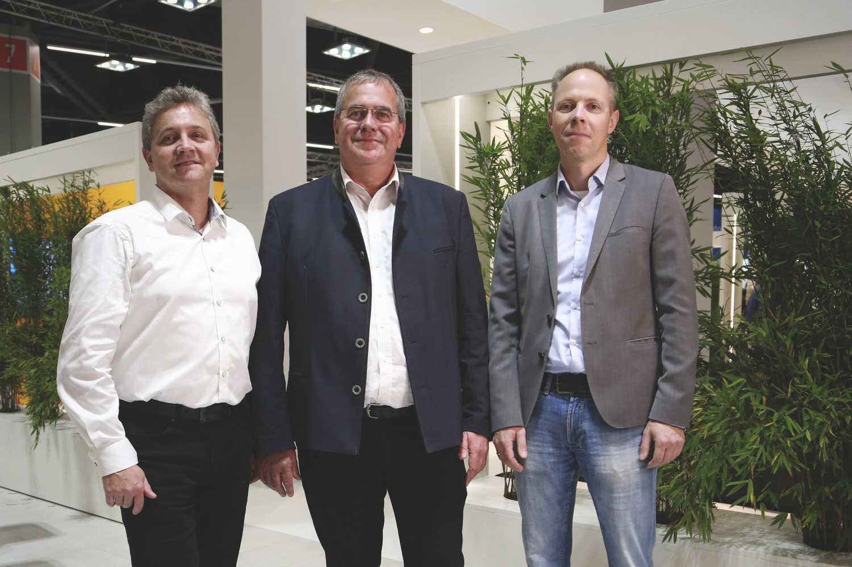
Deep learning for machine vision: B&R, MVTec and Hailo celebrate successful collaboration at SPS 2022.
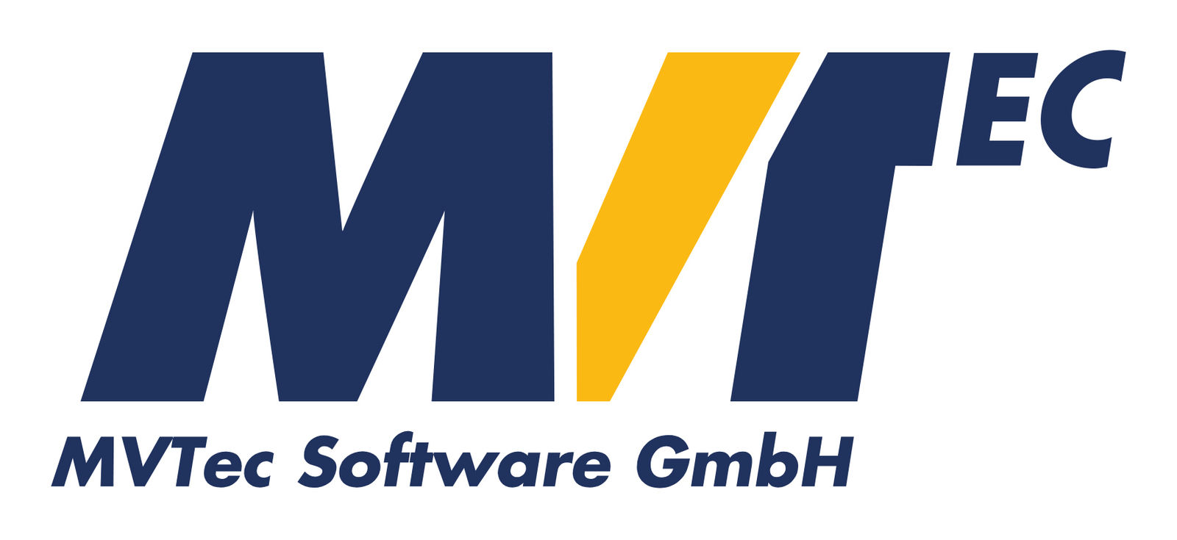
MVTec is a leading manufacturer of standard software for machine vision. MVTec products are used in all demanding areas of imaging: semiconductor industry, surface inspection, automatic optical inspection systems, quality control, metrology, as well as medicine and surveillance. By providing modern technologies such as 3D vision, deep learning, and embedded vision, software by MVTec also enables new automation solutions for the Industrial Internet of Things aka Industry 4.0. With locations in Germany, the USA, and China, as well as an established network of international distributors, MVTec is represented in more than 35 countries worldwide.

Hailo, an AI-focused, Israel-based chipmaker, has developed a specialized AI processor that delivers the performance of a data center-class computer to edge devices. Hailo’s processor is the product of a rethinking of traditional computer architecture, enabling smart devices to perform sophisticated deep learning tasks such as object detection and segmentation in real-time, with minimal power consumption, size, and cost. The processor is designed to fit into a multitude of smart machines and devices, impacting a variety of sectors including security, automotive, Industry 4.0, and retail. For more information visit https://hailo.ai/

About B&R
B&R, a division of ABB Group, is a global leader in industrial automation headquartered in Austria. B&R combines state-of-the-art technology with advanced engineering to provide customers in virtually every industry with complete solutions for machine and factory automation, motion control, HMI and integrated safety technology. With Industrial IoT communication standards including OPC UA, POWERLINK and openSAFETY as well as its Automation Studio software, B&R is constantly redefining the future of automation engineering. The innovative spirit that keeps B&R at the forefront of industrial automation is driven by a commitment to simplifying processes and exceeding customer expectations.
For more information, visit www.br-automation.com.

