B&R is significantly expanding production
Hundreds of additional employees are needed for temporary weekend shifts
The ABB Group is expanding production at B&R, its global center for machine and factory automation based in Eggelsberg (Upper Austria). Now that the global supply chain bottlenecks have eased recently, B&R wants to meet the high customer demand for automation solutions as quickly as possible.

Just this summer, ABB opened a new global innovation and education campus in Innviertel, Upper Austria. In the course of this, production is now also being significantly expanded. B&R will complete the next expansion phase by the first quarter of 2023. The company is also temporarily planning an additional weekend shift. The company announced on Thursday that this will create several hundred more jobs – initially limited to one year. B&R Managing Director Jörg Theis said: "The supply chain bottlenecks have eased significantly in recent months. Increased automation is now high on the agenda in many industries. We have reacted to this, extended production and operating hours and are now temporarily looking for several hundred new employees in production and logistics for a temporary extra weekend shift. As a result, we can quickly process our record-breaking order volume and are prepared for sustained high demand for our automation solutions."
Processing capacity increases to two billion components per year
With the opening of the new innovation and education campus, ABB expanded the B&R headquarters in Eggelsberg to more than 100,000 square meters in the summer. Since then, B&R has been one of the largest centers for integrated production, research and training in Central Europe. All B&R production for the global market takes place in Eggelsberg on fully automated production lines. With the relocation of the offices to the new campus, 7,000 square meters (an area the size of a soccer field) has become free for the further expansion of production. In this area, B&R is once again significantly increasing the production volume for automation solutions. This increases the processing capacity to more than two billion components per year. B&R will therefore be able to process up to 60 percent more components than before.
Order volume at a record high
As part of ABB's Robotics & Factory Automation division, B&R has grown significantly over the past five years. In the past year alone, the total number of orders has grown in the double-digit range. B&R's order volume has reached a record high this year. In the third quarter of the 2022 fiscal year, customer ordering behavior normalized as supply chain bottlenecks eased. Nevertheless, demand is still high.
Additional weekend for one year
In order to process the high order volume quickly, B&R will temporarily also produce and deliver on weekends during the coming year. For this weekend shift, the company will hire several hundred additional production and warehouse employees – in addition to the permanent expansion of production – for a period limited to one year. B&R has developed a new working time model together with the works council and trade unions.
Two days work, five days off – "Job Days" for those who are interested
For a total of 20 hours a week exclusively on Saturdays and Sundays, the company offers a salary that is comparable to a conventional 38.5-hour week from Monday to Friday, including the statutory allowances. "We enable employees who consciously decide to work on Saturdays and Sundays for a year to have an extremely attractive work-life balance," says Robert Perperschlager, Chief Operations Officer at B&R. The HR department at B&R expects to see a large number of people interested in the new positions. That's why the company is planning its own "Job Days" instead of standard job interviews. For more information, see http://www.br-automation.com/wochenendschicht. Overall, ABB employs more than 11,000 people at over 100 locations in 53 countries in the field of robotics and factory automation. Once all vacancies have been filled, more than 3,000 employees will be working at the Eggelsberg site.

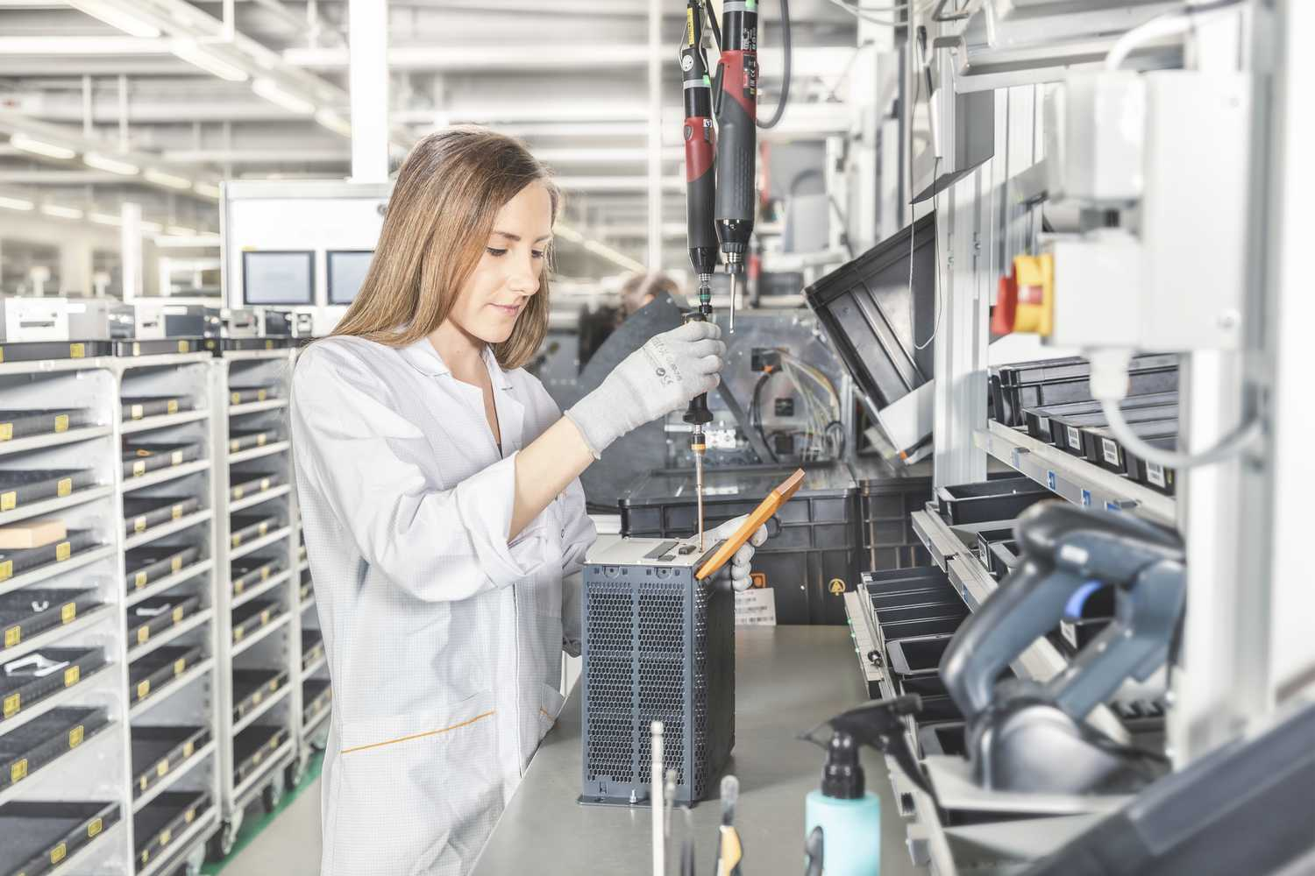
B&R is expanding production in the Innkreis district and is looking for several hundred new employees for a temporary extra weekend shift. Photo credit: B&R

About B&R
B&R, a division of ABB Group, is a global leader in industrial automation headquartered in Austria. B&R combines state-of-the-art technology with advanced engineering to provide customers in virtually every industry with complete solutions for machine and factory automation, motion control, HMI and integrated safety technology. With Industrial IoT communication standards including OPC UA, POWERLINK and openSAFETY as well as its Automation Studio software, B&R is constantly redefining the future of automation engineering. The innovative spirit that keeps B&R at the forefront of industrial automation is driven by a commitment to simplifying processes and exceeding customer expectations.
For more information, visit www.br-automation.com.

