Four times more performance
New backplane bus of B&R increases performance of X20 system
B&R now offers the X2X+ backplane bus as an option, increasing the performance of the X20 system by a factor of four. And because all existing X20 I/O modules are already compatible with X2X+, all it takes to build more powerful machines are bus modules.
The advantages of this new bus are particularly apparent in applications that involve many I/O modules or high data volume but where short cycle times are imperative. It is even possible to set up two separate cycle times so that less time-critical data is transported more slowly and generates less network and processor load. In this way, complex high-speed processes can be controlled reliably using cost-effective standard hardware.
High sampling rates
X2X+ enables faster data transfer and up to four times faster response times. In combination with this higher bandwidth, large amounts of data can be handled better and higher sampling rates can be achieved. This is an advantage when measuring vibration, for example, and results in more accurate condition monitoring across the board.

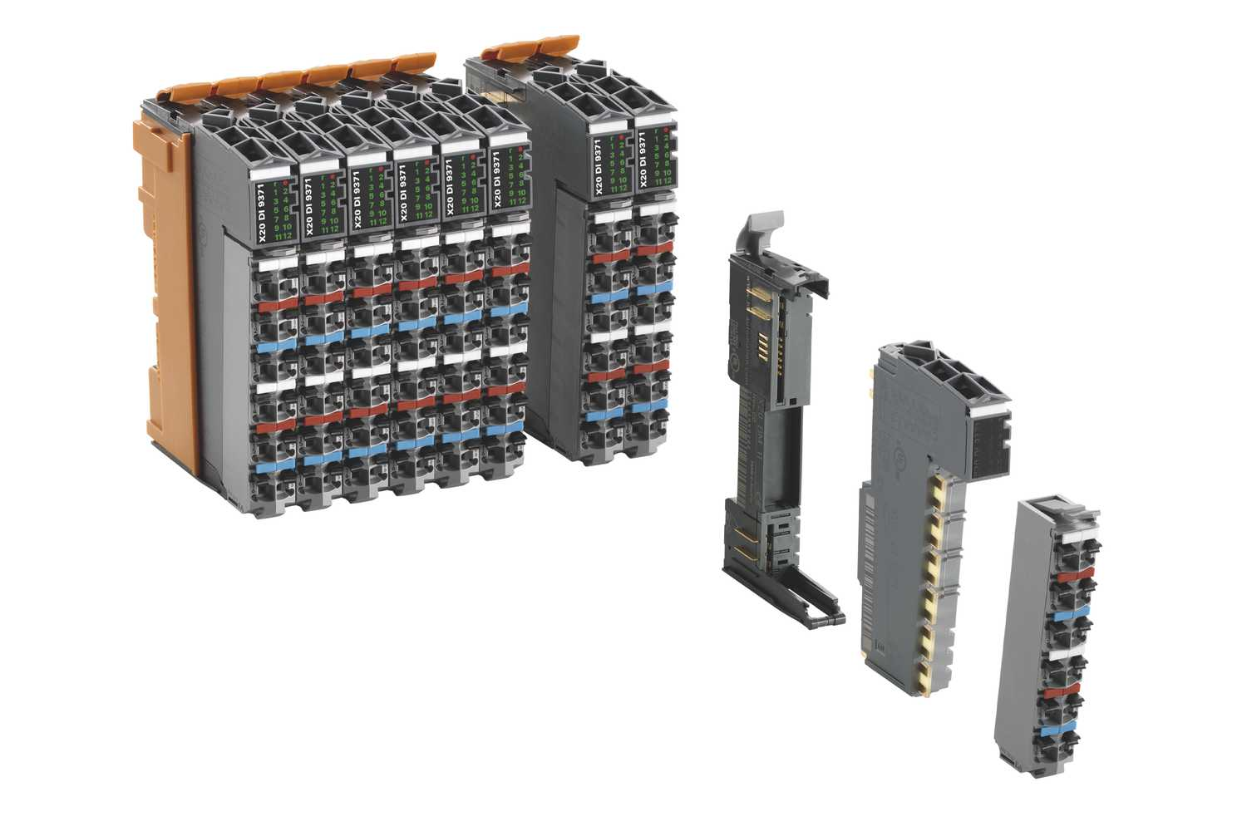
B&R now offers the X2X+ backplane bus as an option, increasing the performance of the X20 system by a factor of four.

About B&R
B&R, a division of ABB Group, is a global leader in industrial automation headquartered in Austria. B&R combines state-of-the-art technology with advanced engineering to provide customers in virtually every industry with complete solutions for machine and factory automation, motion control, HMI and integrated safety technology. With Industrial IoT communication standards including OPC UA, POWERLINK and openSAFETY as well as its Automation Studio software, B&R is constantly redefining the future of automation engineering. The innovative spirit that keeps B&R at the forefront of industrial automation is driven by a commitment to simplifying processes and exceeding customer expectations.
For more information, visit www.br-automation.com.

