Automation Connect 2022: B&R India creating pathway for the future
Ready for the next big step
B&R India organized a grand event in Ahmedabad during the month of October in 2022. Leaders working closely with B&R expressed their views through presentations and a panel discussion, brought up various important opportunities and how innovation is a boon to game-changing automation solutions, which will enable our journey together towards a "Self-Reliant India". The event focused on the major innovations highlighting B&R’s contribution and involvement in steering the automation world by creating future-ready automation solutions for smart machines and factories. The event also showcased how the innovative technologies are helping customers build sustainable solutions and become more resilient. The core agenda of the conference was to look beyond the traditional methods and help Indian manufacturers construct sustainable automation techniques for the growth of manufacturing sector in the country.
Through the keynote address, presentations, and panel discussion, the conference provided a platform for the challenges and provided solutions for implementation of smart automation technology. The conference started with a B&R global update by Mr. Joerg Theis, Chief Executive Officer, B&R; followed by global sales update by Mr. Luca Galluzzi, Chief Sales Officer, B&R. Addressing B&R India’s growth journey towards building innovative solutions and creating sustainable market impact, Mr. Jhankar Dutta, B&R’s Regional Managing Director for Southern & Eastern Asia, showed some important milestones and how smart innovations are changing the growth trends in the Indian market. The demos at the event represented some of the niche technologies by B&R like vision system, PharmaEdge, out of the box - ospVFFS and ACOPOS 6D – showcasing the true collaboration of B&R’s expertise along with ABB robot for adaptive manufacturing.
Overcoming challenges and creating success together
The panel discussion focused on the way our nation is moving ahead by implementing smart innovation techniques and adapting to modern business features to restructure the manufacturing and the core business ecosystem to build a ‘Self-reliant India’. The panel discussion topic was addressed by panelists Mr. Susmit Patel, Senior Manager – Design & Development, Windsor Machines Ltd.; Mr. Gaurov Tyagi, Director – Tycon Automation Pvt. Ltd.; Mr. Dhiraj Taneja, Managing Director – Pet Plast India Inc.; Mr. Subrata Karmakar, President – Head of Robotics & Discrete Automation, ABB India Ltd. and Mr. Dinesh Mungi, Packaging Expert & Branch Head - Pune, B&R India. These experts have shed light on and expressed notable views on some of the important technologies and relevance seen in modern manufacturing practices and how every sector of the manufacturing industry is aligning towards a new path to become more innovative and profitable than before. The new business realities have made stakeholders revisit their operations, supply chain planning, and customer engagement strategies after a period of business disruption in the country. Mr. Himanshu Sharma, Head – Marketing and Corporate Communication curated the panel discussion and concluded with some of the important strategies, staying together in business and adapting to build a ‘Self Reliant India’.
Adapting to modern technologies
The conference also hosted two technical presentations, including "The Adaptive Machines: Fast, Flexible, Futuristic" presented by David Hemetsberger, Strategy Manager – Southern & Eastern Asia, B&R and Mr. Pramod Patil, Director - Unilogic Automation along with Mr. Mukund Patil, Head – PFA Application and business development, B&R India presented some key features and solutions for digital future on Industrial IoT. Mr. Bill Shukla, Chief Executive Officer, Milacron India Pvt. Ltd. addressed the new automation techniques implemented by Milacron. Mr. Vinay Bansod, Executive Director & CEO – Windsor Machines Ltd. and Mr. Pradeep Kumar Rao, Operations Director – Clearpack India Pvt. Ltd. highlighted some of the key features and techniques implemented to achieve excellency. The conference served as an ideal platform for understanding the latest technology trends and helped draw a roadmap for Indian manufacturers to become globally competitive and build a ‘Self-reliant India’. With an exciting lineup of topics and knowledge exchange, delegates received helpful guidance on various state-of-the-art technologies in all the key sectors and gained knowledge regarding the changing face of modern manufacturing practices in India.

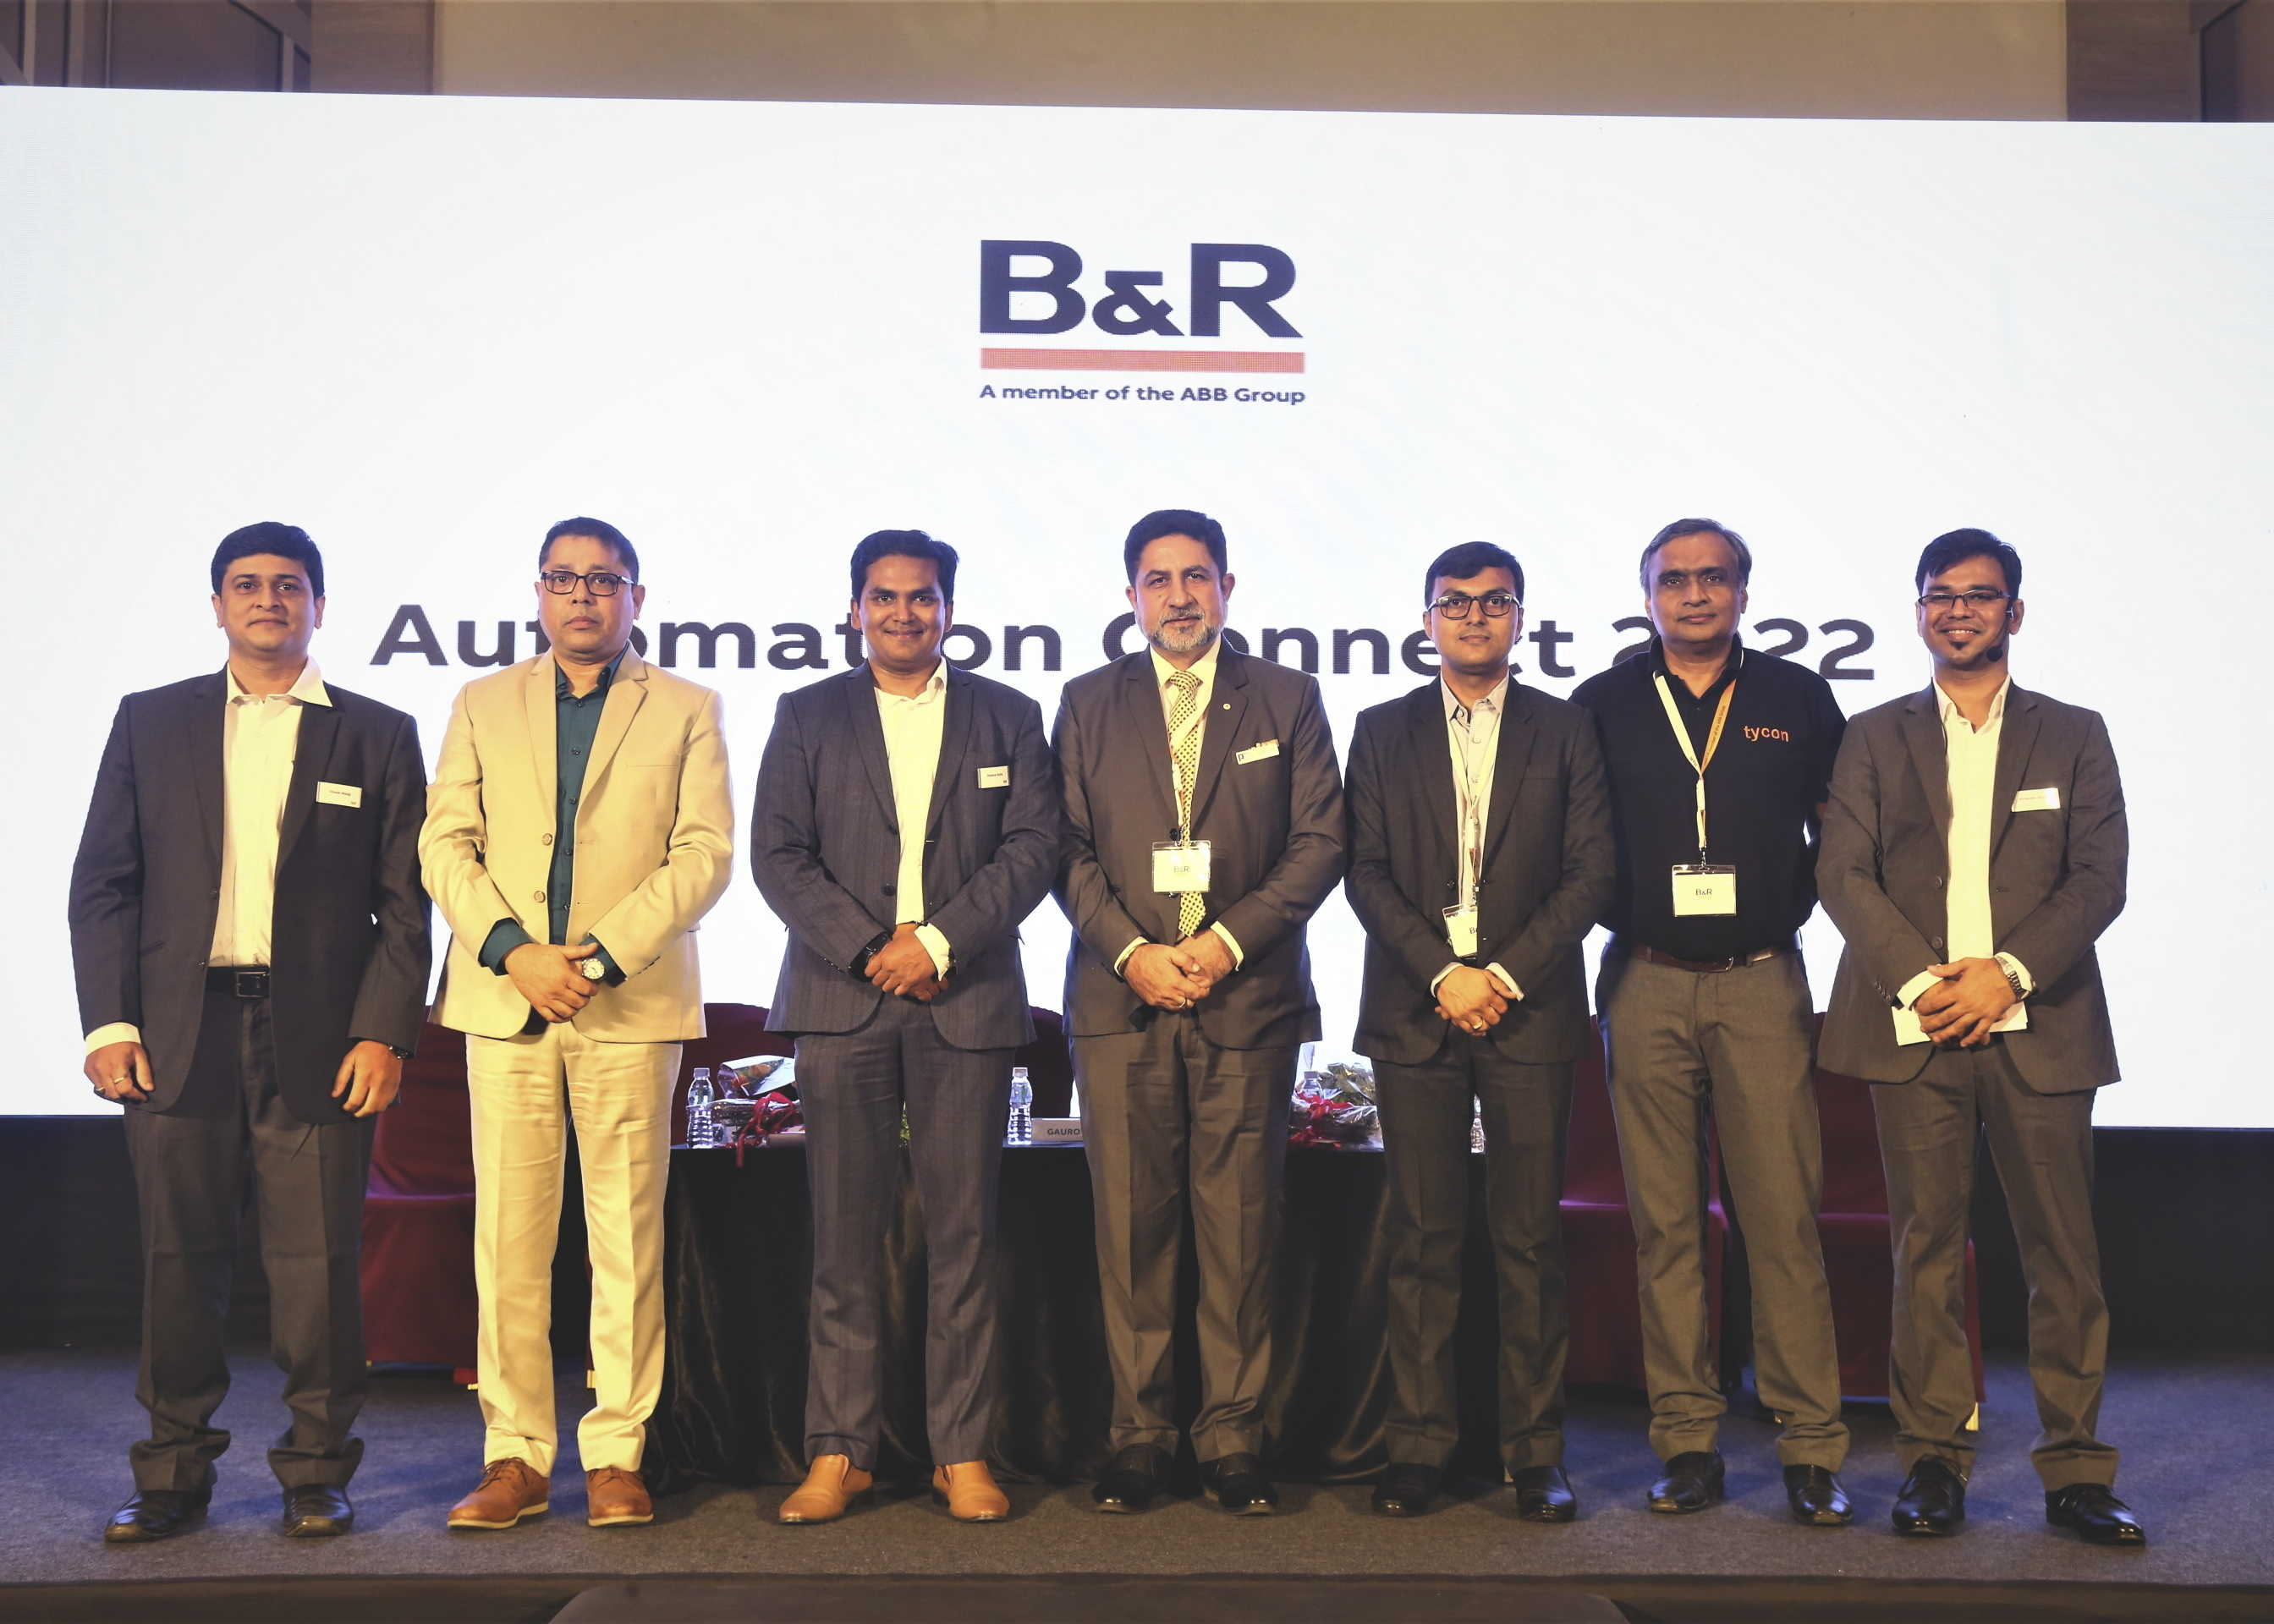
Panel discussion themed "Overcoming challenges - creating success together" focused on technology adoption for enabling India to become self-reliant.
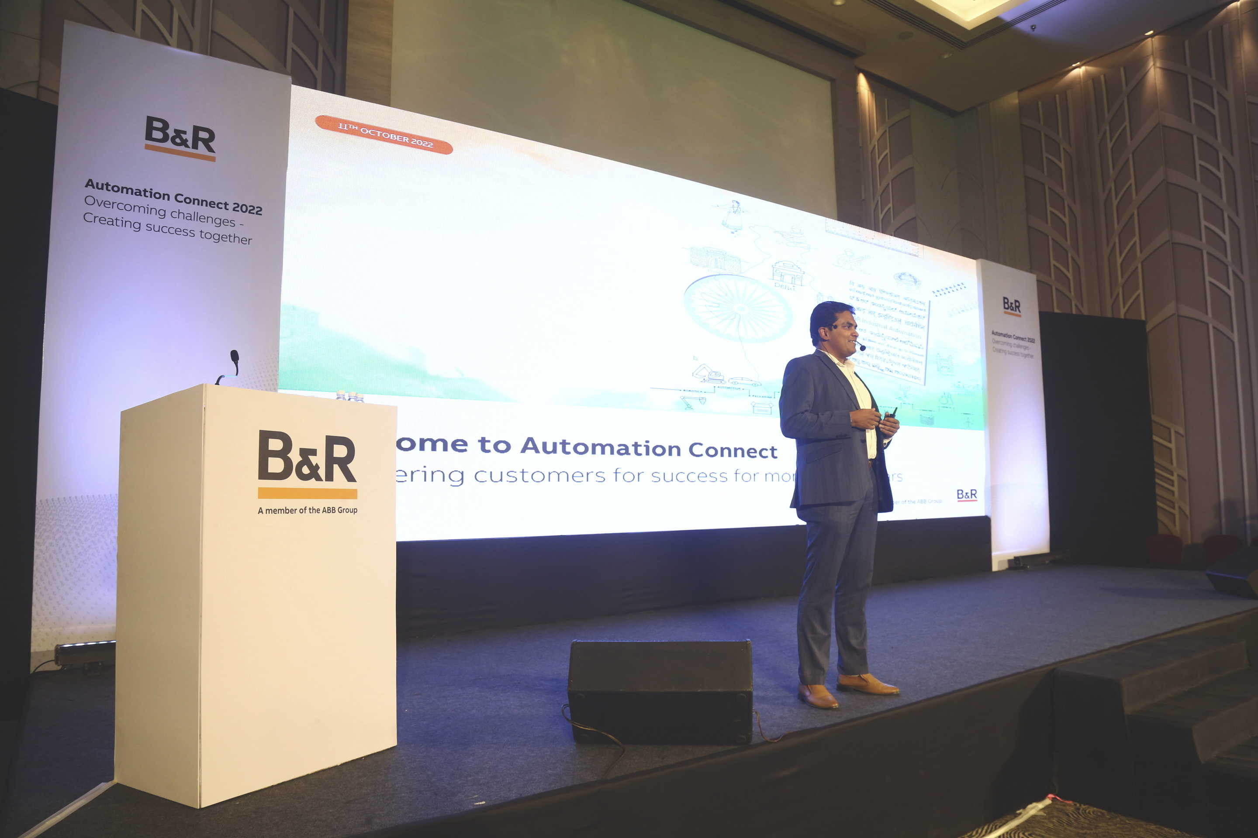
Mr. Jhankar Dutta, B&R’s Regional Managing Director for Southern & Eastern Asia, showed some important milestones and how smart innovations are changing the growth trends in the Indian market.
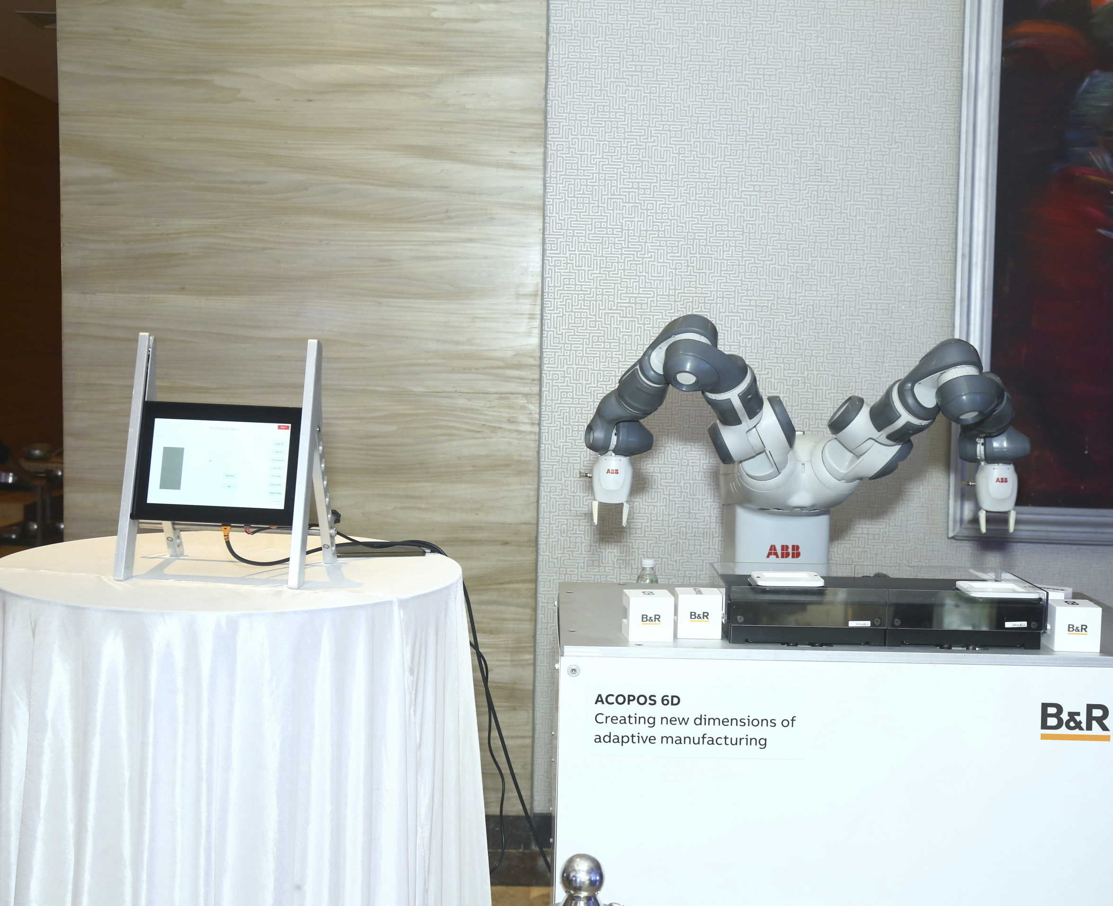
#ThinkAdaptive: Multidimensionally moving ACOPOS 6D shuttles and ABB robot showcasing the possibilities of adaptive manufacturing.

About B&R
B&R, a division of ABB Group, is a global leader in industrial automation headquartered in Austria. B&R combines state-of-the-art technology with advanced engineering to provide customers in virtually every industry with complete solutions for machine and factory automation, motion control, HMI and integrated safety technology. With Industrial IoT communication standards including OPC UA, POWERLINK and openSAFETY as well as its Automation Studio software, B&R is constantly redefining the future of automation engineering. The innovative spirit that keeps B&R at the forefront of industrial automation is driven by a commitment to simplifying processes and exceeding customer expectations.
For more information, visit www.br-automation.com.

