500 new employees in production
B&R introduces new employment model to meet high demand for automation
To more rapidly meet increasing demand for its automation solutions, B&R is implementing new weekend shifts in production for a period of one year. For 20 hours per week on Saturdays and Sundays, the company offers a salary comparable to that of a full-time job in Austria. In only a few weeks, more than 700 people applied. 300 of them started work in March, 200 more will follow in April.
The measure was made necessary by a dramatic increase in demand for automation solutions in the wake of the COVID-19 pandemic and global supply chain crisis. "Automation is at the top of the agenda in many industries, especially when it comes to moving production closer to target markets," explains B&R CEO Jörg Theis.
"Our solutions play a key role in companies' ability to sustain and expand their business and their workforce. In recognition of this urgency, we want to meet our customers' high demand for automation solutions as quickly as possible. To do that, we have substantially increased our production capacity and are additionally implementing temporary weekend shifts."
Diverse range of applicants
Applicants for the new model came from many different age groups, walks of life and family constellations. They included students and parents, people between jobs and people looking for a career change. Others were self-employed and looking for a side job or seniors looking to bridge the gap to retirement.
Some had completed apprenticeships, others have bachelor's or master's degrees. A substantial portion of the applicants came from as far away as Linz, Vienna and neighboring Bavaria – within a 4-hour radius of the B&R headquarters.
Targeted measure for one year
Rather than conducting individual interviews with more than 700 applicants, B&R organized seven "Job Days" throughout the months of January and February. At these events, the applicants were able to get a first impression of their new workplace.
"We are very grateful to the works counsel and union for the opportunity to respond to this unique situation with such an innovative measure, and to the many people who chose to apply for it," emphasizes Theis. The weekend shift was agreed upon as a temporary measure and will expire at the end of February 2024 – at which point B&R hopes that many of the new employees will stay on board and move to one of the existing shifts.
Jobs with a future
As ABB's global center for machine and factory automation, B&R counts among the many successful global companies investing in jobs of the future in Austria. With the opening of the new innovation and education campus last summer, ABB expanded the B&R headquarters in Eggelsberg to more than 100,000 square meters. This made B&R one of Central Europe's largest centers for integrated production, research and training.

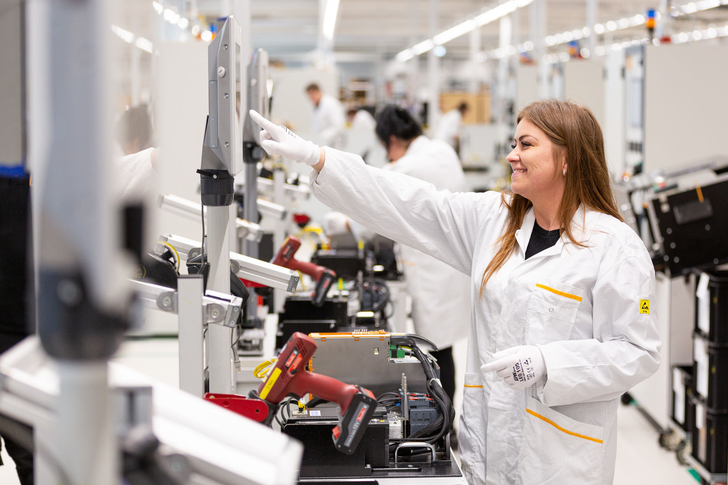
B&R has implemented an innovative new employment model to meet the high demand for automation solutions as rapidly as possible. 300 new employees have already begun work in the temporary weekend shift. (Source: B&R)

About B&R
B&R, a division of ABB Group, is a global leader in industrial automation headquartered in Austria. B&R combines state-of-the-art technology with advanced engineering to provide customers in virtually every industry with complete solutions for machine and factory automation, motion control, HMI and integrated safety technology. With Industrial IoT communication standards including OPC UA, POWERLINK and openSAFETY as well as its Automation Studio software, B&R is constantly redefining the future of automation engineering. The innovative spirit that keeps B&R at the forefront of industrial automation is driven by a commitment to simplifying processes and exceeding customer expectations.
For more information, visit www.br-automation.com.

