Automation and robotics needed by any OEM will be present at Advanced Factories
B&R's booth in the central aisle of the exhibition (booth D436) will give visitors an introduction to the world of automation and robotics in april 18th to 20th. Showcasing their own leadership, B&R and ABB will share their own island in Hall 6 at Fira de Barcelona.
A demo has been developed in which he will be performing product transport tasks for code reading through an Smart Camera. It does not matter on which visible side the code is located because the ACOPOS 6D can rotate 360 degrees to position the product within the camera's field of view.
This scanning, through artificial vision, exemplifies how B&R's integrated automation is taken to its maximum exponent. This demonstration allows the validation of identification, position and product traceability by reading codes typical of industries as demanding as the pharmaceutical industry.
Suitable for hygienic areas
ACOPOS 6D shuttles levitate freely, without any contact or friction. As there is no abrasive wear, no maintenance of the parts is required. By placing a stainless steel cover over the motor segments, ACOPOS 6D offers IP69K protection, which is ideal for hygienic areas, clean rooms or food and beverage production.
In addition, shuttle path planning is performed in a dedicated control, connected to the machine network via POWERLINK; this means that it does not affect the performance of the network or the machine control system. ACOPOS 6D is fully integrated into the B&R ecosystem.
Codian robots playing checkers
Robotics will be a major focus for B&R at the show. Codian delta robots for pick-and-place tasks will have a prominent space in a demo cell developed specifically for Advanced Factories. Fully controlled by B&R technology, it can be seen how two delta robots placed in parallel play checkers on a chessboard, showing the precision with which they can work.
The Codian family includes robots for pharmaceutical and food applications within its broad range of modular robots up to IP69K hygienic designs.

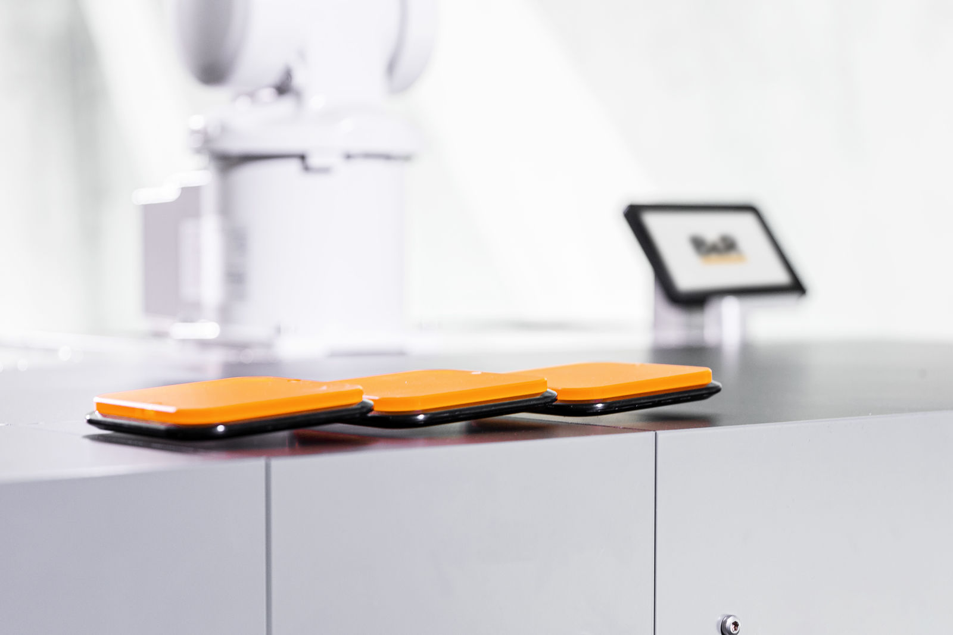
The floating shuttles of ACOPOS 6D are ideal for small-batch production with frequent changeover between products of different designs and dimensions.

Industry 4.0 Congress
Ludwig Hafner, B&R's Industry expert for PFA Hybrid Industries, will present "Hybrid Automation Solutions for the SMART Factory". Hybrid automation solutions enable plant managers to take their factory to the next level with control from the sensor to the cloud providing value in the production phases, data acquisition, data analytics and real-time control of production lines and their machines.

