Visit @ Campus Eggelsberg 2023

Due to the high demand at the Passion4Automation Day 2022, last November, B&R Switzerland invites you to a trip to the new B&R Campus in Eggelsberg on 19 and 20 June 2023.
The Highlight at the B&R headquarters will be the guided tour through the production and the ultra-modern campus.
Curious? Secure your place and register right now. We look forward to seeing you!
Rough programme
Monday, 19 June 2023
• Start in the morning from various destinations
• Welcome in the auditorium
• Further programme in groups:
° Presentations of the Product Group Managers
° Guided tour through the new production and visit of the campus
• Transfer to the hotel in Salzburg
• Dinner in Salzburg
Tuesday, 20 June 2023
• Breakfast and Transfer to Eggelsberg
• Welcome in the auditorium
° Presentations of the Product Group Managers
° Guided tour through the new production and visit of the campus
• Start of the jurney home approx. 11:00 a.m.
• Arrival at Home latest 17:00 p.m.
Travelling
Travelling in a comfortable car. Travelling in a comfortable car.
Accommodation
In the stylish MotelOne Süd in Salzburg.
Contribution towards expenses
150 Euro or 100 Euro for double occupancy of the hotel room. The flat rate of 150 or 100 Euro includes:
• Transport by car
• Meals during the entire visit
• Hotel room incl. breakfast
Registration deadline
For organizational reasons we need your definite registration until April 21, 2023.

Registration Link
Cancellation and further information
After registration you will receive an e-mail confirmation. The invoice will be sent at a later date. There is a right of withdrawal free of charge up to 14 days before the event. The detailed programme and all important information will be made available to you as soon as possible.

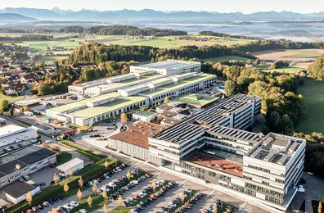

About B&R
B&R, a division of ABB Group, is a global leader in industrial automation headquartered in Austria. B&R combines state-of-the-art technology with advanced engineering to provide customers in virtually every industry with complete solutions for machine and factory automation, motion control, HMI and integrated safety technology. With Industrial IoT communication standards including OPC UA, POWERLINK and openSAFETY as well as its Automation Studio software, B&R is constantly redefining the future of automation engineering. The innovative spirit that keeps B&R at the forefront of industrial automation is driven by a commitment to simplifying processes and exceeding customer expectations.
For more information, visit www.br-automation.com.

