25 years of B&R India
Celebrating collaboration and shared growth
This year marks a major milestone for B&R India: 25 years of collaboration and growth together with its customers. Time and again, the spirit of partnership and courage to strive for a better future have enriched the automation sector with groundbreaking innovative solutions. Over the past 25 years, the company has witnessed high praise and recognition, heralded industry transformation, and built a competitive edge for its customers through development, support, training, and co-creation.
Starting Indian business operations in 1998, B&R has become one of the country's leading suppliers of automation technology. In addition to its headquarters in Pune, B&R India also has six local offices providing solutions and support to the respective regions. On this silver jubilee occasion, the company celebrates 1000+ successfully completed automation projects, 100+ employees, a 4,000 sq-mt warehouse and service facility in Chakan, 7 training facilities, and a world-class support hotline for machine builders and manufacturers. Through its Education Network, the company has also helped to spread knowledge and inspire the next generation of engineers with a passion for automation.
Industry-focused solutions
Along with cutting-edge technology and high-end automation products, B&R India has launched an out-of-the-box automation solution for vertical form fill seal (VFFS) machines called ospVFFS. This scalable solution offers limitless possibilities and configurations for new as well as retrofit machines. With PharmaEdge, B&R India has also introduced an integrated single-PC solution that helps users in the pharmaceutical industry monitor and controls their entire operations and meets the increasing demands of FDA compliance.
Customers and employees integral in success
B&R India has established itself as a pillar of the company's global presence, with long-term partnerships and innovative technology that helps Indian manufacturers gain a competitive edge in the global market. Speaking on this special occasion, Mr. Jhankar Dutta, B&R's Regional Managing Director for Southern & Eastern Asia, congratulated the employees of B&R India and thanked them for their integral role in helping the company achieve its goals. He also expressed appreciation to B&R's customers for their continued trust and partnership.

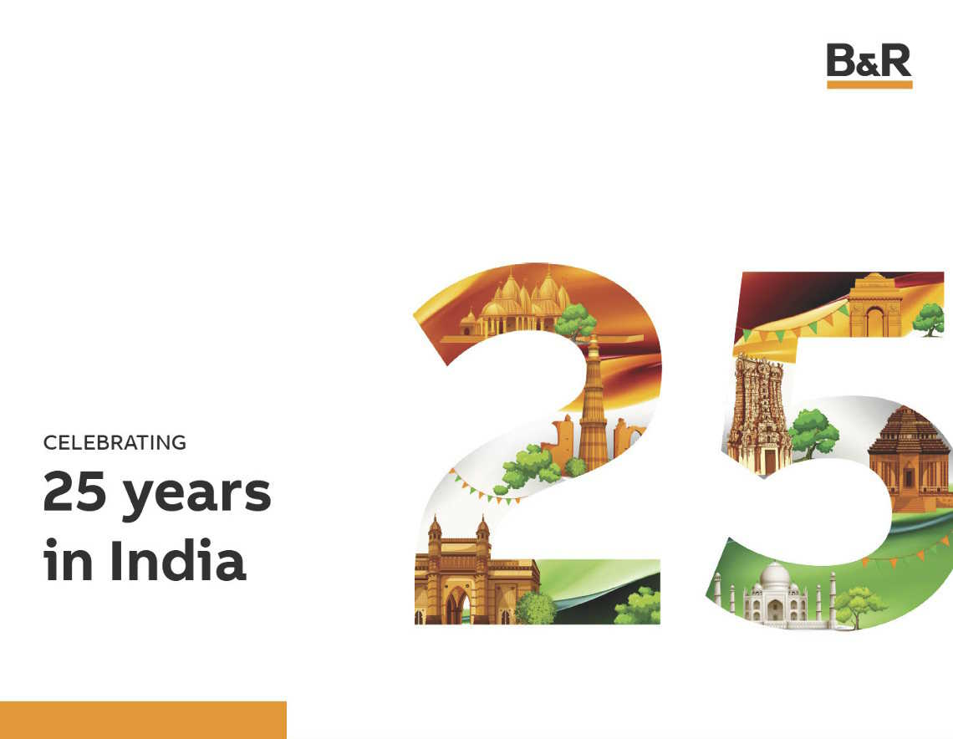
25 years of collaboration and growth together with its customers

About B&R
B&R, a division of ABB Group, is a global leader in industrial automation headquartered in Austria. B&R combines state-of-the-art technology with advanced engineering to provide customers in virtually every industry with complete solutions for machine and factory automation, motion control, HMI and integrated safety technology. With Industrial IoT communication standards including OPC UA, POWERLINK and openSAFETY as well as its Automation Studio software, B&R is constantly redefining the future of automation engineering. The innovative spirit that keeps B&R at the forefront of industrial automation is driven by a commitment to simplifying processes and exceeding customer expectations.
For more information, visit www.br-automation.com.

