B&R provides cyber security support to customers
Development process for Automation Runtime certified according to IEC 62443-4-1
The development process for Automation Runtime, the real-time operating system provided by automation specialist B&R, has been certified. The successful audit by TÜV Rheinland confirms the standard-compliant implementation of the processes for secure product development of industrial automation technology according to IEC 62443-4-1. B&R takes cyber security into account in all phases of the software product lifecycle – from specification to design, development, testing and maintenance.
Robert Fuchs, cyber security officer at B&R, explains, "B&R takes its responsibility for OT security in the supply chain seriously. IEC 62443-4-1 certification underscores the company's ability to implement modern vulnerability management, perform comprehensive security testing and assist in identifying and addressing security risks." Orientation to the industry standard makes it easier for B&R customers to conduct time-consuming in-house analyses and supplier audits related to the cyber security of OT systems.
Florian Schneeberger, Chief Technology Officer at B&R, adds: "Management sees this certification as a key milestone in the strategy to further anchor cyber security in our product portfolio. We will successively expand our activities in this area because the development of robust products is becoming increasingly important for the commercial success of our customers."

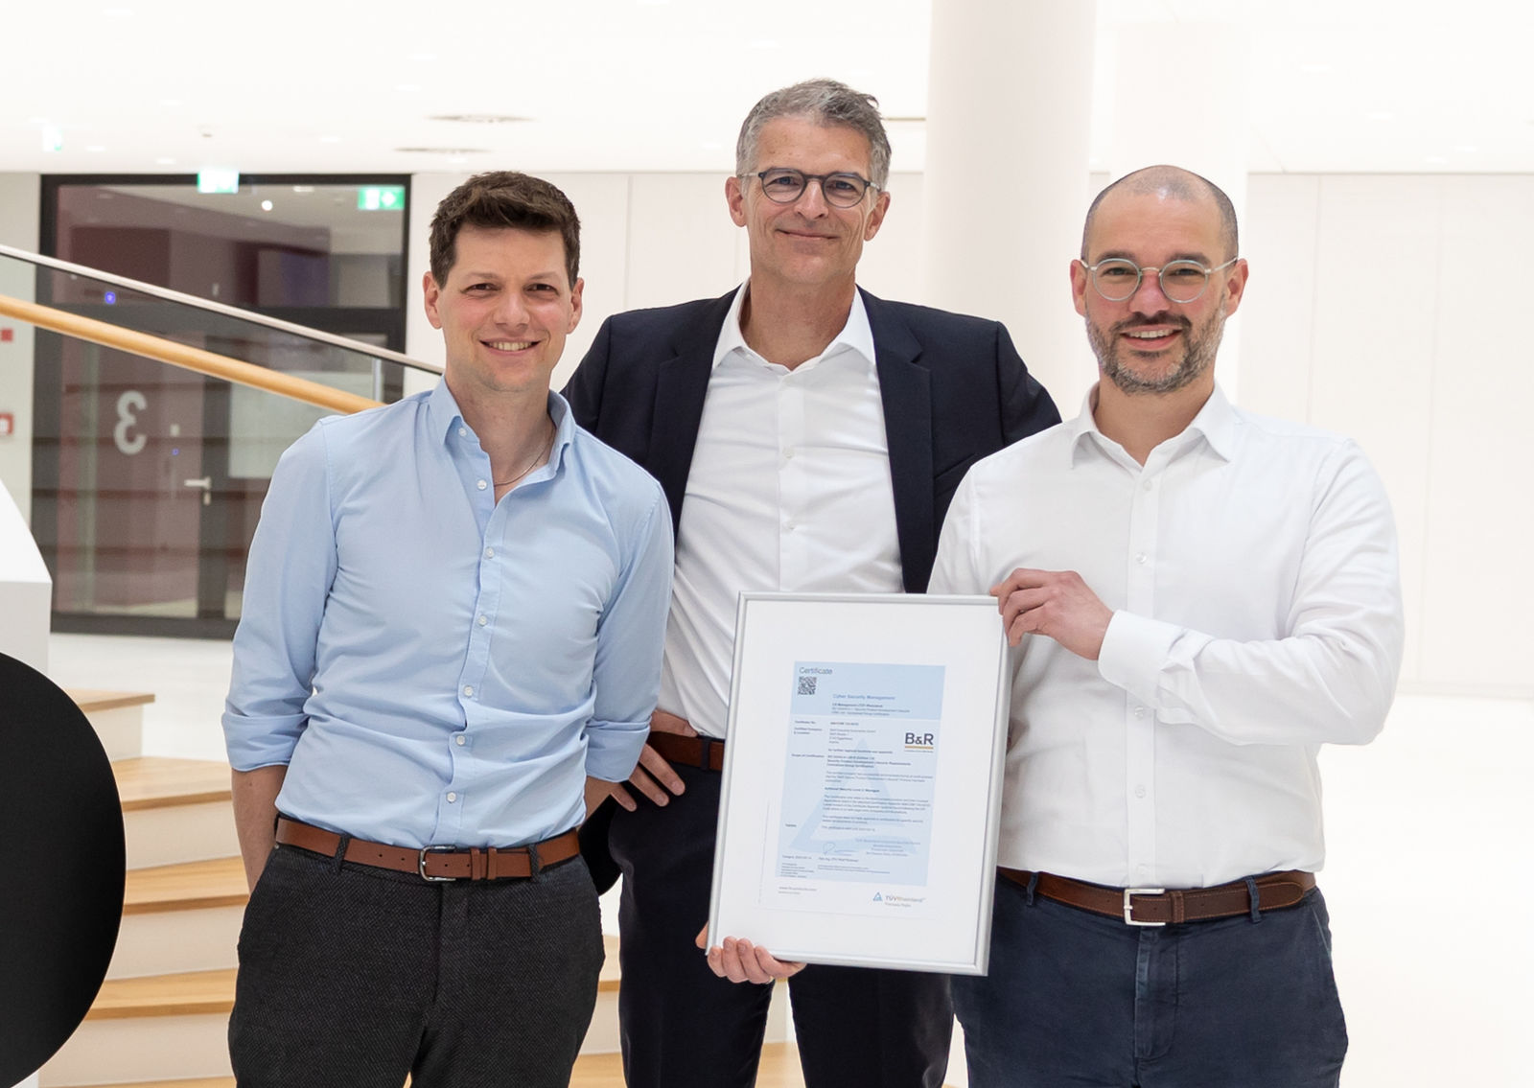
A milestone for certified OT security at B&R: Florian Schneeberger (CTO, center), Robert Fuchs (right) and Gregor Auer (left) from the cyber security team show the certificate. (Image: B&R Industrial Automation, Eggelsberg)

About B&R
B&R, a division of ABB Group, is a global leader in industrial automation headquartered in Austria. B&R combines state-of-the-art technology with advanced engineering to provide customers in virtually every industry with complete solutions for machine and factory automation, motion control, HMI and integrated safety technology. With Industrial IoT communication standards including OPC UA, POWERLINK and openSAFETY as well as its Automation Studio software, B&R is constantly redefining the future of automation engineering. The innovative spirit that keeps B&R at the forefront of industrial automation is driven by a commitment to simplifying processes and exceeding customer expectations.
For more information, visit www.br-automation.com.

