Young champions crowned at World Robot Olympiad Austria
Two teams earn trip to world finals in Panama
On Thursday, June 22nd, 2023, the Austrian finals of the World Robot Olympiad brought some of the next generation's best robot developers to the B&R headquarters in Eggelsberg – ABB's global center for machine and factory automation. The atmosphere in the innovation and training campus was charged with excitement as youth between the ages of 9 and 18 competed for a trip to the world finals in Panama City. In November, the two winning teams and their self-built robots will face off against participants from more than 90 nations.

The World Robot Olympiad (WRO) is an international robotics competition created to spark interest in computer science, robotics and automation and inspire young students to pursue careers in IT and engineering. Austria has participated in the event since 2018. In each round of the competition, the participants put their skills and talent to the test through multiple phases of construction and evaluation. Ultimately, world champions are crowned in the categories RoboMission, RoboSports, Future Innovators and Future Engineers.
Under the motto "Connecting the World", the theme of this year's competition is transport and logistics. For the national Olympiad, the teams faced the challenge of adapting and programming their robots to complete four rounds on the course. "The kids demonstrated impressive creativity, technical skills and teamwork," said Florian Schneeberger, CTO of B&R, who hosted the event for the first time this year. "That's a combination we urgently need for the automated world of tomorrow, which is why B&R invests in collaboration with educational institutions and supports the World Robot Olympiad Austria."
Fostering STEM talent around the world
The World Robot Olympiad was started as a non-profit organization in 2004 with the goal of fostering young talents and increasing diversity in the fields of science, technology, engineering and math (STEM). Herbert Ibinger, organizer of WRO Austria and director of the Techno-Z technology center in Braunau explains: "With this competition, we hope to inspire young people and prepare them to be the digital pioneers, innovators and engineers of the future."
"We've noticed that this playful approach helps get a wider audience excited about coding and robotics," adds Ibinger, who was pleased to report that nearly half of the participants at the Austrian finals were female, including the all-girl "Eisbärlis" team from Riedau Secondary School, who dominated the Senior age group for 14 to 19 year-olds. Their schoolmates, the "Plasma-Bots", took the Junior title for ages 12 to 13 and will join them at the world finals in Panama.
80% of educators: Robotics and automation will shape the future
Despite the general appetite for automation in industry, ABB's 2022 global education survey found a significant gap in the education and training needed to ensure the skills necessary for work in the increasingly connected and automated workplaces of the future. Of the global education professionals surveyed, 80% believe robotics and automation will shape the future of employment in the next ten years, while only one in four education institutions currently use robots as part of their teaching programs.
To help bridge the skills gap, ABB has bolstered its global Robotics and Automation education program with new training centers, including a 100-million-Euro investment in the global innovation and training campus in Austria. The campus is an "open innovation hub" where B&R collaborates closely with international customers, regional companies and start-ups as well as research and educational institutions to codevelop automation solutions and train the talents needed for the factories of the future.
The innovation and training campus at B&R in Eggelsberg is ABB's global center for machine and factory automation. Education is a top priority at the campus, where B&R's Automation Academy offers training capacity for up to 4,000 people per year, including students, apprentices, professionals and employees of B&R and its customers from around the world. Globally, ABB operates over 40 training facilities, educating more than 30,000 students from schools, colleges and universities, as well as apprentices and workers each year. Through more than 100 global partnerships with schools and universities, ABB generates curriculum materials with education providers to help educate future generations and prepare them the jobs of tomorrow.

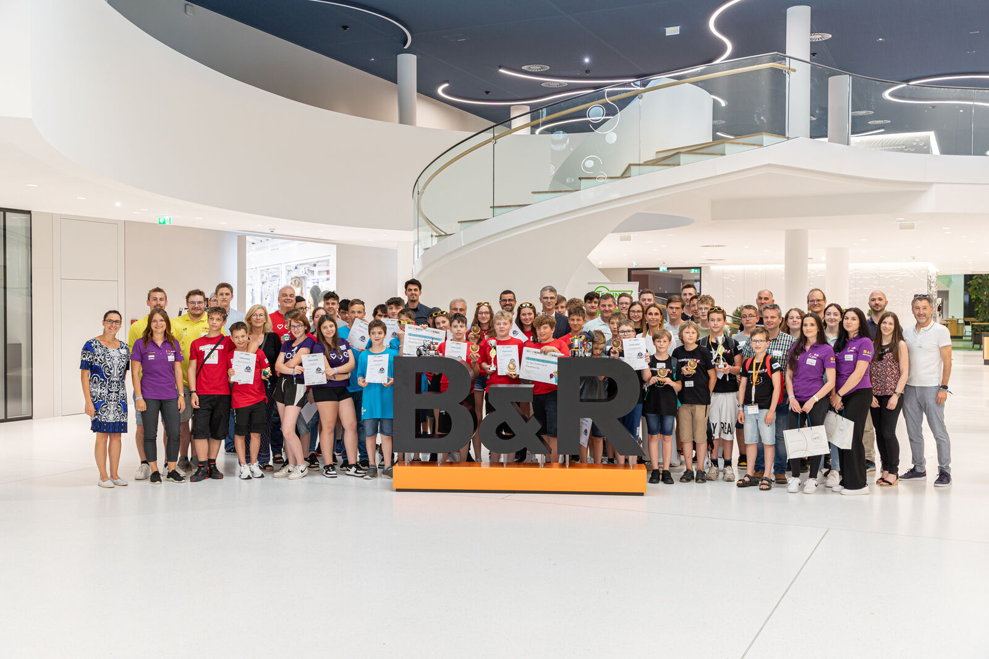
Youth from across Austria met at B&R in Eggelsberg for the Austrian final of the World Robot Olympiad. (Photo: B&R)
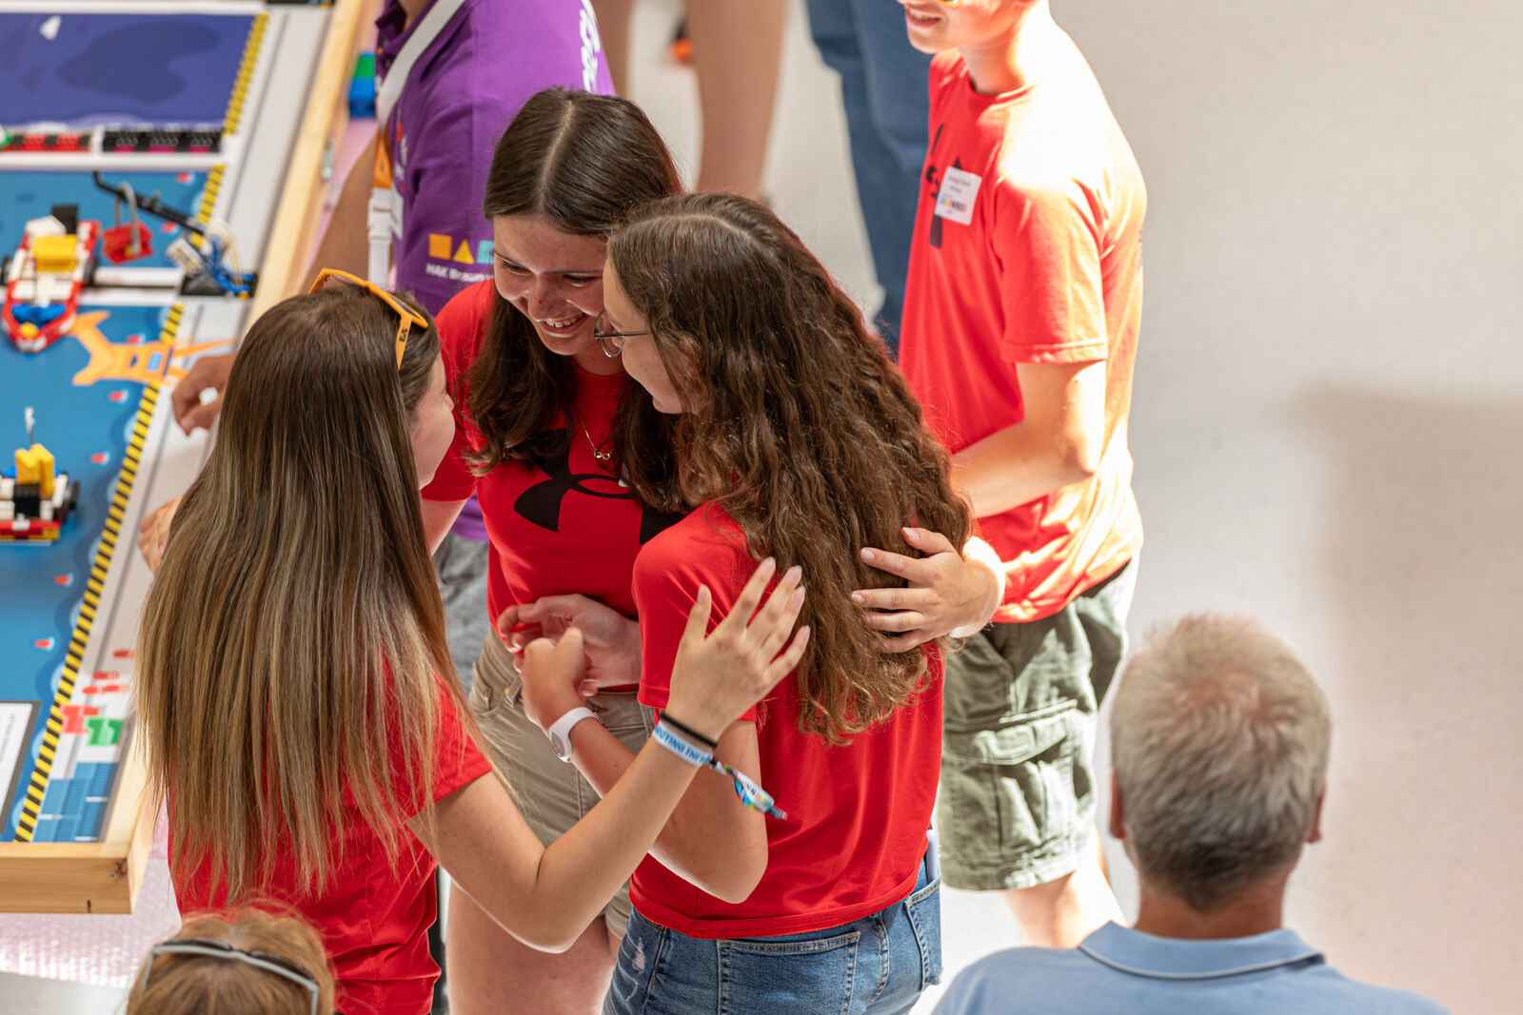
The "Eisbärlis" demonstrated strong skills, creativity and nerves as they dominated the Senior age group. (Photo: B&R)
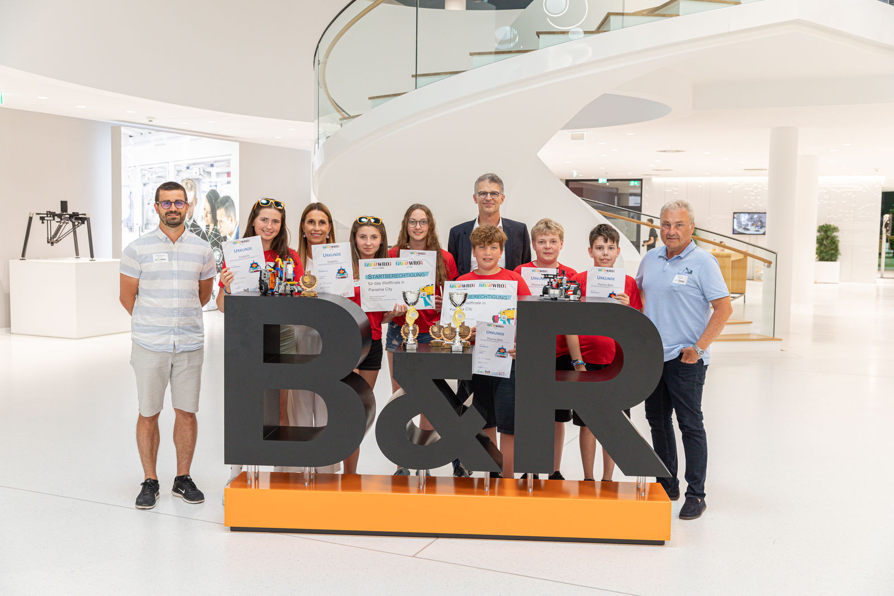
Flanked by their coaches, the "Eisbärlis" and "Plasma-Bots" were congratulated by B&R CTO Florian Schneeberger (middle) and Regional Education Director Eva Panholzer (3rd from left). (Photo: B&R)
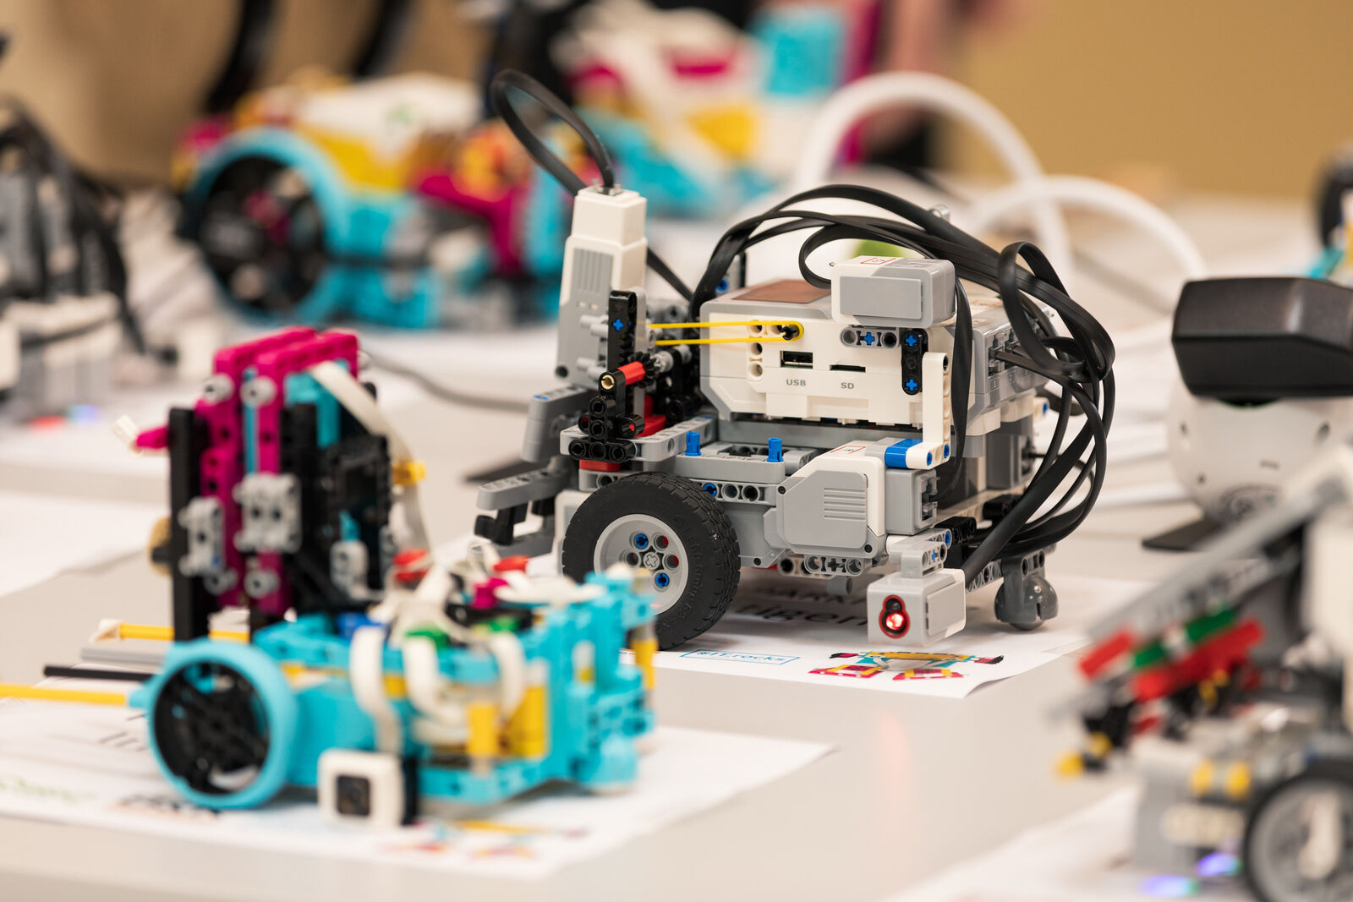
The two winning teams and their self-built robots will fly to Panama City for the World Robot Olympiad world finals in November. (Photo: B&R)

About B&R
B&R, a division of ABB Group, is a global leader in industrial automation headquartered in Austria. B&R combines state-of-the-art technology with advanced engineering to provide customers in virtually every industry with complete solutions for machine and factory automation, motion control, HMI and integrated safety technology. With Industrial IoT communication standards including OPC UA, POWERLINK and openSAFETY as well as its Automation Studio software, B&R is constantly redefining the future of automation engineering. The innovative spirit that keeps B&R at the forefront of industrial automation is driven by a commitment to simplifying processes and exceeding customer expectations.
For more information, visit www.br-automation.com.

