Create a pick-and-place application in minutes
mapp Robotics makes machines faster, more flexible and more efficient
A ready-made software solution from B&R helps OEMs implement pick-and-place applications significantly faster with minimal investment risk. The Pick-and-Place process solution from mapp Robotics makes machines faster, more flexible and more efficient.

Pick-and-place robots open up new degrees of freedom for engineers when designing production processes. In particular, machines designed to produce small quantities down to batch size 1 and high product variance benefit from automated handling that is synchronized with the processes in microsecond precision.
Configuring, not programming
To create such applications, B&R offers a ready-made software solution for pick-and-place robots from its mapp Technology software toolbox. This allows applications to be configured intuitively by selecting ready-made function blocks. These are linked together in the editor, as with other mapp applications, allowing an executable robotics application to be created within a minutes.
In-depth robotics know-how is not required. It takes only a few clicks to set up coordination with other motion axes, track systems, B&R machine vision components or web-based mapp View HMI applications. This eliminates much of the manual programming work and development time is shortened.
Maximum freedom when designing processes
The mapp Pick-and-Place software solution offers maximum freedom when designing processes. Any number of delta robots can be used. The number of conveyor belts for the infeed and outfeed is also freely configurable. As a special highlight, the software automatically optimizes the process for maximum pick rate.

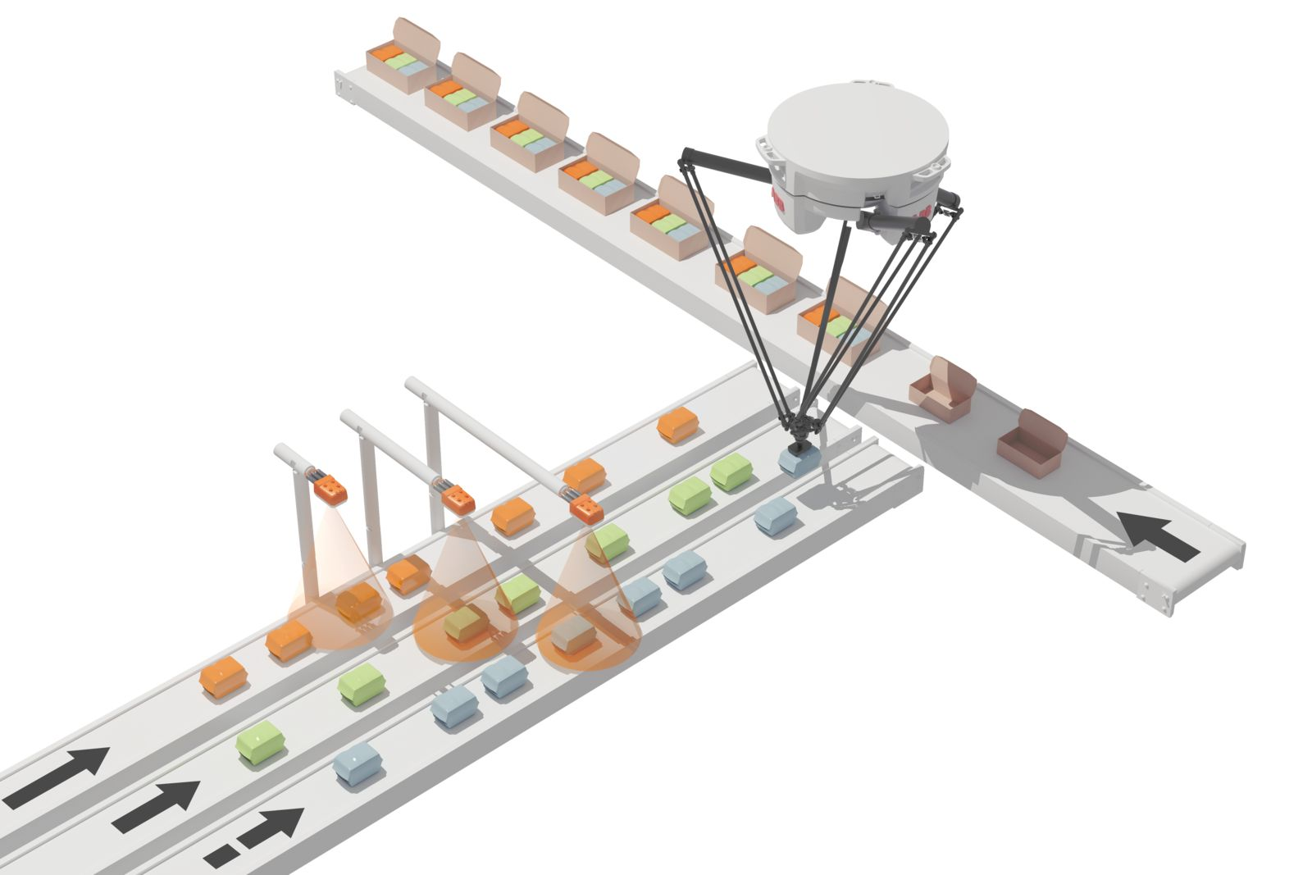
With mapp Pick-and-Place, applications can be set up with just a few clicks. (Image: B&R)
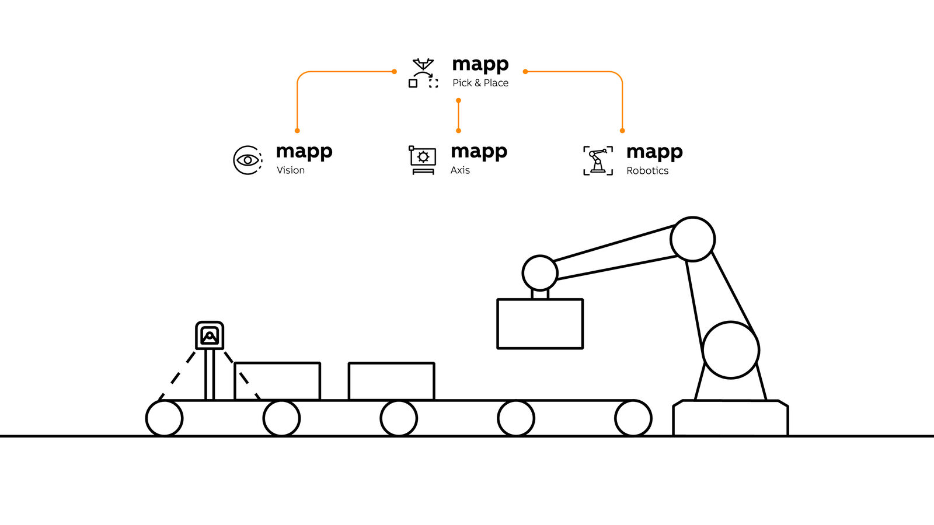
The mapp components exchange all the information they need with each other automatically. (Image: B&R)

About B&R
B&R, a division of ABB Group, is a global leader in industrial automation headquartered in Austria. B&R combines state-of-the-art technology with advanced engineering to provide customers in virtually every industry with complete solutions for machine and factory automation, motion control, HMI and integrated safety technology. With Industrial IoT communication standards including OPC UA, POWERLINK and openSAFETY as well as its Automation Studio software, B&R is constantly redefining the future of automation engineering. The innovative spirit that keeps B&R at the forefront of industrial automation is driven by a commitment to simplifying processes and exceeding customer expectations.
For more information, visit www.br-automation.com.

