B&R printed circuit board plant in Eggelsberg independent of natural gas thanks to new industrial heat pumps

• B&R takes another big step toward carbon neutrality: €2.5 million investment to save more than 1,800 MWh of gas and 450 tons of CO2 annually
• New industrial heat pump system heats and cools 15,500 m² of production and office space
• B&R's own photovoltaic system, one of the largest in Austria, is to be expanded from 1.8 MWp to 3.2 MWp
• A massive expansion of electric fleet vehicles from 10 percent to 90 percent is targeted, 59 EV charging stations are already in operation on site
Automation specialist B&R, member of the ABB Group, is phasing out its reliance on natural gas, beginning with the printed circuit board plant at its headquarters in Eggelsberg, Austria. This is made possible by a new industrial heat pump system, in which B&R invested €2.5 million, that will use waste heat from machines for climate-friendly heating and cooling of 15,500 m² of production and office space. The resulting savings in gas consumption are approximately the equivalent of a small community.
The new heat pump system requires about a quarter of the energy previously used. 100% of the electricity for this comes from renewable energy sources, first and foremost from the company's own photovoltaic system, with a current output of 1.8 MW that will be expanded to 3.2 MW in the coming years.
Upper Austria's provincial councilor for economic affairs, Markus Achleitner, explains: "Automation specialist B&R is not only a leading and highly innovative company in Upper Austria, but also a pioneer in phasing out fossil fuels such as natural gas. As the no. 1 industrial state in the republic, Upper Austria in particular plays a special role in energy transformation of the manufacturing sector. Industrial or large-scale heat pump systems like this one at B&R Eggelsberg are lighthouse projects on the road to climate neutrality. Austria-wide, there is significant potential to cover more than 12% of the demand for industrial heat with heat pumps. We need to exploit this potential to the best of our ability and drive it forward together."
Electrification of corporate fleet a further step on the way to carbon neutrality
B&R aims to become completely carbon neutral by 2030. To this end, the company will also focus more on electromobility within the company. Currently, one in ten B&R fleet vehicles is electric, and the proportion is steadily increasing. B&R's goal is to convert over 90 percent of the vehicle fleet at its headquarters to electric, and 59 electric vehicle (EV) charging stations are currently in operation at the Eggelsberg site. Further EV charging stations are already being planned.
"We're right on schedule to start the next decade as a carbon neutral company," says B&R President Jörg Theis. There are still major concerns that phasing-out gas in industry isn't economically feasible. Our new heat pump proves that this step is indeed possible today in many industrial plants where gas is not required for actual production. As part of the ABB Group, B&R has a clearly defined goal for carbon neutrality by 2030. The phase-out of natural gas at our printed circuit board plant brings us a big step closer to this goal. In this way, we are paving the way for sustainably produced automation components and climate-friendly supply chains for our customers."
Heat pump saves gas consumption equivalent to nearly 200 households
In the future, B&R's new heat pump system will replace over 1,800 MWh of gas per year. This is equivalent to the consumption of 150 to 200 households. The total heat pump capacity at B&R's printed circuit board plant is 980 kW. The cooling capacity is 850 kW and is especially relevant for those production areas that need to be cooled to a specific temperature in summer.
Waste heat, air and photovoltaics as main energy sources
In 2022, 131 industrial heat pumps were sold across Austria, according to the Federal Ministry for Climate Protection, Environment, Energy, Mobility, Innovation and Technology (BMK). The great potential of heat pumps lies primarily in the utilization of industrial waste heat, which significantly reduces electricity requirements. This is also the case at B&R, where the new heat recovery system uses waste process heat from production as an energy source to heat the office and production areas. The additional energy required is generated by a heat pump system, and excess heat can be used in other parts of the building. Only natural refrigerants are used in all heat pumps. Innovative measurement and control technology from B&R ensures that all components used in this solution work together in the best possible way.
Expansion of the photovoltaic system and electric fleet is underway
The new heating system at the PCB plant is one of several measures that have already been implemented or are planned as part of B&R's sustainability strategy. The ABB Innovation and Training Campus at B&R Eggelsberg, which opened last year, is already home to one of Austria's largest self-consumption photovoltaic (PV) systems. In the last year alone, the PV system supplied 1,786 MWh of electricity. The system will be further expanded in the coming years, along with other measures, such as conversion of the company fleet to electric vehicles. Thermal energy storage between production sites is also being implemented and is intended to ensure optimum use of the climate-friendly energy that is generated.
Note: This project was supported by funds from the BMK's (Federal Ministry for Climate Protection) environmental promotion program.

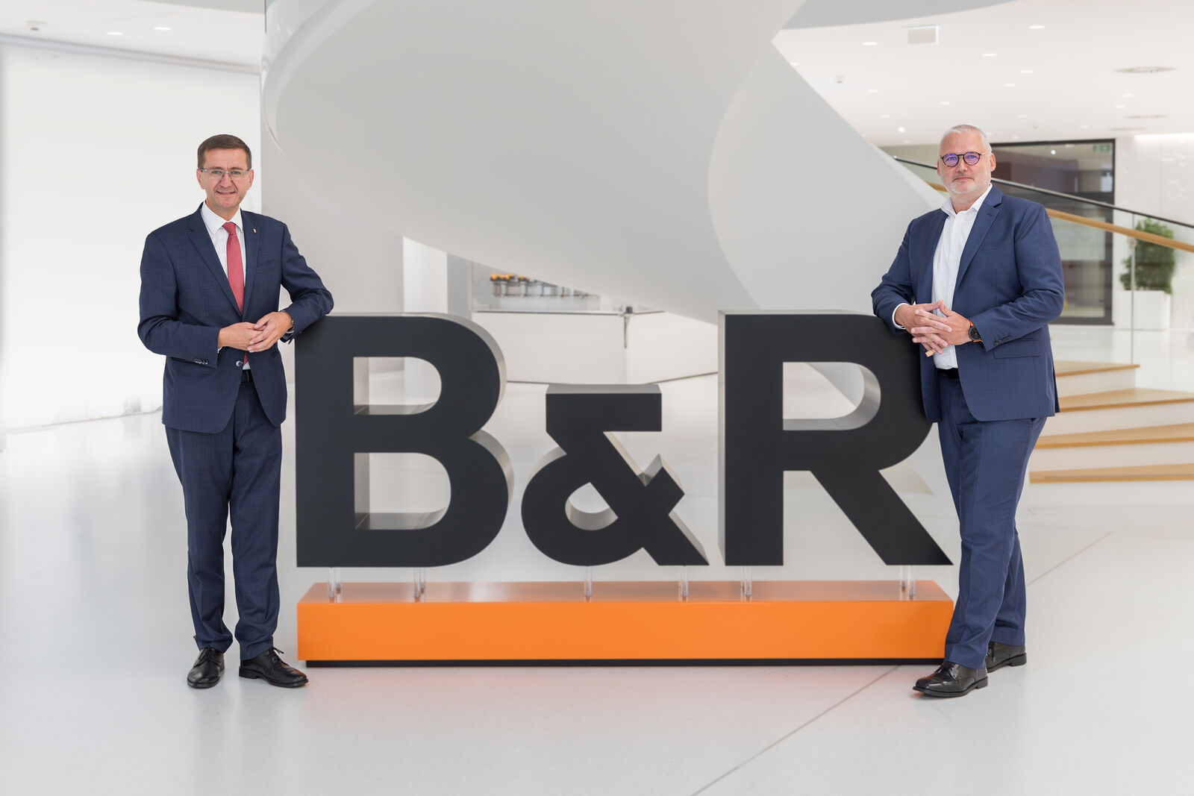
B&R President Jörg Theis welcomed Markus Achleitner (State Minister for Economic Affairs, Upper Austria) at the B&R campus to view the innovative heat pump solution first hand.
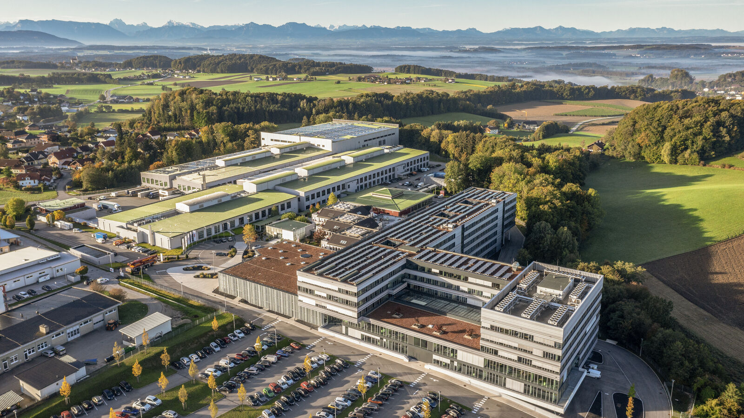
B&R Campus sets course for carbon neutrality with new industrial heat pump and expansion of photovoltaic system (Image: B&R Industrial Automation)
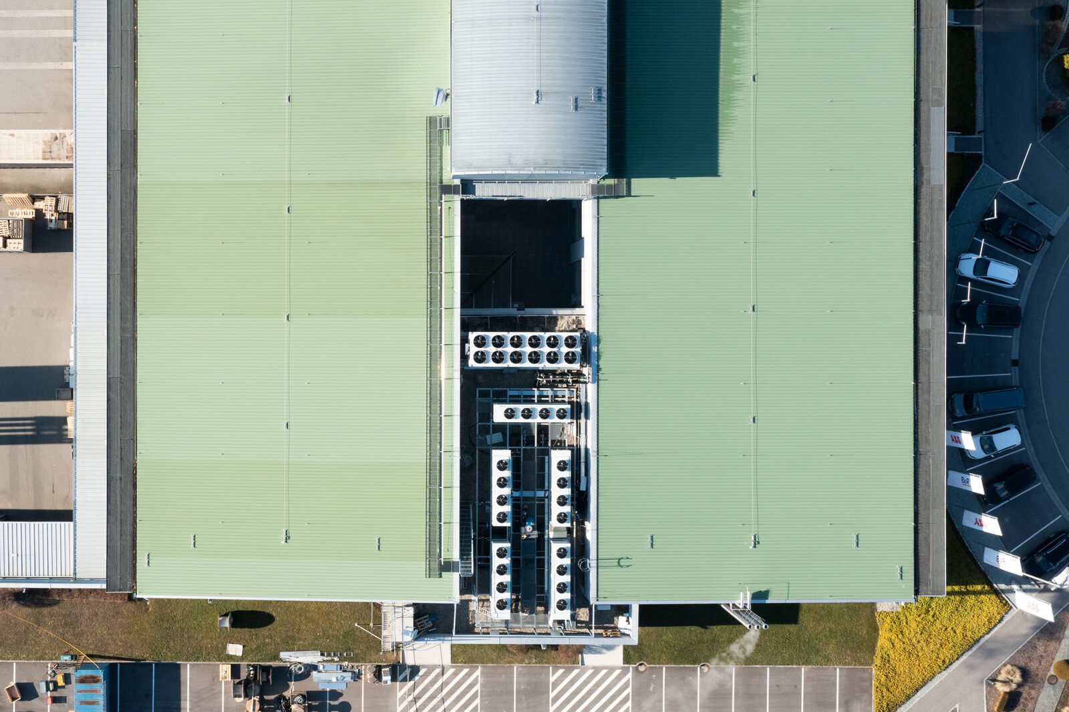
A trend-setting heat pump system at B&R makes the PCB plant independent of natural gas and replaces an amount equal to household gas consumption in a small community (Image: B&R Industrial Automation)
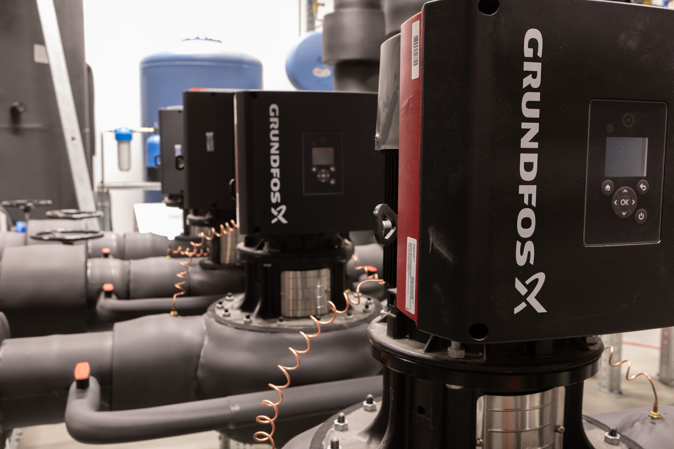
The B&R Campus as a lighthouse project: Heat pumps could cover 15 percent of the required industrial heating (Image: B&R Industrial Automation)

About B&R
B&R, a division of ABB Group, is a global leader in industrial automation headquartered in Austria. B&R combines state-of-the-art technology with advanced engineering to provide customers in virtually every industry with complete solutions for machine and factory automation, motion control, HMI and integrated safety technology. With Industrial IoT communication standards including OPC UA, POWERLINK and openSAFETY as well as its Automation Studio software, B&R is constantly redefining the future of automation engineering. The innovative spirit that keeps B&R at the forefront of industrial automation is driven by a commitment to simplifying processes and exceeding customer expectations.
For more information, visit www.br-automation.com.

Source: The contribution of heat pumps to heat transition (July 2023), BMK https://www.bmk.gv.at/themen/energie/publikationen/beitrag-waermepumpen.html

