Open robot mechanics and adaptive automation at PackExpo
Productivity and flexibility for personalized packaging with B&R Codian
Automation specialist B&R is using this year's PackExpo exhibition in Las Vegas to feature open solutions with Codian robot mechanics, now integrated and rebranded within B&R. The Codian portfolio of delta configurations, including class-leading hygienic models, is open to any control platform and can be incorporated into any machine configuration. B&R's Machine-Centric Robotics solution combines Codian mechanics and B&R controls to offer machine builders and manufacturers single-source robotics and automation for precise synchronization and ease of engineering – ideal when implementing highly flexible packaging solutions.
"As consumer demand for personalized products continues to accelerate, packaging lines rely on cutting-edge automation and robotics to handle increasing product variety without compromising productivity," says Jörg Theis, President of B&R Industrial Automation. “With an extensive selection of pick-and-place robot mechanics open to any control platform, we are committed to offer the best solution for our customer's applications," adds Wouter Valk, Managing Director of Codian Robotics, which was acquired by B&R in 2020.
At PackExpo, visitors to Booth 5442 in the Central Hall will see the full Codian portfolio, currently with more than 100 variants, including class-leading hygenic models ideal for applications such as food and beverage and pharmaceutical packaging.
At Booth 4343 in the Central Hall, B&R will also be showing how robotics work in seamless synchronization with mechatronic product transport systems like ACOPOStrak and ACOPOS 6D, as well as machine vision. Visitors can expect to see B&R's world-class portfolio of control and motion technology to create adaptive manufacturing solutions with dynamic change capability between different products and packaging, enabling profitable mass customization.
B&R's full portfolio of cutting-edge robotics and automation technology offers machine builders and manufacturers unprecedented precision and synchronization. Its Machine-Centric Robotics solutions combine Codian robot mechanics with B&R machine controls in a single-source solution that requires only one controller, one user interface and one engineering system.

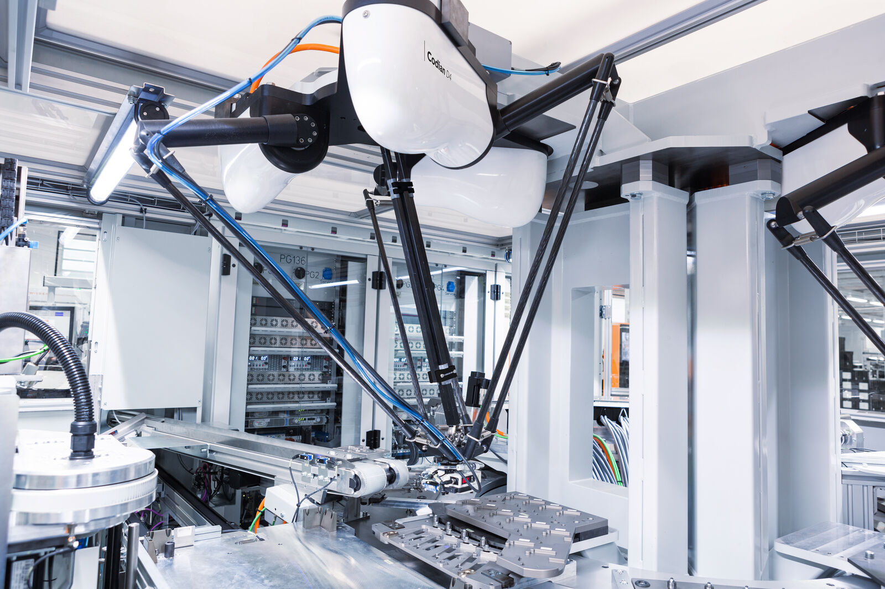
Codian's open robot mechanics can be combined with any control platform and are used for precise pick-and-place tasks such as those in cosmetics packaging. (Image: B&R Industrial Automation)

About B&R
B&R, a division of ABB Group, is a global leader in industrial automation headquartered in Austria. B&R combines state-of-the-art technology with advanced engineering to provide customers in virtually every industry with complete solutions for machine and factory automation, motion control, HMI and integrated safety technology. With Industrial IoT communication standards including OPC UA, POWERLINK and openSAFETY as well as its Automation Studio software, B&R is constantly redefining the future of automation engineering. The innovative spirit that keeps B&R at the forefront of industrial automation is driven by a commitment to simplifying processes and exceeding customer expectations.
For more information, visit www.br-automation.com.

