B&R India organizes 7th Innovations Day in Pune
Empowering Indian manufacturers to build an adaptive manufacturing ecosystem
To showcase new technologies and solutions for the Indian market, B&R Industrial Automation recently organized Innovations Day on August 31, 2023 in Pune to experience the future of automation with ground-breaking innovations, especially for machine builders, system integrators and end users. The event brought esteemed manufacturers and experts from leading companies in machine building together for an event that catapulted some of the finest business presentations, talks from renowned leadership speakers, and candid conversations. This event centered on demonstrating adaptive manufacturing technologies and spreading knowledge among machine builders. The conference witnessed more than 300 attendees, exploring the various capabilities and innovative features of the products displayed and presented from the Innovations basket of B&R.
Adaptive technologies are transforming the way of manufacturing
The Innovations Day event focused on adaptive manufacturing with the tagline "Think Adaptive for the Future", which was the theme for this year's event. Delegates gained inspiration for business growth through various demos showcased by B&R; they witnessed product applications through live demos like ACOPOStrak, ACOPOS 6D, Integrated Machine Vision and Machine-Centric Robotics solutions. The products featured some of the finely tuned applications to help the delegates experience and understand the different benefits adaptive manufacturing possesses and how easy it is to switch over and implement into their existing system. Adaptive manufacturing has already been a frequent topic of conversation globally, but being able to understand and implement it seamlessly along with other running machines was well appreciated by the attendees at the event. The leaders and the presenters also acquainted everyone with the sustainability benefits of adaptive manufacturing technology and how every machine builder should aim to achieve their sustainability targets by implementing such innovations in their manufacturing facility.
Accelerating collaboration and innovation with business partners
B&R management from Austria and India shared their outlook on industry trends and business growth with delegates. They emphasized the innumerable opportunities the Indian market possesses and how adaptive manufacturing can help machine manufacturers build a sustainable future with B&R products and solutions. The conference started with a B&R global update by Mr. Joerg Theis, Chief Executive Officer, B&R, followed by a global sales update by Mr. Luca Galluzzi, Chief Sales Officer, B&R. Addressing India’s growth journey towards building innovative solutions and empowering Indian machine builders, Mr. Jhankar Dutta, B&R’s Regional Managing Director for Southern and Eastern Asia, uprooted some inspiring points to help customers become adaptive, efficient, and sustainable. Mr. Wlady Martino, Adaptive Global Expert at B&R, along with Mr. Dinesh Mungi, B&R India Branch Head-Pune and Packaging Expert, helped manufacturers walk through the various opportunities of adaptive advancements globally. Delegates gained inspiration for their business growth with insights from Mr. Sumit Dhingra, Director of Supply Chain, Unilever India. He has led businesses at Unilever with his diligent understanding of the end-user market and showed us a glimpse of the market scenario to achieve momentum. He also added how machine builders can catalyse market opportunities by providing solutions with zero manufacturing defects. Adding depth to the market capitalization and how technology itself can bring profit for machine builders, Mr. Varun Gude, Director, Avaj Innopack Private Ltd., explained the varied benefits of adaptive manufacturing.
The conference concluded by inspiring everyone and facilitating an insightful interaction among the delegates, with B&R India achieving a milestone and completing 25 years of successful business in India. The entire B&R team marked this event with great vigour and thanked everyone in good spirits. The event was well appreciated by the attendees and presenters for organizing a medium to bring an innovative acceleration of minds to building a nation with a secured future. For all participants, including customers, partners and journalists, the conference provided the know-how and an easy path for successful implementation of adaptive technologies in machines and factories to succeed in the dynamic world of manufacturing.

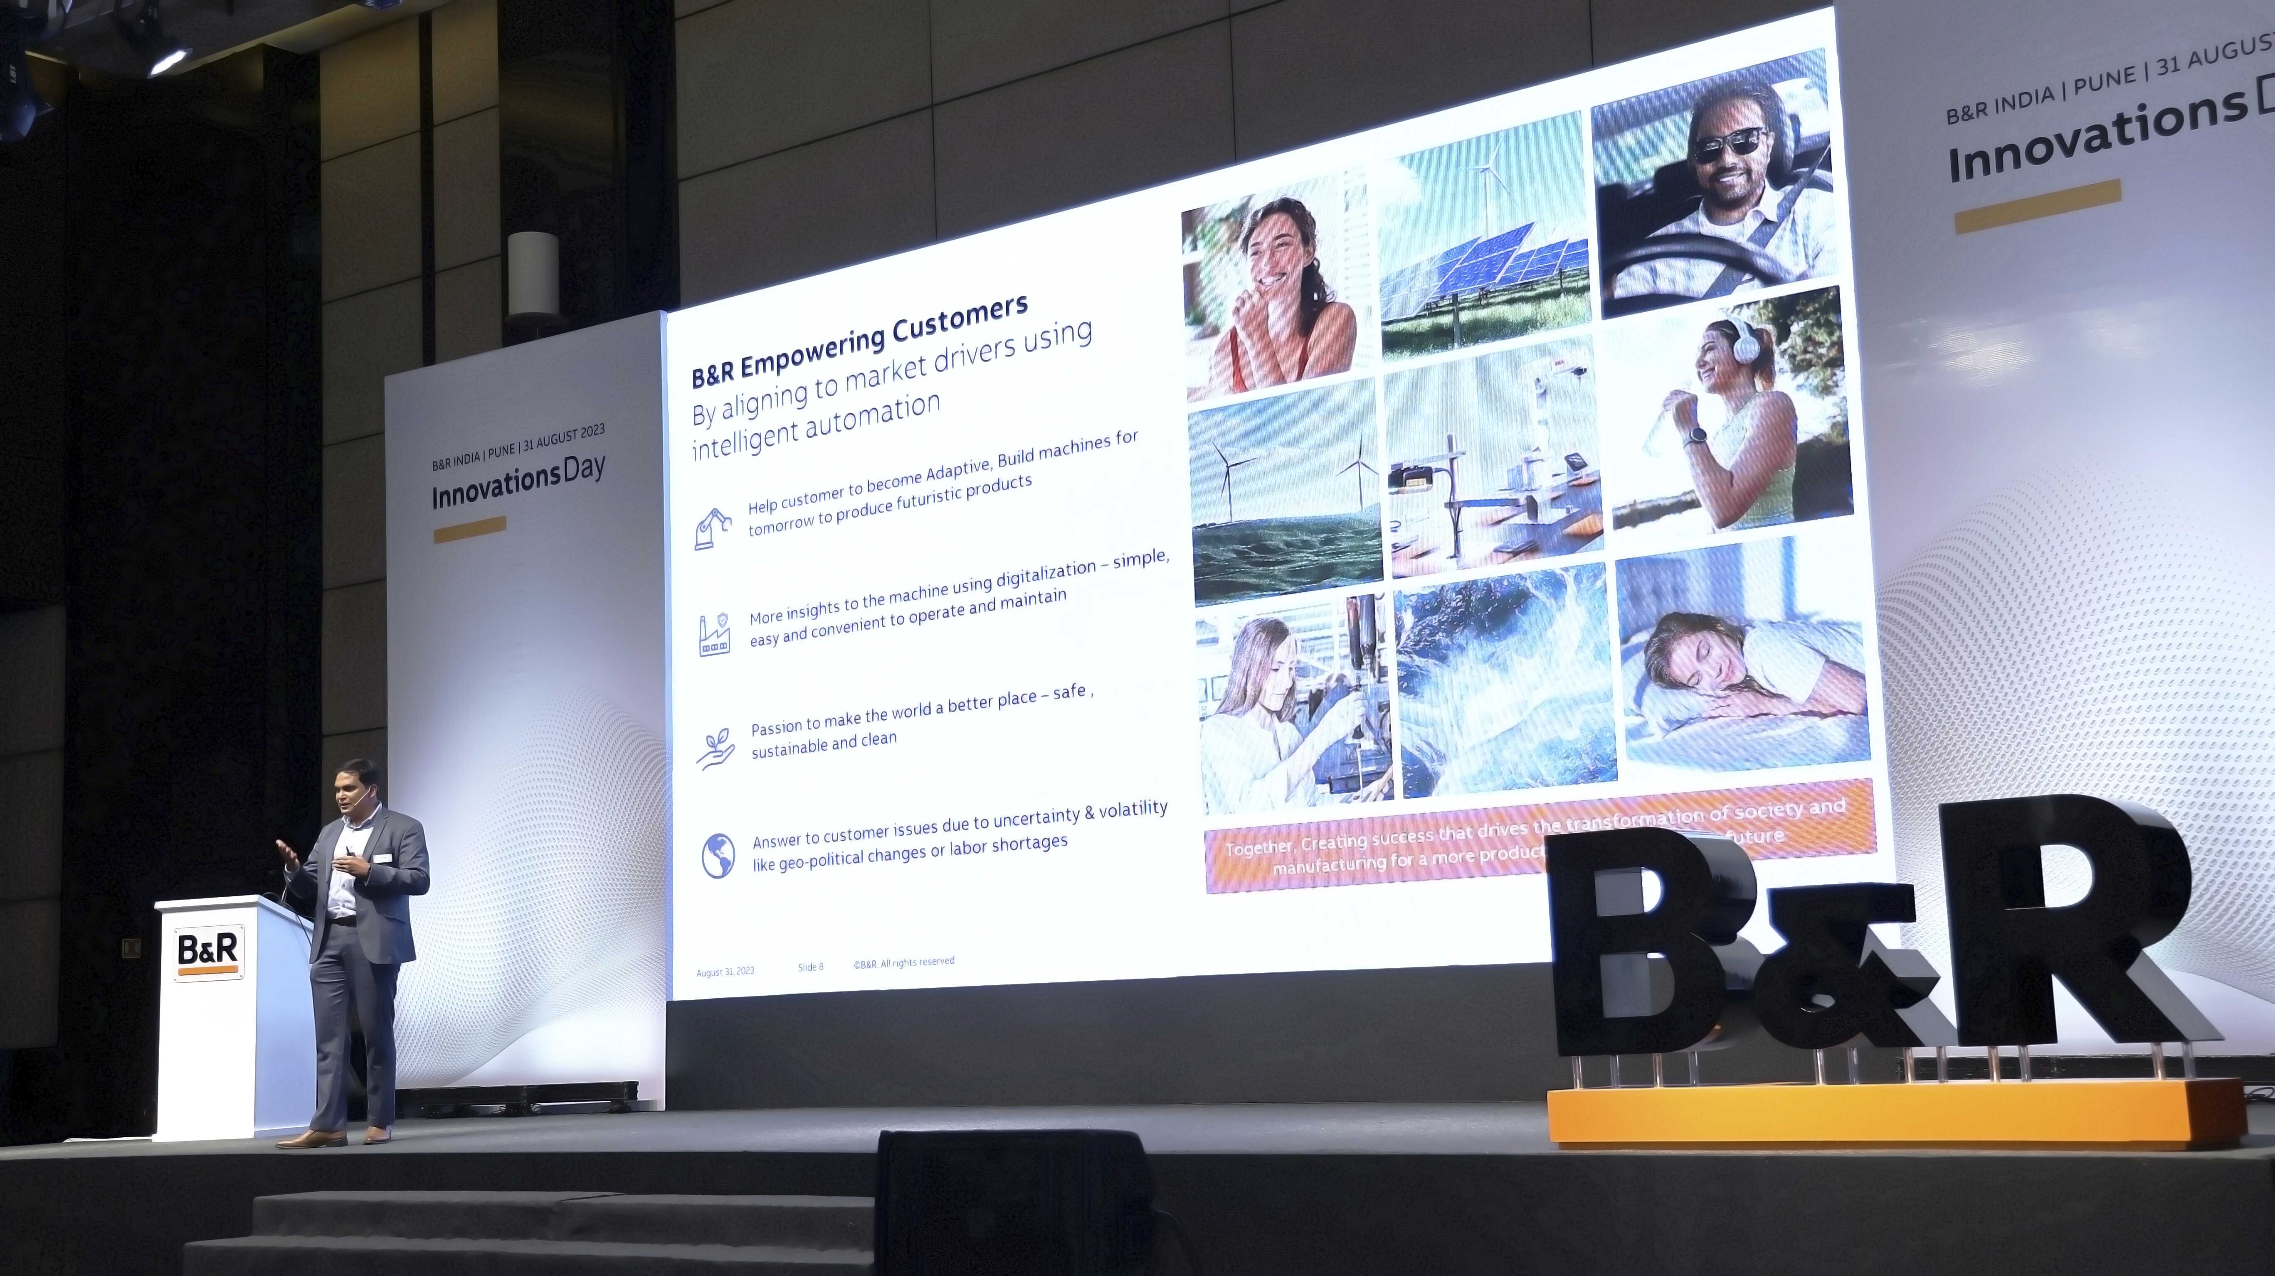
Mr. Jhankar Dutta presents ways to empower Indian machine manufacturers and prepare them for the future with adaptive manufacturing
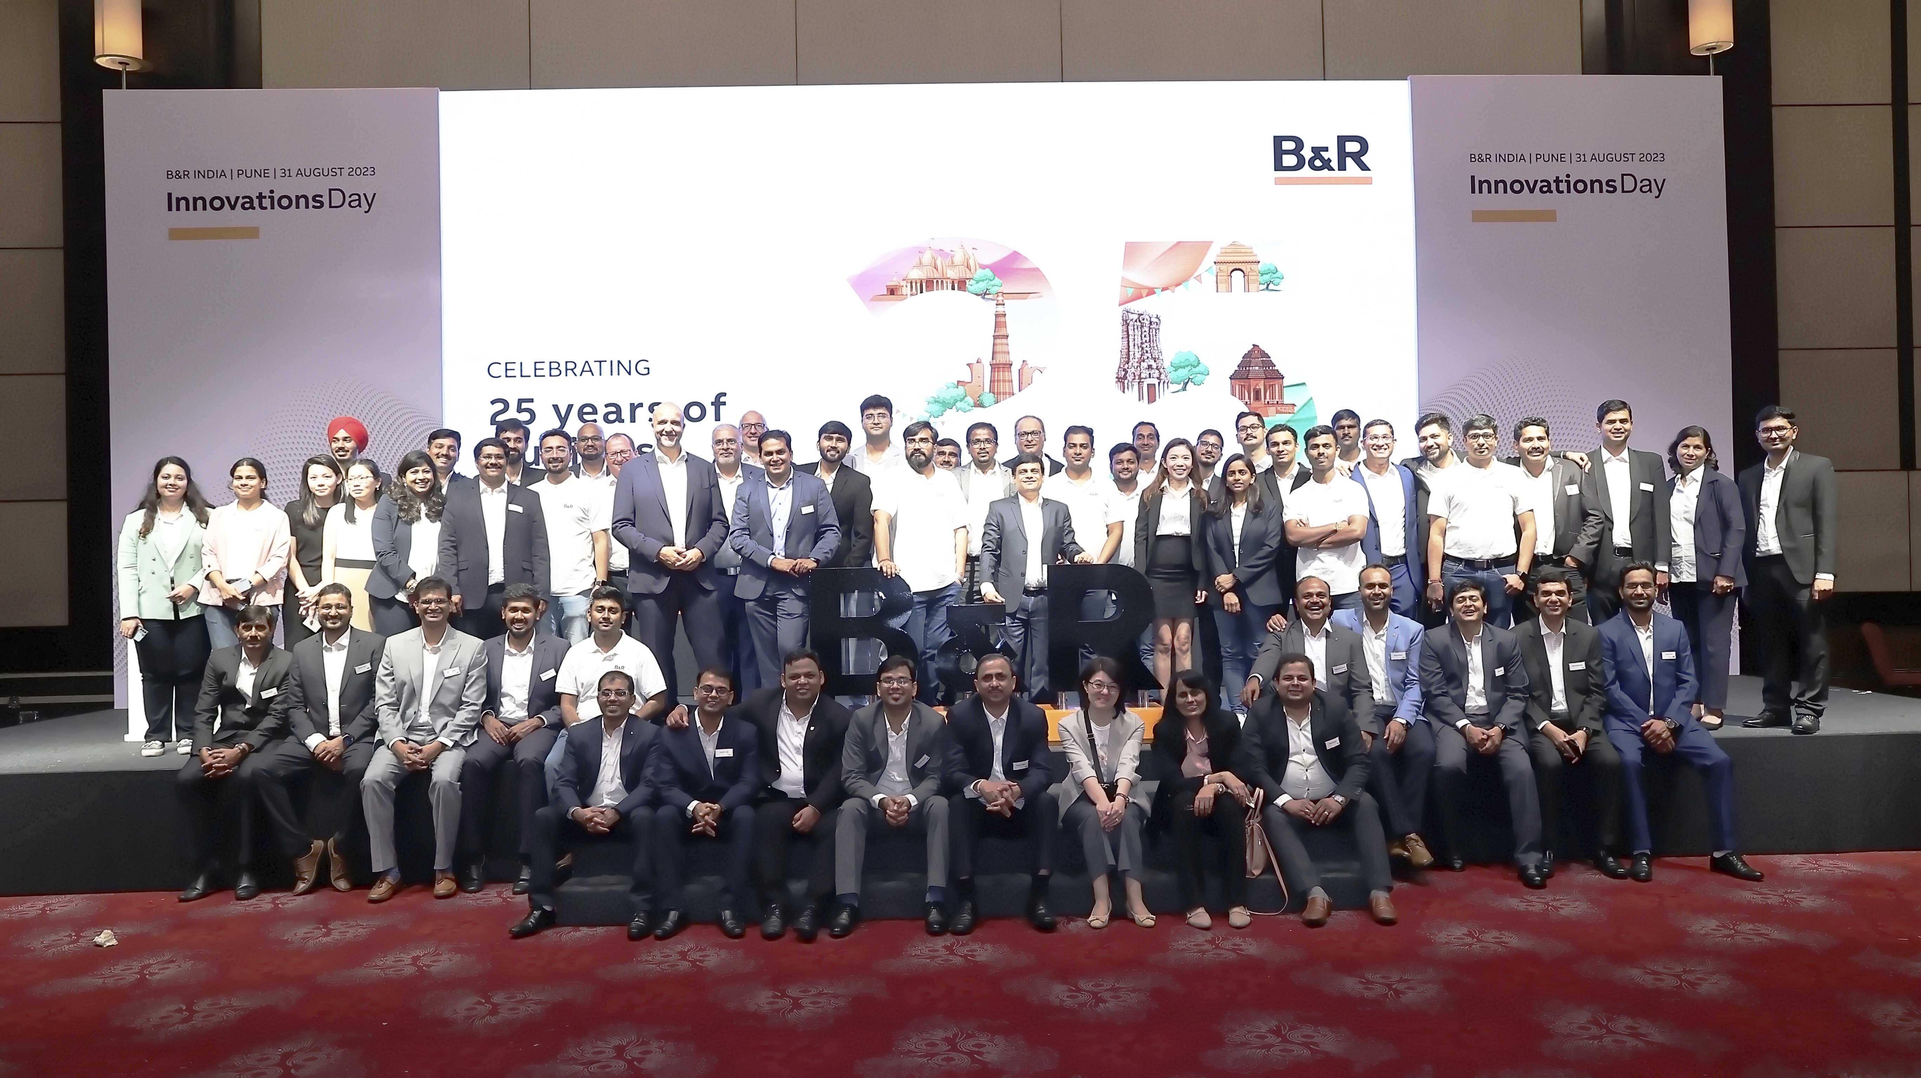
B&R India celebrates 25 years
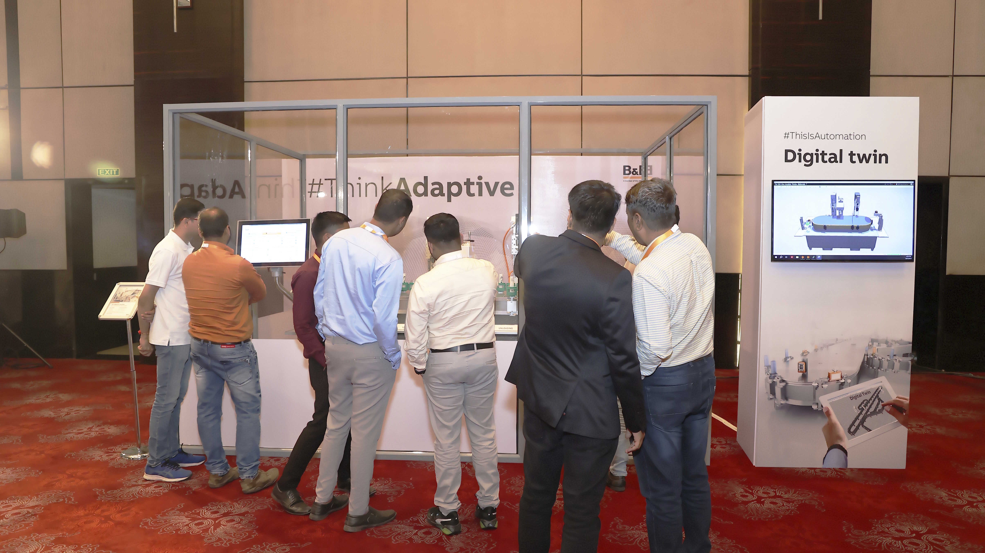
Delegates getting engaged with ACOPOStrak and exploring the digital twin possibilities
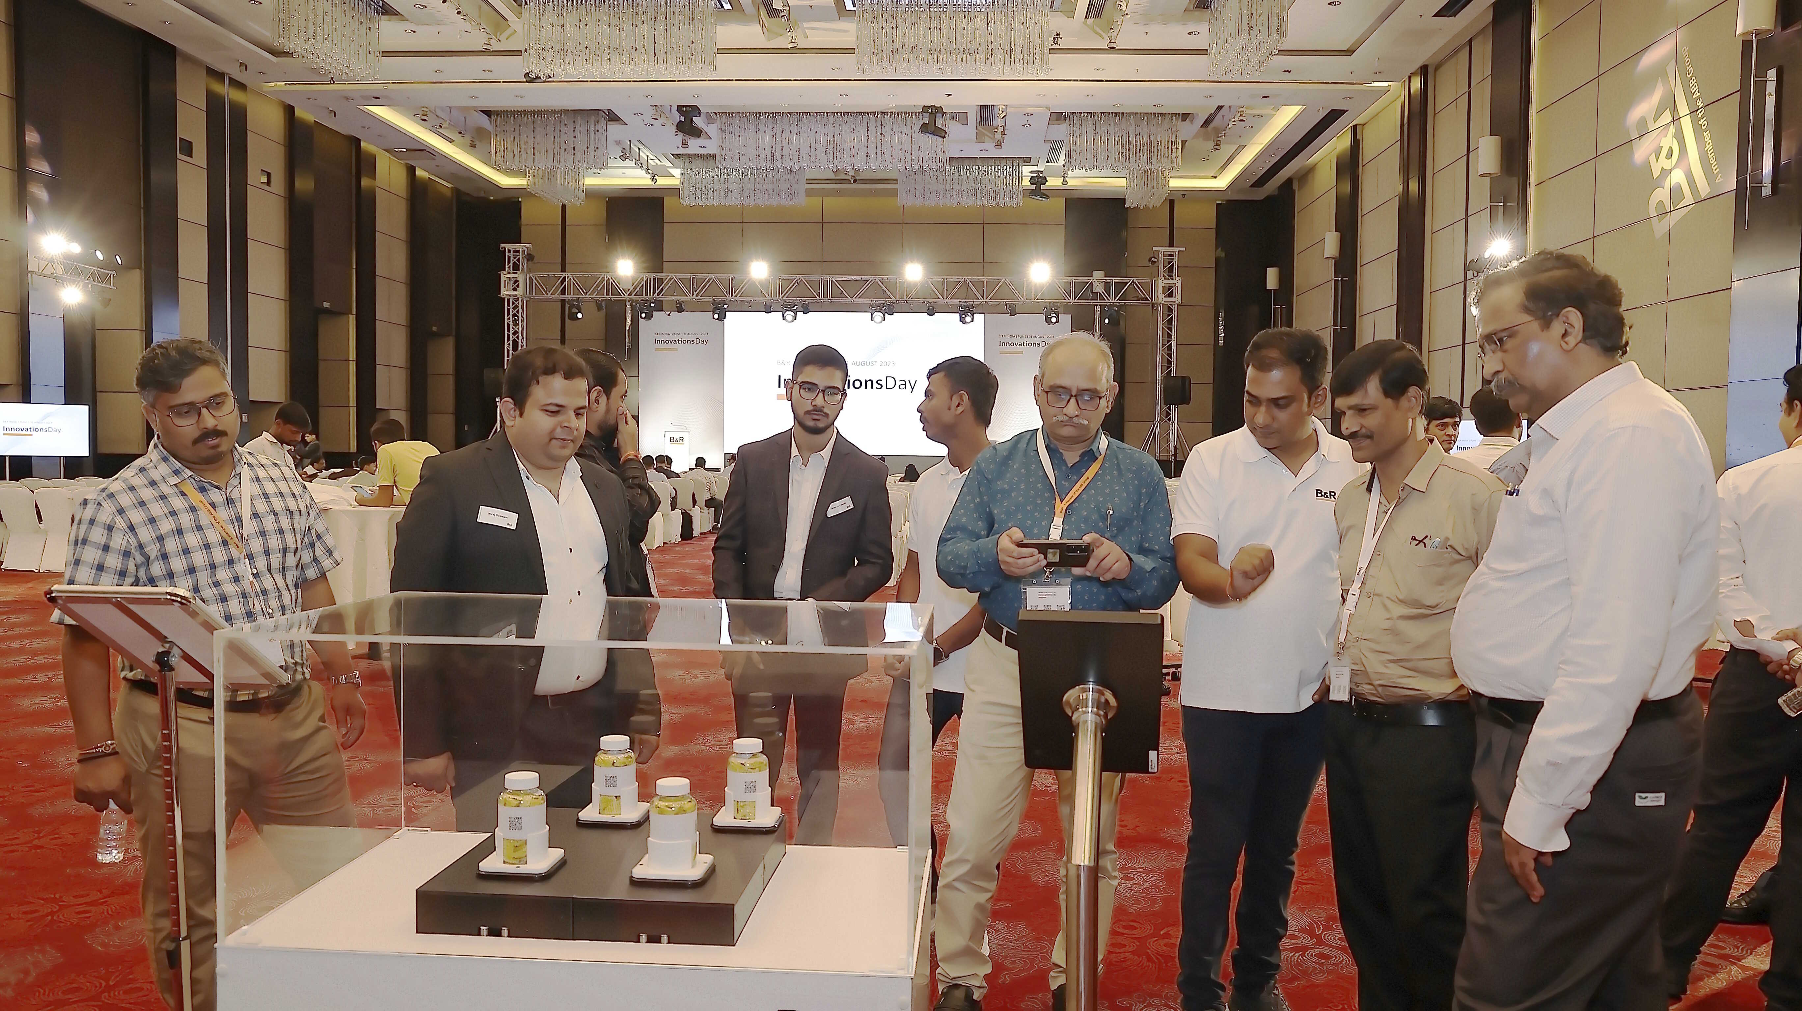
Acopos 6D demo showcasing the 6 dimensions in manufacturing

About B&R
B&R, a division of ABB Group, is a global leader in industrial automation headquartered in Austria. B&R combines state-of-the-art technology with advanced engineering to provide customers in virtually every industry with complete solutions for machine and factory automation, motion control, HMI and integrated safety technology. With Industrial IoT communication standards including OPC UA, POWERLINK and openSAFETY as well as its Automation Studio software, B&R is constantly redefining the future of automation engineering. The innovative spirit that keeps B&R at the forefront of industrial automation is driven by a commitment to simplifying processes and exceeding customer expectations.
For more information, visit www.br-automation.com.

