Startup without waiting
Standby mode increases productivity of off-highway and agricultural vehicles
Standby mode on the X90 CP150 compact controller provides the option of restarting a machine or vehicle immediately after the engine was shut down for a short time. The CP150, which complements B&R's wide range of products specifically for medium-sized and medium-complexity mobile machines, is the first B&R controller with this newly developed standby mode.
With the CP150 compact controller, the wait for the electronics to start up again after the engine is shut down for a short time is completely eliminated. This saves time and increases productivity in everyday work. Operators can eliminate the wait and also decrease emissions with the CP150, reducing their environmental footprint. B&R uses the vehicle's battery for the standby function.
Smart battery monitor for charge status
When the machine is in standby, the application remains active and monitors the machine to immediately switch back to operating mode after a wake-up event triggered by engine ignition, CAN or I/O. If the machine is in standby mode for a longer period of time, the controller prevents the vehicle battery from discharging using an integrated battery monitor. These innovative functions are parameterized according to customer requirements.
The CP150 expands B&R's extensive portfolio of controllers for machines used in harsh environments – in off-highway commercial vehicles, for example. While the fully modular CP170 is predominantly used for high-end machines, the medium machine market with its slightly reduced system requirements is the preferred area of application for the new CP150.
Protected from dust, humidity and extreme temperatures
The CP150 compact controller is ideally equipped for harsh environments: The design protects against dust, moisture and extreme temperatures. The CP150 also copes well with greatly changing levels of vibration, as can occur with mobile machines. The high resistance to vibrations leads to less downtime for the operator and thus increases productivity. The new compact controller has IP69K protection and can therefore be washed down with high pressure together with the rest of the machine. Optionally, the CP150 can use POWERLINK to connect via daisy chaining to other components.

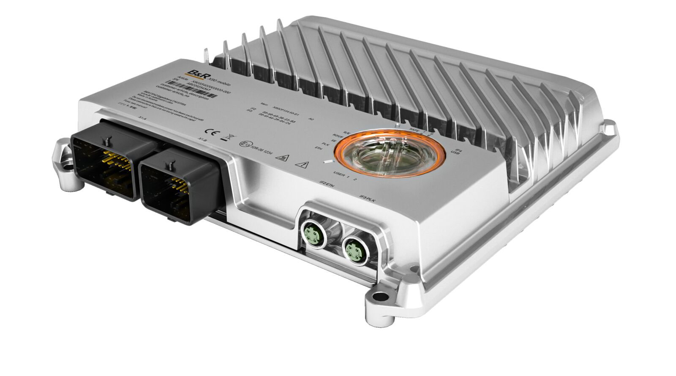
The CP150 compact controller with newly developed standby mode: The wait for the electronics to start up again is completely eliminated allowing the machine to be ready for operation more quickly. (Image: B&R Industrial Automation)

About B&R
B&R, a division of ABB Group, is a global leader in industrial automation headquartered in Austria. B&R combines state-of-the-art technology with advanced engineering to provide customers in virtually every industry with complete solutions for machine and factory automation, motion control, HMI and integrated safety technology. With Industrial IoT communication standards including OPC UA, POWERLINK and openSAFETY as well as its Automation Studio software, B&R is constantly redefining the future of automation engineering. The innovative spirit that keeps B&R at the forefront of industrial automation is driven by a commitment to simplifying processes and exceeding customer expectations.
For more information, visit www.br-automation.com.

