"klimaaktiv" award for B&R
Natural gas phase-out of B&R printed circuit board production honored as showcase project for industry
This week, Climate Protection Minister Leonore Gewessler awarded Austria's leading automation company B&R the "klimaaktiv" award. B&R, a member of the ABB Group, received the award for its newly installed heat pump system at the printed circuit board plant in Eggelsberg, Upper Austria, which saves approximately 1800 MWh of natural gas per year and thus 450 tons of CO2. This is equivalent to the consumption of 150 to 200 households. The company's goal is to achieve CO2-neutral operation by 2030. In addition to the progressive gas phase-out, the photovoltaic roof systems will be expanded by almost double in the coming years and the vehicle fleet will be fully electrified.
Every year, the initiative of the Climate Protection Ministry presents awards to around 20 of Austria's model companies in terms of energy efficiency and climate protection due to outstanding projects. B&R received the award for its pioneering heat pump solution for climate-friendly heating and cooling in industry.
The award reinforces B&R's commitment to sustainability. "As a leader in machine and factory automation, we help our customers optimize their processes and make them more energy efficient," explains Robert Perperschlager, B&R Global Operations Development Manager. "At the same time, as an industrial company with more than 3,000 employees in Austria, we want to rapidly drive decarbonization in our own company. We are therefore very pleased to receive an award for our project, which shows that the industrial heat pump is the most economically and ecologically sensible alternative to gas in the low-temperature range."
Use of industrial waste heat reduces electricity demand
Via a heat recovery system, the company's own process waste heat is used for climate-friendly heating and cooling of the 15,500 m² of production and office space. Any additional electricity required comes from renewable sources, but mainly from the company's own photovoltaic system at its headquarters in Eggelsberg.
"It was already one of the largest self-consumption PV systems in Austria when the ABB Innovation and Education Campus at B&R opened in 2022, with 1,800 kilowatt-peak, and it will be expanded to 3,200 kilowatt-peak in the next phase of expansion. At present, just under a third of our fleet consists of electric vehicles and by 2030 we will be converting completely to electric. The infrastructure for this has already been created with 60 charging stations in the underground parking garage," says Perperschlager.
Note: This project was supported by funds from the BMK's (Federal Ministry for Climate Protection) environmental promotion program.

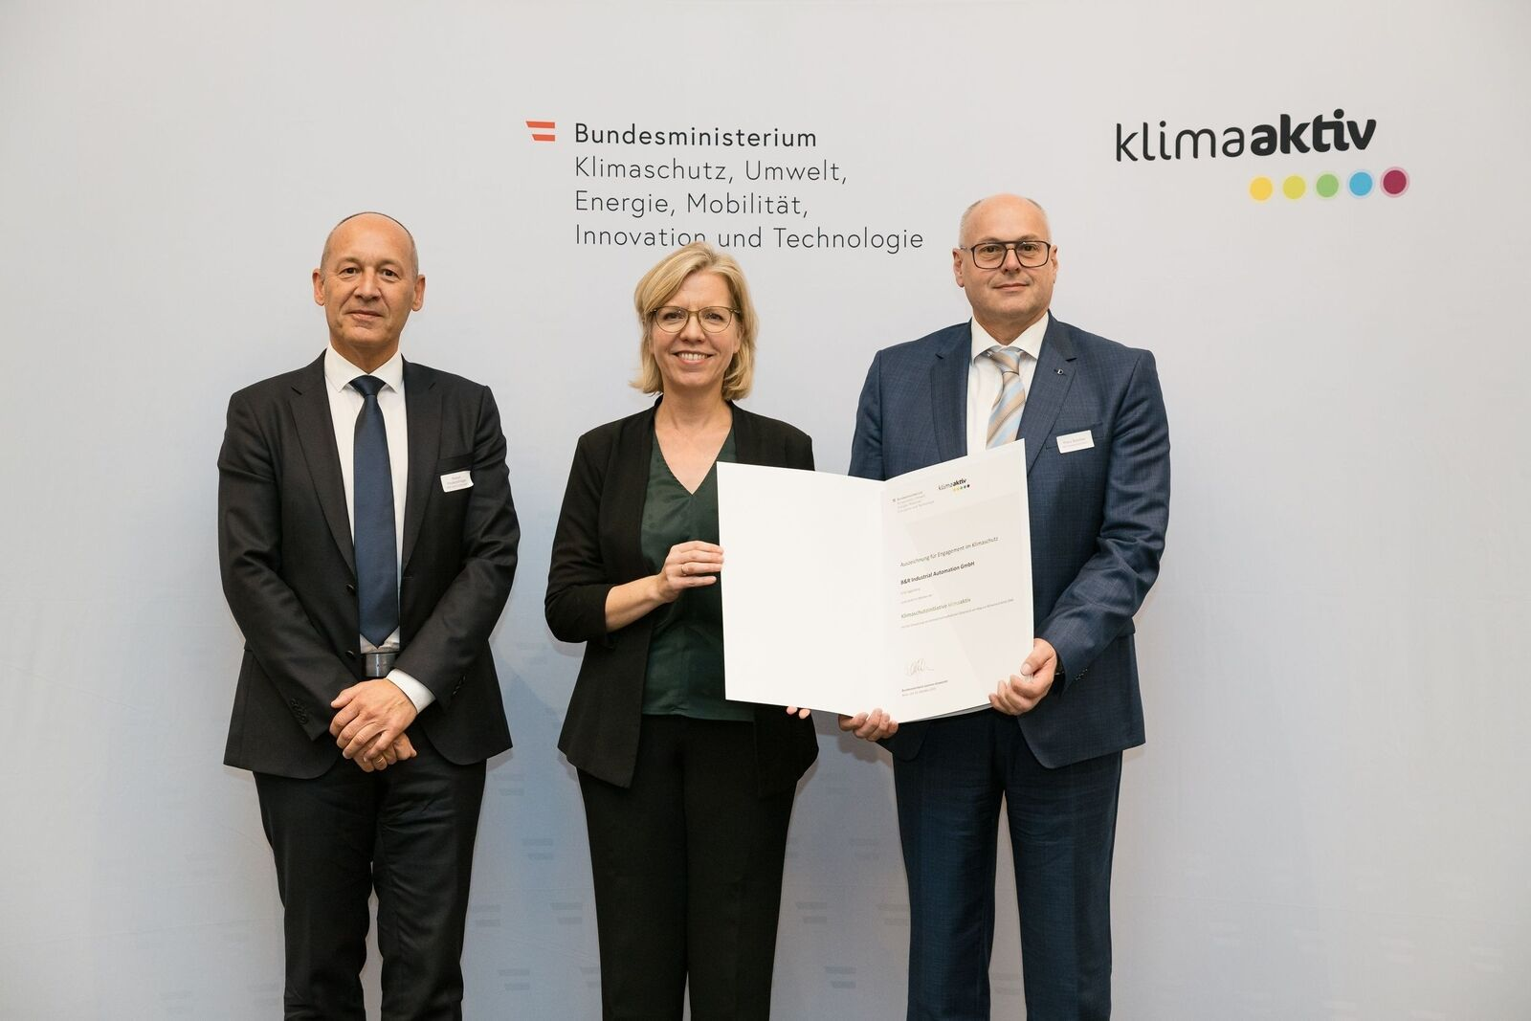
With a new large industrial heat pump, B&R replaces the natural gas consumption of 150 to 200 households at its printed circuit board plant in Eggelsberg, Upper Austria. This week, Climate Protection Minister Leonore Gewessler presented the "klimaaktiv" award to Robert Perperschlager, B&R Global Operations Development Manager (left) and Franz Baischer, Health, Safety and Environment – B&R Sustainability Specialist (right). (Image: Peter Griesser. Reprintable free of charge)

About B&R
B&R, a division of ABB Group, is a global leader in industrial automation headquartered in Austria. B&R combines state-of-the-art technology with advanced engineering to provide customers in virtually every industry with complete solutions for machine and factory automation, motion control, HMI and integrated safety technology. With Industrial IoT communication standards including OPC UA, POWERLINK and openSAFETY as well as its Automation Studio software, B&R is constantly redefining the future of automation engineering. The innovative spirit that keeps B&R at the forefront of industrial automation is driven by a commitment to simplifying processes and exceeding customer expectations.
For more information, visit www.br-automation.com.

