B&R at SPS 2023: Software-driven efficiency
Intelligent automation for a better future
• At SPS 2023 in Nuremberg, from November 14-16 (Hall 07, Booth 206), B&R will show solutions for industry today that contribute to a more productive and sustainable tomorrow.
• The B&R booth features a Software Hub showcasing software, simulation, AI and IIoT solutions that provide data-driven insight and make machines more efficient to design, build and operate.
• Adaptive manufacturing solutions at the B&R booth enable high efficiency despite frequent changes in production requirements and market demand.
At this year's SPS trade show in Nuremberg (November 14-16, 2023), B&R is showcasing some of the ways it partners with machine builders and manufacturers to navigate through huge industry transformations, while also being aligned to a sustainable future. Sustainability is at the top of the agenda as a fundamental consideration of what our customers need, what consumers want and how we commit to a better future for all,” said B&R CEO Jörg Theis. "With our adaptive solutions, we help our customers build machines that consume less energy and produce less waste – and at the heart of these solutions, there is always software."
The central role of software in automation is reflected at the B&R booth (Hall 07, Booth 206). In and around a Software Hub, six workstations demonstrate how B&R supports customers through the entire machine lifecycle. “From conceptual design to commissioning and beyond, our emphasis is on agility and collaboration. With our software solutions and opportunities, we want to empower our customers to create innovative solutions with real impact, supporting the entire design-build-operate process,” said B&R CTO Florian Schneeberger.
Visitors can experience the future of simulation-based, low-code and no‑code design with ACOPOS 6D LaunchPad and the new ACOPOStrak design tool. They can learn about IIoT solutions which provide data-driven insight for operational excellence, as well as explore the newly released Automation Studio 6 with mapp 6, featuring an experimental AI copilot that helps development teams spend less time troubleshooting and more time innovating.
SPS 2023 will also provide the first opportunity to experience the B&R Community – a new digital home for collaboration where B&R users around the world can come to share knowledge, find answers and work together in exciting new ways.
With over 150 B&R experts, 16 live demos and much more over 1118 square meters, SPS visitors can expect to learn and discuss B&R's extensive portfolio of future-proof automation solutions.

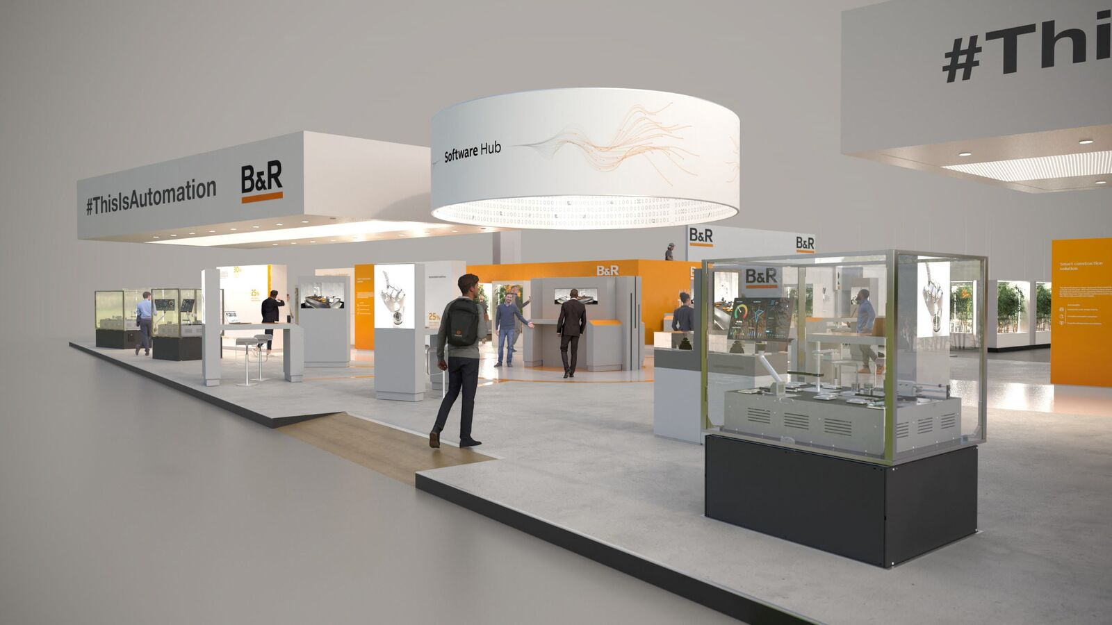
At the heart of the B&R booth (Hall 7, Booth 206), a Software Hub offers a look at how B&R supports customers through the entire development cycle. (Photo: B&R)
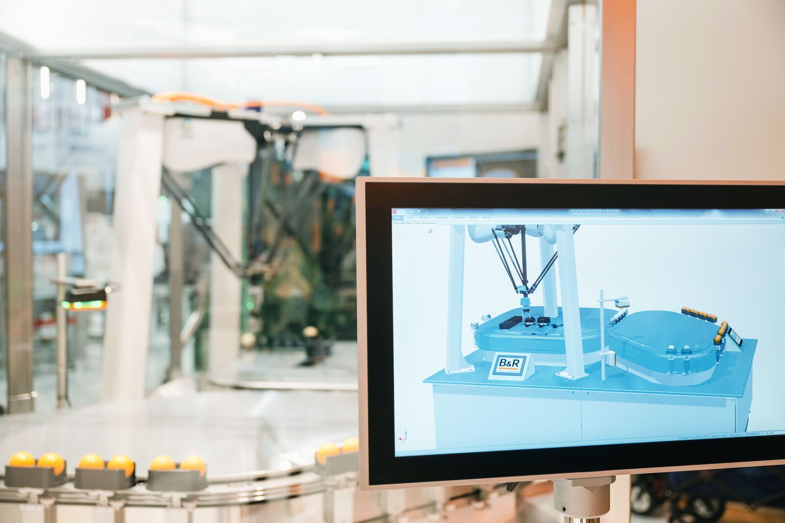
Software, simulation, AI and IIoT solutions provide data-driven insight and make machines more efficient to design, build and operate. (Photo: B&R)

About B&R
B&R, a division of ABB Group, is a global leader in industrial automation headquartered in Austria. B&R combines state-of-the-art technology with advanced engineering to provide customers in virtually every industry with complete solutions for machine and factory automation, motion control, HMI and integrated safety technology. With Industrial IoT communication standards including OPC UA, POWERLINK and openSAFETY as well as its Automation Studio software, B&R is constantly redefining the future of automation engineering. The innovative spirit that keeps B&R at the forefront of industrial automation is driven by a commitment to simplifying processes and exceeding customer expectations.
For more information, visit www.br-automation.com.

