ABB acquires R&D engineering company to further advance AI and software-driven automation
• Latest ABB investment will accelerate capabilities in software engineering and AI-based applications including machine learning and vision
• Acquisition will serve as new R&D hub to accelerate development of AI-powered solutions from ABB’s Machine Automation division (B&R) focused on industries such as logistics and manufacturing

ABB announced today it has agreed to acquire a majority of software service provider Meshmind to expand its research and development capabilities in AI, Industrial IoT and machine vision. Through this acquisition ABB will integrate engineering talent, AI and software knowledge to form a new global R&D hub to further accelerate the development of innovative automation solutions within its Machine Automation division (B&R).
“AI-powered robotics and automation have the power to transform industries, providing businesses with greater flexibility and intelligence amidst critical global trends and workforce challenges,” said Sami Atiya, President, ABB Robotics and Discrete Automation Business Area. “Through this acquisition, we will further accelerate the development of our software and AI-powered solutions to make automation more adaptive and accessible, enabling businesses of all sizes to become more resilient.”
The integration of Meshmind's approximately 50 employees will expand collaboration between B&R teams on a range of R&D projects, including deep learning vision systems, AI-powered engineering tools and IoT app development. Meshmind's office in Sarajevo, Bosnia, will serve as the B&R division's new global competence center for AI and software development. Financial details of the transaction, which is expected to be completed in the first quarter of 2024, have not been disclosed.
“This acquisition builds on our successful relationship with Meshmind to establish a new global R&D hub for B&R,” said Machine Automation Division President Joerg Theis. “As part of our wider ecosystem that includes universities, partners and start-ups, this latest investment will strengthen our capacity and expertise to create solutions that make our customers' lives easier, helping them shape the future of their industries.”
The investment coincides with ABB’s recent acquisition of Sevensense, a leading provider of AI-enabled 3D vision navigation technology for autonomous mobile robots (AMRs). Together, they emphasize ABB and B&R’s strategic investment focus on innovative AI and software solutions to deliver value for its customers through the most productive and efficient technology.

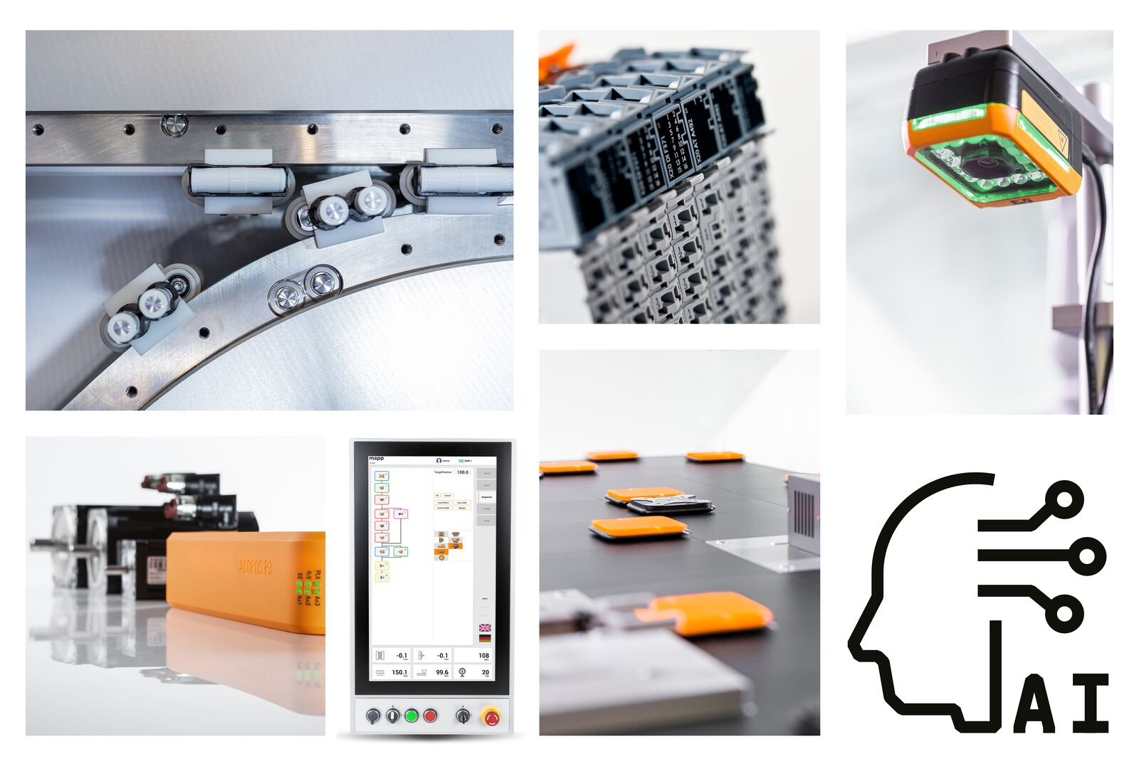
ABB acquires R&D engineering company to further advance AI and software-driven automation. (Image: B&R)

About B&R
B&R, a division of ABB Group, is a global leader in industrial automation headquartered in Austria. B&R combines state-of-the-art technology with advanced engineering to provide customers in virtually every industry with complete solutions for machine and factory automation, motion control, HMI and integrated safety technology. With Industrial IoT communication standards including OPC UA, POWERLINK and openSAFETY as well as its Automation Studio software, B&R is constantly redefining the future of automation engineering. The innovative spirit that keeps B&R at the forefront of industrial automation is driven by a commitment to simplifying processes and exceeding customer expectations.
For more information, visit www.br-automation.com.

