B&R Global Value Provider Conference 2024
Automation partners meet at B&R Innovation and Training Campus
From January 30-31, 2024, B&R is hosting the first-ever Global Value Provider Conference at its Innovation and Training Campus in Eggelsberg, Austria. Under the banner of "Creating value for manufacturers and win-win outcomes for partners’’, the event offers members of B&R's global partner program exclusive insight into the company's strategy and latest developments, as well as many opportunities for valuable exchanges with peers, partners and industry experts.

From digitalization to decarbonization, from resilience to reindustrialization, the world of manufacturing is undergoing multiple profound transformations. "To bridge the gap between the new needs of today's markets and the new potential of today's technology, it takes a new paradigm of partnership," said B&R CEO Joerg Theis. "We're moving away from one-on-one relationships, sequential value chains and incremental improvements toward an ecosystem of collaboration that multiplies value and delivers real transformation for industries and for society as a whole."
B&R's global Value Provider community includes partners who have proven expertise working with B&R technology in the areas of sales and distribution, consulting and engineering, and systems integration. "We're excited to welcome our partners this week at our beautiful campus and share two days of insights and networking," said conference host Davide Pagliarulo, B&R Global Sales Channel Manager. "With talks on B&R strategy and the latest market trends, an industry roundtable and exclusive keynotes showcasing cutting-edge technology – this is a must-attend event for anyone looking to stay ahead of the curve in the rapidly evolving world of automation."

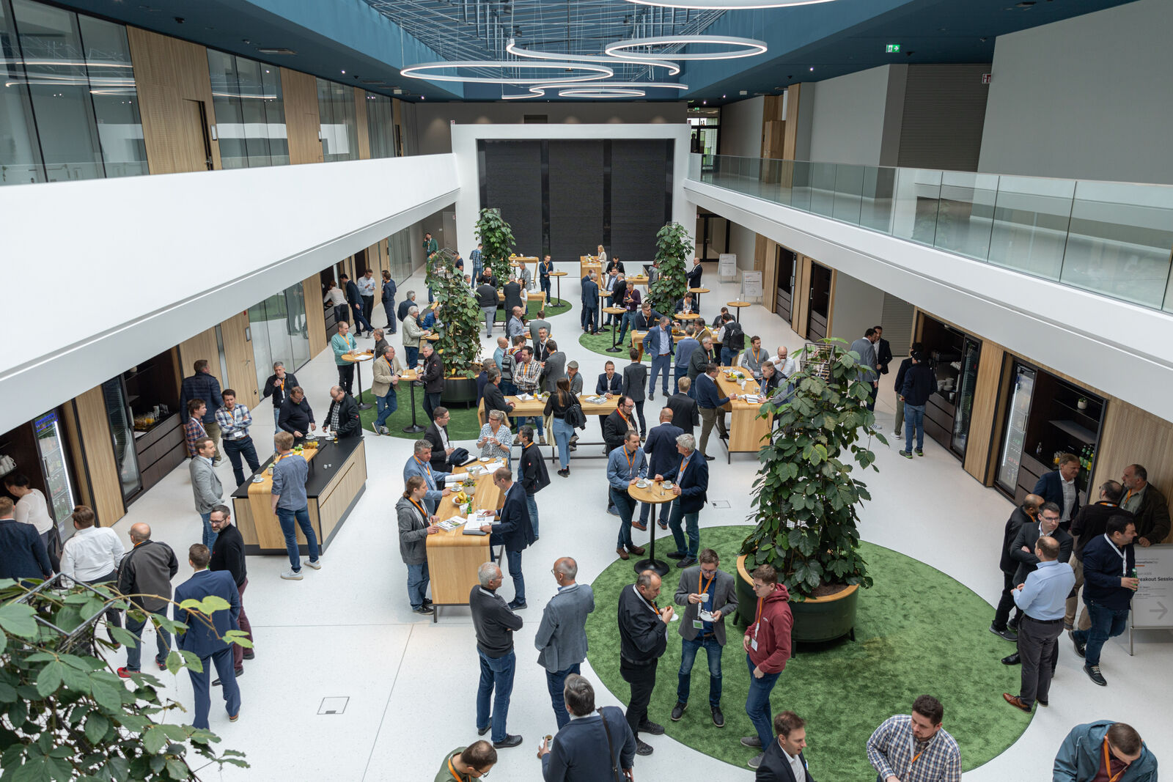
Automation partners meet at B&R Innovation and Training Campus to talk trends and strategies, share insights and inspiration. (Photo: B&R)
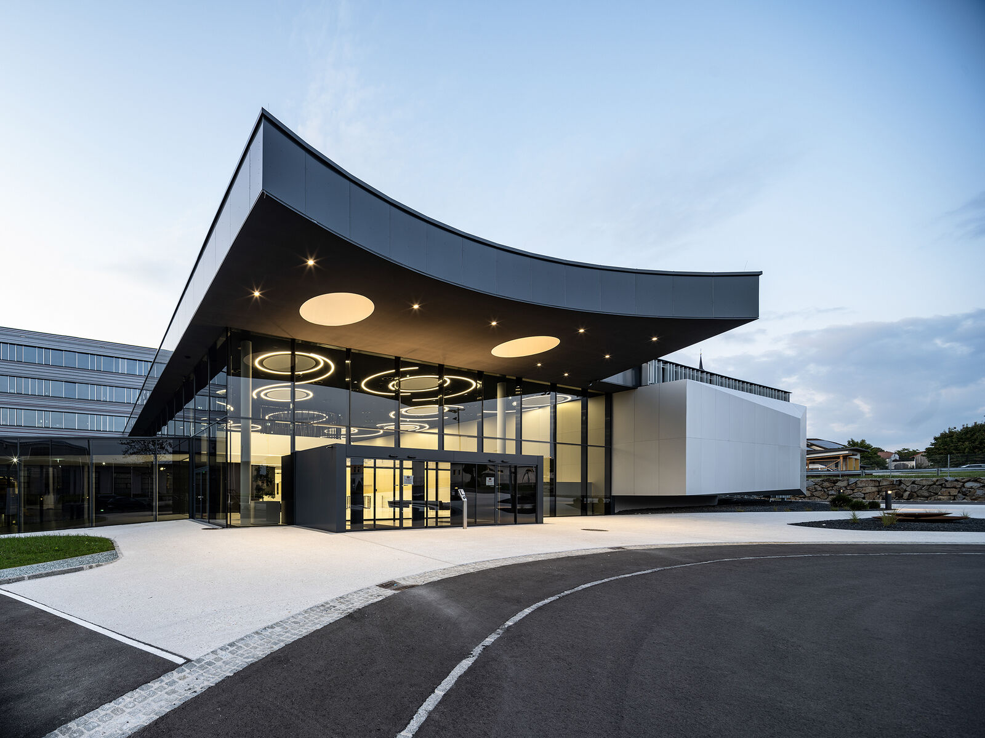
The new B&R Innovation and Training Campus in Eggelsberg, Austria. (Photo: B&R)

About B&R
B&R, a division of ABB Group, is a global leader in industrial automation headquartered in Austria. B&R combines state-of-the-art technology with advanced engineering to provide customers in virtually every industry with complete solutions for machine and factory automation, motion control, HMI and integrated safety technology. With Industrial IoT communication standards including OPC UA, POWERLINK and openSAFETY as well as its Automation Studio software, B&R is constantly redefining the future of automation engineering. The innovative spirit that keeps B&R at the forefront of industrial automation is driven by a commitment to simplifying processes and exceeding customer expectations.
For more information, visit www.br-automation.com.

