Young engineers recycle batteries to make green hydrogen
B&R team tackles sustainability challenges at Smart Green Island Makeathon 2024
From February 28th to March 2nd, more than 300 engineering students from over 40 countries are meeting in Gran Canaria for this year's Smart Green Island Makeathon. Organized by engineering and consulting company ITQ, this long-standing event brings together students, companies and educational institutions from around the globe to address some of the most pressing sustain-ability challenges facing today's industry. Under the guidance of platinum sponsor B&R, one team is taking aim at the global issue of electronic waste by revolutionizing how we handle used battery cells.

"Imagine a world in which faulty batteries are no longer thrown away, but instead used to power machines in ever-more sustainable ways," said Patrick Haberstroh, head of B&R's Education Net-work. "That may sound like a fantasy, but we think our B&R team is up to the challenge." The inter-national team, comprised of students from Hochschule Kempten, Hochschule Bremerhaven FH Aa-chen, and the University of Genova, among others, will work with B&R hardware and receive on-site support from B&R specialists during a week of collaborating, ideating, and inventing.
Four days – Endless possibilities
In what promise to be an intense few days, participants in the Smart Green Island Makeathon will develop projects in the areas of Smart Farming, Smart Green Energy, Smart Green Mobility, Smart Automation, IoT, Robotics, Smart Production, Smart Shipping and Circular Economy. The challenge presented to the B&R team: Create a functional prototype that tests, recycles, and reuses faulty battery cells – and make it run on renewable energy.
"Recycling battery cells using renewable energy is a perfect example of the important role intelli-gent automation can play in accelerating the energy transition – for the benefit of our customers and society as a whole," said Haberstroh. "It's a vital project that reflects B&R's sustainability mis-sion of achieving Net Zero by 2050, and I'm really excited to see what our team comes up with."
The young engineering talents will build an automated testing facility that checks the health of bat-tery cells, separating the operational from the faulty. In addition, they will seek to use the remaining electrical energy from the faulty cells – along with a little help from the sun – to produce green hydrogen that can be used to recharge the cells that are still operational.
Plugging the skills shortage
In addition to raising awareness for important sustainability topics – including maximizing energy efficiency, reducing waste, mitigating harmful environmental impacts, and preserving resources – one of the primary aims of the makeathon is to help address the global shortage of skilled workers in this space. "To make faster progress on climate change, we need more young people who are not only environmentally conscious, but also imbued with the necessary passion and skills to develop key technologies," said Haberstroh.
What is a makeathon?
A makeathon is an interactive platform for young people who want to make a difference. The combination of "To make" and "Marathon" clearly show what the creative format is all about: Agile teams with young talent develop innovative concepts and prototypes in a short time. The focus is on working together to complete tasks, which are specified by companies that provide hardware, software and relevant know-how.

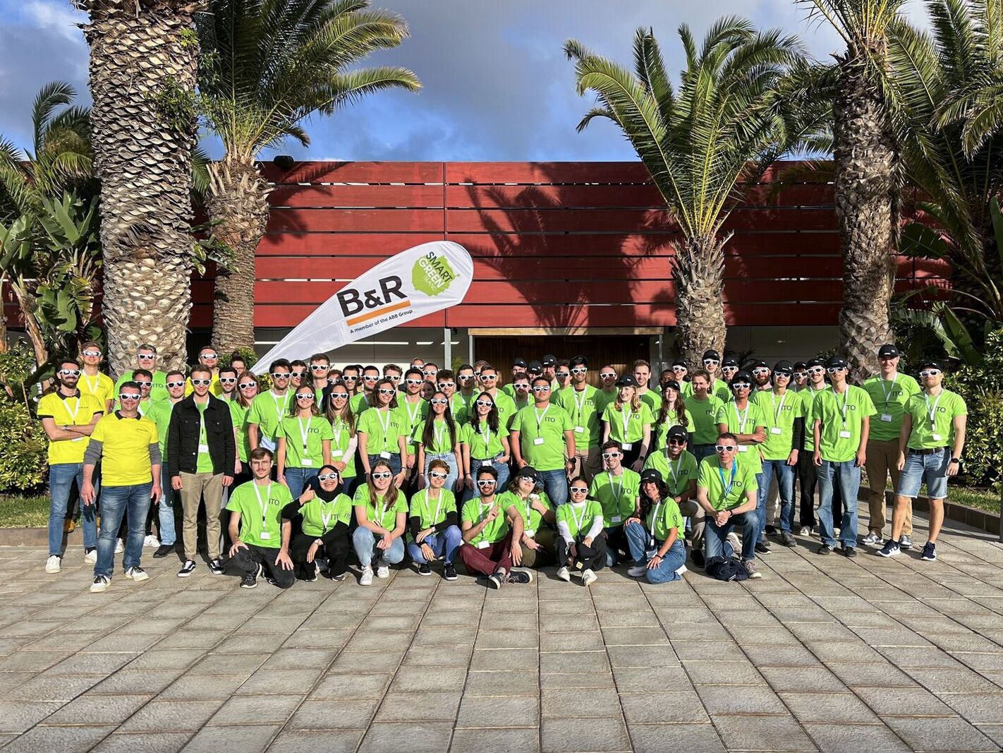
The B&R team has landed on Gran Canaria: The 60 young international talents come from Kempten University of Applied Sciences, Bremerhaven University of Applied Sciences, Aachen University of Applied Sciences, the University of Genoa and many more. (Photo: B&R)

About B&R
B&R, a division of ABB Group, is a global leader in industrial automation headquartered in Austria. B&R combines state-of-the-art technology with advanced engineering to provide customers in virtually every industry with complete solutions for machine and factory automation, motion control, HMI and integrated safety technology. With Industrial IoT communication standards including OPC UA, POWERLINK and openSAFETY as well as its Automation Studio software, B&R is constantly redefining the future of automation engineering. The innovative spirit that keeps B&R at the forefront of industrial automation is driven by a commitment to simplifying processes and exceeding customer expectations.
For more information, visit www.br-automation.com.

