Canadian ambassador visits B&R
The bright future of automation technology in Canada
During his inaugural tour, Canadian Ambassador to Austria Troy Lulashnyk recently visited the B&R headquarters in Eggelsberg. With B&R CEO Joerg Theis he discussed the future of automation technology in Canada and learned about the company's latest innovations and vision for growth in the North American market.
Together with Christian Kastinger, Strategy Manager Americas, Theis led the ambassador and the Canadian business delegation on a company tour, presenting a wide range of smart manufacturing technology. "In challenging and complex times, adaptability is key,” said ambassador Lulashnyk. “B&R helps its customers do this in really impressive ways, helping to make our industries not only more productive, but more sustainable in the process.”
B&R is an important partner for Canadian machine builders in many sectors, including life sciences, electromobility, packaging and plastics. “It’s an honor to welcome the Ambassador here in Eggelsberg," said Theis. "Especially this year, as we celebrate twenty successful years in Canada and look ahead to a strong future of growth in the North American market.”

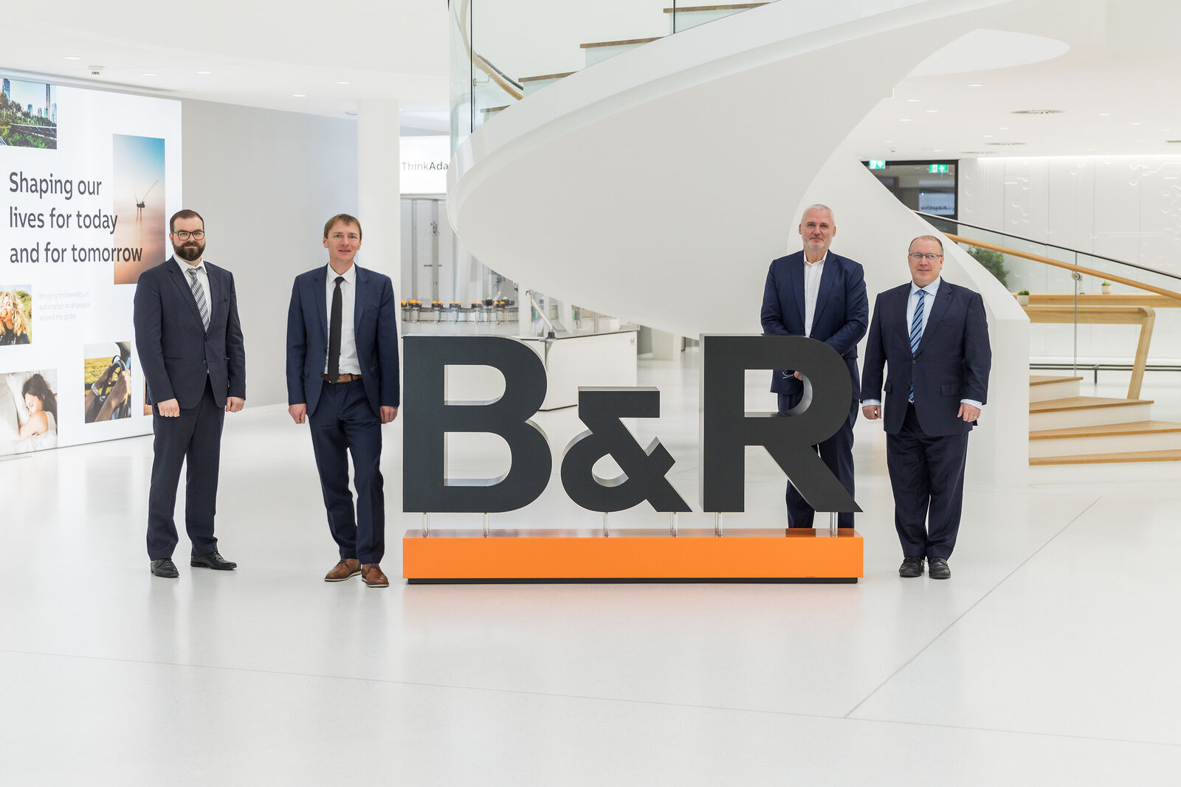
Canadian Ambassador to Austria Troy Lulashnyk (R) during his visit to B&R with CEO Joerg Theis (R2), Strategy Manager Americas Christian Kastinger (L2) and Sales Representative Philipp Rogner (L1) who hosted the Canadian business delega-tion. (Photo: B&R)

About B&R
B&R, a division of ABB Group, is a global leader in industrial automation headquartered in Austria. B&R combines state-of-the-art technology with advanced engineering to provide customers in virtually every industry with complete solutions for machine and factory automation, motion control, HMI and integrated safety technology. With Industrial IoT communication standards including OPC UA, POWERLINK and openSAFETY as well as its Automation Studio software, B&R is constantly redefining the future of automation engineering. The innovative spirit that keeps B&R at the forefront of industrial automation is driven by a commitment to simplifying processes and exceeding customer expectations.
For more information, visit www.br-automation.com.

