One year of weekend shifts at B&R
Temporary job model exceeds expectations
• Successful weekend shift model resulted in reduced delivery times and increased flexibility to respond to market demand.
• Over a third of the weekend employees will remain with B&R, switching to regular weekday shifts.
• Weekend shifts leveraged B&R’s recent 60% increase in processing capacity.
In March 2023, B&R introduced a year-long, 20-hour weekend production shift at its headquarters in Eggelsberg, Austria to process order backlogs that had resulted from global delivery bottlenecks. The last weekend shift took place on February 25, 2024, as planned. Over 300 new employees reached their productivity target in weeks, leading to a rapid reduction in delivery times for customers.
The new employment model comprised 20 hours of work on the weekend and time off Monday through Friday, while offering a salary comparable to a full-time position. "The model that we developed together with our works council and the trade unions has proven itself in every respect," explained B&R CEO Joerg Theis: "This additional utilization of our expanded plant capacities enabled us to quickly normalize delivery times and react more flexibly to market needs. Now that it is coming to an end, we are very pleased that more than a third of the employees will remain part of the B&R team and switch to regular shift work."
Enabling growth with automation
Automation and artificial intelligence are key technologies and a focus of investment for more than 90 percent of companies in Europe. To support businesses in this, B&R has increased its processing capacity in Eggelsberg by 60 percent to two billion components per year, with the number of employees at the headquarters in Eggelsberg rising to over 3,000. "Our employees, their skills and their dedication are our most valuable asset and a decisive factor in our success," said Theis. "Faced with the rapid increase in demand for qualified jobs in the technology sector, we are fully committed to welcoming new talent with an interest in technology, while also nurturing and developing critical competencies through the training and further education we offer."
Investing in talent development
In response to the increasing need for skills and talent in key technologies, B&R has been investing in a number of initiatives: In 2022, ABB opened a global innovation and education campus at the B&R headquarters in Eggelsberg which provides training capacity for up to 4,000 people per year. Through its Education Network, B&R cooperates with universities and technical colleges around the world. Starting this September, the company is launching a new apprenticeship program in the areas of Application Development and Coding, Operational Logistics and IT Systems Technology.

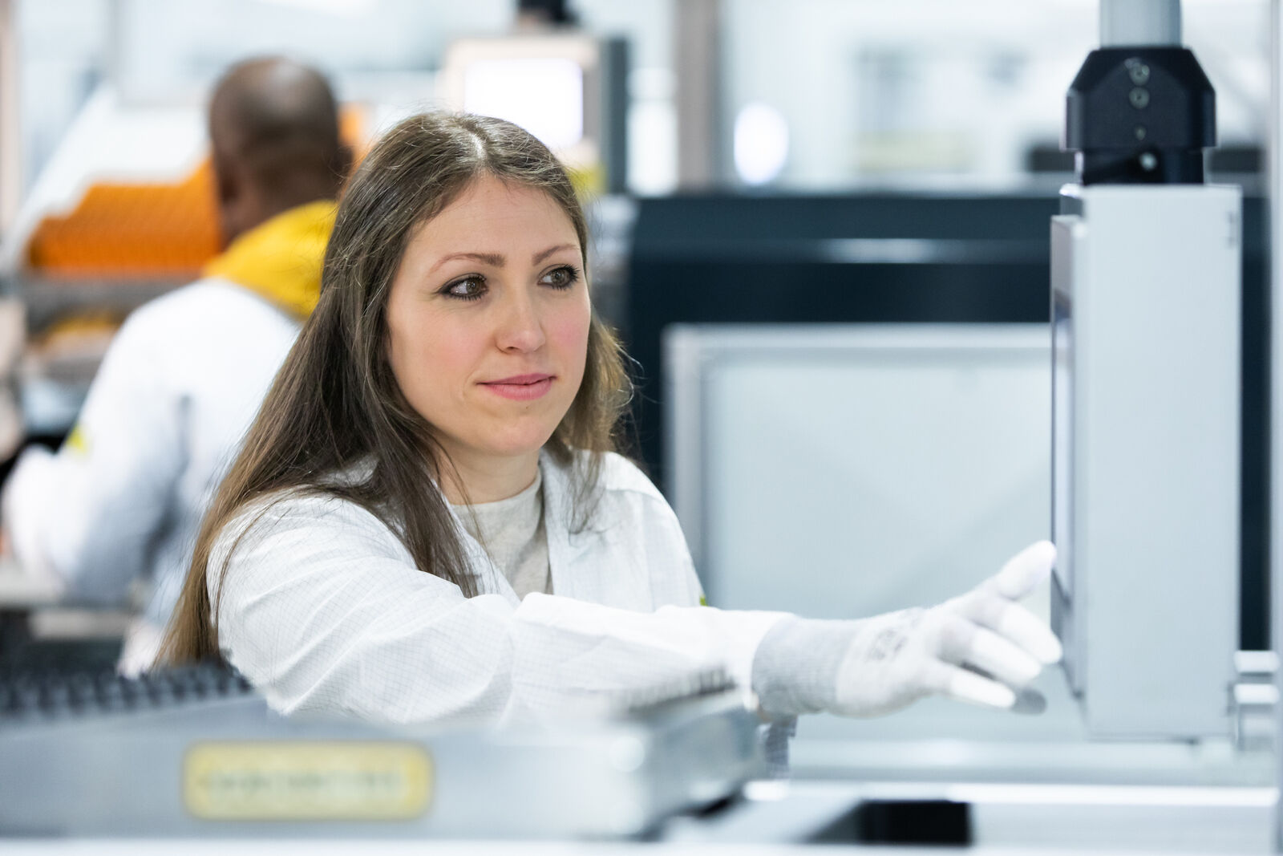
B&R's innovative weekend shift model successfully reduced delivery times and increased flexibility to respond to market demand. (Photo: B&R)

About B&R
B&R, a division of ABB Group, is a global leader in industrial automation headquartered in Austria. B&R combines state-of-the-art technology with advanced engineering to provide customers in virtually every industry with complete solutions for machine and factory automation, motion control, HMI and integrated safety technology. With Industrial IoT communication standards including OPC UA, POWERLINK and openSAFETY as well as its Automation Studio software, B&R is constantly redefining the future of automation engineering. The innovative spirit that keeps B&R at the forefront of industrial automation is driven by a commitment to simplifying processes and exceeding customer expectations.
For more information, visit www.br-automation.com.

