"They did it!" B&R team creates battery recycling prototype in just three days
Sustainability mission accomplished for engineering students at Smart Green Island Makeathon 2024
From February 28th to March 2nd, the B&R team of 60 young talents spanning 12 schools and universities (covering Germany, Italy, Spain, and India) joined a total of nearly 400 engineering students from over 40 countries in Gran Canaria for this year's Smart Green Island Makeathon. Organized by engineering and consulting company ITQ, this annual event brought together students, companies, and educational institutions from around the globe to address some of the most pressing sustainability challenges facing today's industry. Under the guidance of platinum sponsor B&R, one team took on the global issue of electronic waste by revolutionizing the handling of used battery cells.
"They did it! Our B&R team reached its goal of developing a machine that evaluates the health of a battery cell in an automated way," said Patrick Haberstroh, head of B&R's Education Network. "I must admit we had our doubts as to whether it could really be done in only three days. But this highly motivated team proved they were more than up to the challenge!"
Teamwork makes the dream work
The challenge faced by the B&R team: Over an intense few days of collaboration, create a functional prototype that tests, recycles, and reuses faulty battery cells – and make it run on renewable energy.
The students worked intensively to identify each battery cell using a vision system, measure its internal resistance, and evaluate its capacity by completing a loading and unloading cycle. To store the energy released by unloading the batteries, the students constructed an electrolyzer that uses it to produce hydrogen. This hydrogen was then reused by a fuel cell to generate a part of the electrical power needed to reload the batteries.
"Recycling battery cells using renewable energy is a perfect example of the important role intelligent automation can play in accelerating the energy transition – for the benefit of our customers and society as a whole," said Haberstroh. "It's a vital project that reflects B&R's sustainability mission of achieving Net Zero by 2050, and I couldn't believe what the team came up with. It's incredible."
"This was a great learning experience for the young people," adds Haberstroh. "They had to quickly establish a structure, manage the project, and create the prototype – and all in just three days. It really was an example of exceptional teamwork."
Plugging the skills shortage
In addition to raising awareness for important sustainability topics – including maximizing energy efficiency, reducing waste, mitigating harmful environmental impacts, and preserving resources – one of the primary aims of the makeathon was to help address the global shortage of skilled workers in this space. "To make faster progress on climate change, we need more young people who are not only environmentally conscious, but also imbued with the necessary passion and skills to develop key technologies," said Haberstroh.
What is a makeathon?
A makeathon is an interactive platform for young people who want to make a difference. The combination of "To make" and "Marathon" clearly show what the creative format is all about: Agile teams with young talent develop innovative concepts and prototypes in a short time. The focus is on working together to complete tasks, which are specified by companies that provide hardware, software and relevant know-how.

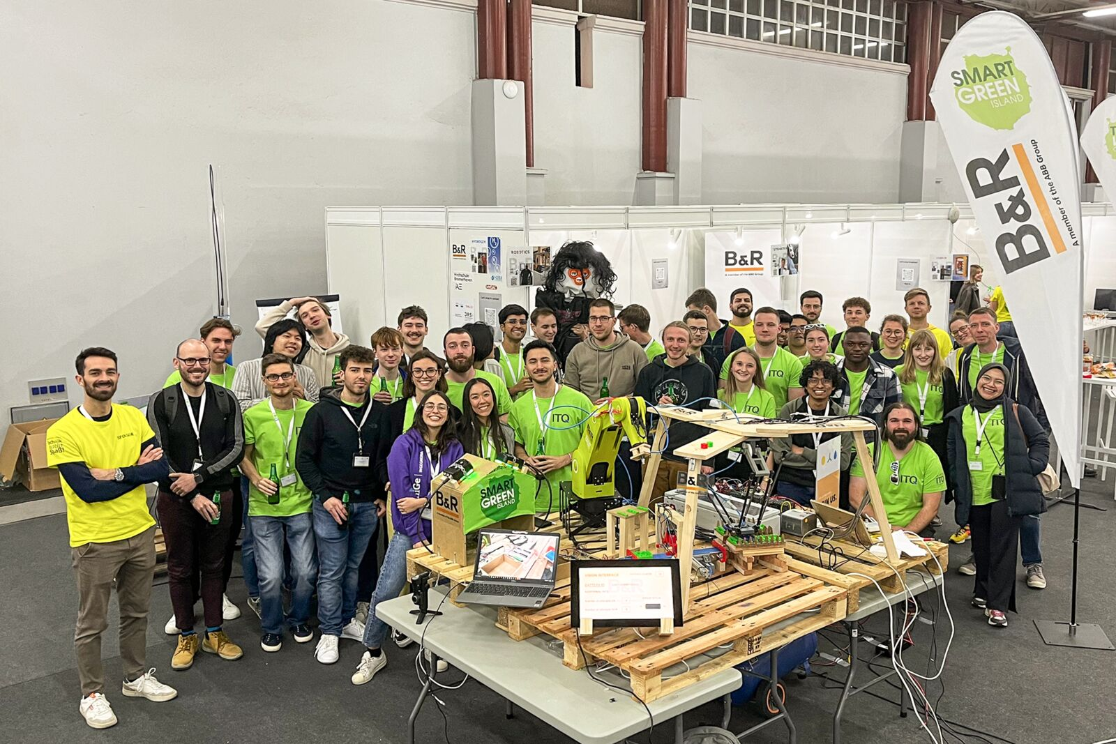
B&R supported its team on site at this year's Makeathon in Gran Canaria. The goal was to develop a machine that automatically evaluates the condition of a battery cell. (Picture: B&R)

About B&R
B&R, a division of ABB Group, is a global leader in industrial automation headquartered in Austria. B&R combines state-of-the-art technology with advanced engineering to provide customers in virtually every industry with complete solutions for machine and factory automation, motion control, HMI and integrated safety technology. With Industrial IoT communication standards including OPC UA, POWERLINK and openSAFETY as well as its Automation Studio software, B&R is constantly redefining the future of automation engineering. The innovative spirit that keeps B&R at the forefront of industrial automation is driven by a commitment to simplifying processes and exceeding customer expectations.
For more information, visit www.br-automation.com.

