ABB co-launches interoperability initiative to unlock Industrial IoT insights for more efficient and sustainable industry
• Margo, a new open standard initiative for interoperability, will address key roadblocks to digital transformation
• The initiative is hosted by the Linux Foundation and driven by a founding group of industrial automation solution providers, including ABB Process Automation and ABB Machine Automation (B&R)
• Margo aims to unlock interoperability at the edge – a key layer of Industrial IoT ecosystems where plant data is transformed into AI-powered insights to drive efficiency and sustainability

At the Hannover Messe on April 23, 2024, founding members ABB (including B&R), Capgemini, Microsoft, Rockwell Automation, Schneider Electric (including AVEVA) and Siemens announced collaboration on a new initiative to deliver interoperability for Industrial IoT ecosystems. Hosted by the Linux Foundation and open to further interested parties, the Margo initiative draws its name from the Latin word for 'edge' and will define mechanisms for interoperability between applications, devices and orchestration software at the edgeof industrial ecosystems. In particular, Margo will make it easy to run and combine applications from any ecosystem member on top of the hardware and runtime system of any other member. Margo aims to deliver on its interoperability promise through a modern and agile open-source approach, which will bring industrial companies increased flexibility, simplicity and scalability as they undergo digital transition in complex, multi-vendor environments.
“Mastering efficiency, flexibility and quality faster than competitors is key to success in today’s industrial world,” said Bernhard Eschermann, CTO, ABB Process Automation. “Digitalization can help deliver on these benefits, but digital ecosystems require a robust, secure and interoperable framework at the edge, connecting operations and information technologies. For ABB, a long-standing advocate of open automation systems, driving a forward-thinking collaborative initiative like Margo is key to achieving this goal.”
Interoperability is key to digital transformation at scale
"The more sources you get data from, the better the decisions you can make," explained Florian Schneeberger, CTO of ABB's Machine Automation division (B&R). "Yet, while the benefits of digitalization increase with scale, so do the challenges of navigating heterogeneous industrial ecosystems. That's why interoperability is so crucial to unlocking the full potential of digitalization. It empowers organizations to adopt and scale Industrial IoT solutions at full speed without large teams of IT specialists."
In March 2024, ABB became a member of the Linux Foundation. This will enable the company to further enhance efforts in promoting open community collaboration, helping unlock innovation and enable better products and experiences for customers. This further strengthens ABB’s commitment to open standard based systems.
In a live panel discussion at the Hannover Messe, representatives from the six founding members met to present their vision for edge interoperability in the Industrial IoT and appeal to like-minded industry peers to join the community and contribute to building a meaningful and effective standard. A recording of the panel discussion will be available at www.margo.org

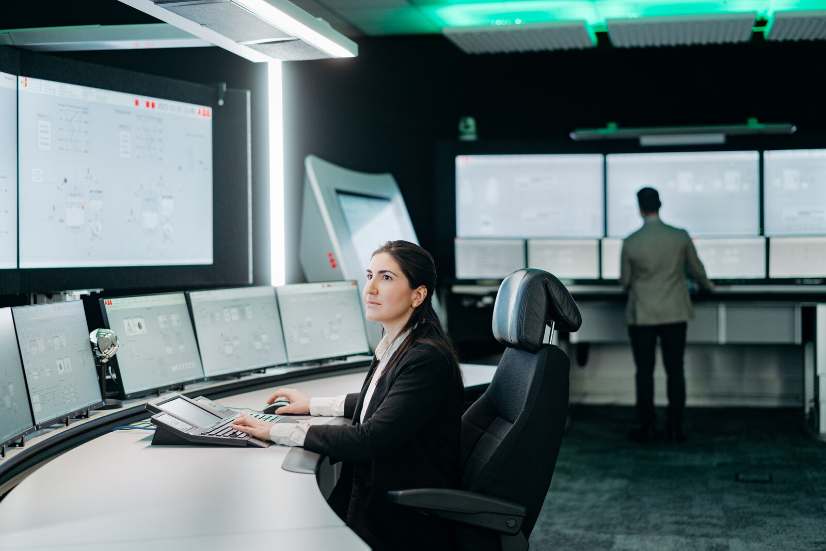
Delivering interoperability at the edge of industrial automation ecosystems, Margo will address key roadblocks to unlock digital transformation at scale. (Picture: ABB)

About B&R
B&R, a division of ABB Group, is a global leader in industrial automation headquartered in Austria. B&R combines state-of-the-art technology with advanced engineering to provide customers in virtually every industry with complete solutions for machine and factory automation, motion control, HMI and integrated safety technology. With Industrial IoT communication standards including OPC UA, POWERLINK and openSAFETY as well as its Automation Studio software, B&R is constantly redefining the future of automation engineering. The innovative spirit that keeps B&R at the forefront of industrial automation is driven by a commitment to simplifying processes and exceeding customer expectations.
For more information, visit www.br-automation.com.

The layer of an Industrial IoT ecosystem located on-premises at industrial sites, between field-level controls and cloud-based platforms. Edge solutions often use AI to process and analyze data from machines and production lines close to the source. This makes it possible to optimize operations, ensure security and improve the cost and performance of cloud communication.

