Profitable short-run production with plug-and-print modularity
B&R presents solutions for the future of printing at DRUPA 2024
At DRUPA 2024, from May 28 to June 7 in Düsseldorf, Germany, B&R is showing how intelligent automation technology can address the evolving needs of the printing sector. At Booth B70 in Hall 13, the industrial automation company is demonstrating solutions that make short-run production more productive and efficient, minimize energy consumption and waste, and adapt to changing requirements through open interoperability and modular design.

"Changes in consumer preference and personalized marketing strategies are driving demand for increasingly individualized print media. That's why our solutions are engineered to maximize efficiency and output while at the same time empowering them to adapt with less downtime and waste," says B&R CEO Joerg Theis.
One of the primary ways that builders of printing machinery adapt to the unique demands of their customers is by offering modular solutions. Visitors to the B&R booth will learn how automation solutions based on open standards and adaptive software are helping machine builders get custom modular solutions up and running with minimal cost and effort. Among the booth highlights is an 8-axis cable robot with multi-vendor controls. As it juggles a ball, it demonstrates the high level of precision that can be achieved in a heterogenious field-level control system with OPC UA FX communication.
Scalable performance and efficient engineering
B&R experts will be on hand to discuss how the new deep learning capabilities for B&R's machine vision cameras can help increase productivity and reduce waste in printing applications. There will also be opportunities to learn about the latest evolutions in some of B&R's flagship products: The new 4100 and 3200 series of its Automation PCs bring big steps in performance and scalability, while a major update to the B&R engineering environment, Automation Studio 6, offers a new level of collaborative, user-focused engineering across the full machine lifecycle.
For more information on B&R's participation in DRUPA 2024 and its solutions for the printing indus-try, please visit drupa 2024.

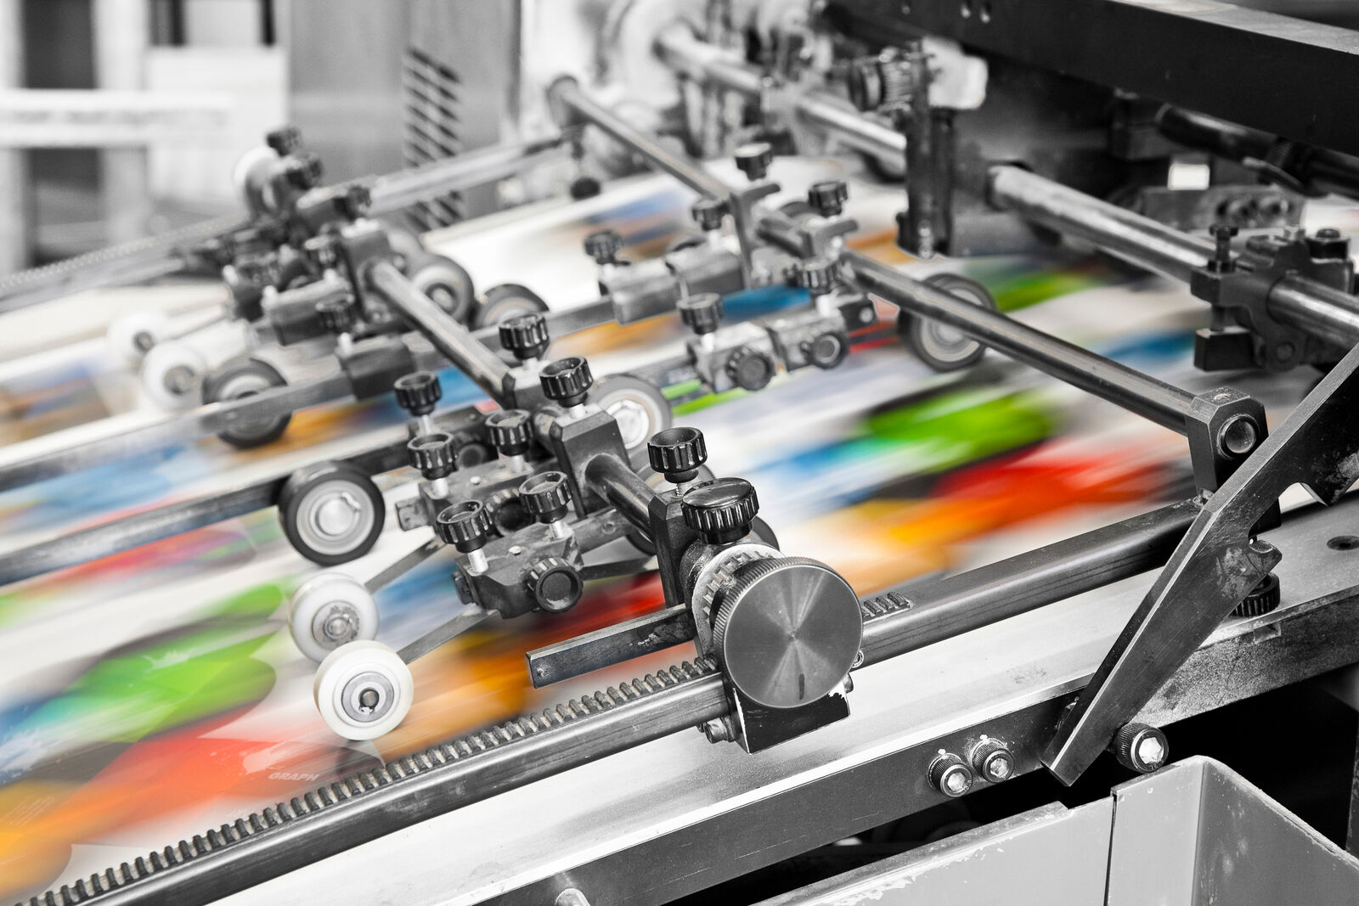
At DRUPA 2024 (Booth B70, Hall 13) B&R presents solutions to make short-run printing more productive and sustainable. (Photo: B&R)

About B&R
B&R, a division of ABB Group, is a global leader in industrial automation headquartered in Austria. B&R combines state-of-the-art technology with advanced engineering to provide customers in virtually every industry with complete solutions for machine and factory automation, motion control, HMI and integrated safety technology. With Industrial IoT communication standards including OPC UA, POWERLINK and openSAFETY as well as its Automation Studio software, B&R is constantly redefining the future of automation engineering. The innovative spirit that keeps B&R at the forefront of industrial automation is driven by a commitment to simplifying processes and exceeding customer expectations.
For more information, visit www.br-automation.com.

