Fast changes on a small footprint
B&R presents adaptive solutions for MedTech and Pharma at ACHEMA 2024
At ACHEMA 2024, from June 10-14 in Frankfurt, Germany, B&R is showing how adaptive automation technology can address the latest challenges in the assembly and packaging of medical devices and pharmaceuticals. At Booth A47 in Hall 3.1, the industrial automation company is demonstrating solutions for handling small batches, variable dosages and increasing personalization.
"Our focus on intelligent, adaptive automation helps make labor-intensive processes more productive and flexible – without adding unnecessary floorspace," says B&R CEO Joerg Theis. "It is also one of the best ways to get energy costs under control and make smarter decisions across the board in terms of time, materials and resources."
As medicines and medical devices grow more and more personalized, batch sizes shrink. At the same time, assembly and packaging processes increase in complexity. B&R's answer to these trends is called adaptive manufacturing, a breed of solution best represented at ACHEMA by B&R's Adaptive Automation demo. This highlight of the B&R booth allows visitors to witness firsthand the seamless interaction between B&R's Codian pick-and-place mechanics, its machine vision cameras, and its linear and planar product transport systems ACOPOStrak and ACOPOS 6D.
A new process station, a different order of stations, adjusted cycle times: All can be designed, validated and running in much less time with an adaptive line. At ACHEMA, B&R industry experts are on hand to discuss how adaptive automation can benefit applications such as personalized therapies and clinical trials, where small batches and variable dosages otherwise rely on manual processes. Visitors can experience live demonstrations of the new compact curve for B&R's ACOPOStrak system, the new hygienic shuttles for ACOPOS 6D, the APROL PharmaEdge solution for future-ready FDA compliance, and more.
Scalable performance and efficient engineering
Other highlights of the B&R Booth include the new deep learning capabilities for B&R's machine vision cameras, which help increase productivity and reduce waste. There will also be opportunities to learn about the latest evolutions in some of B&R's flagship products: The new 4100 and 3200 series of its Automation PCs bring big steps in performance and scalability, while a major update to the B&R engineering environment, Automation Studio 6, offers a new level of collaborative, user-focused engineering across the full machine lifecycle.
For more information on B&R's participation in ACHEMA 2024 and its solutions for the printing industry, please visit ACHEMA 2024

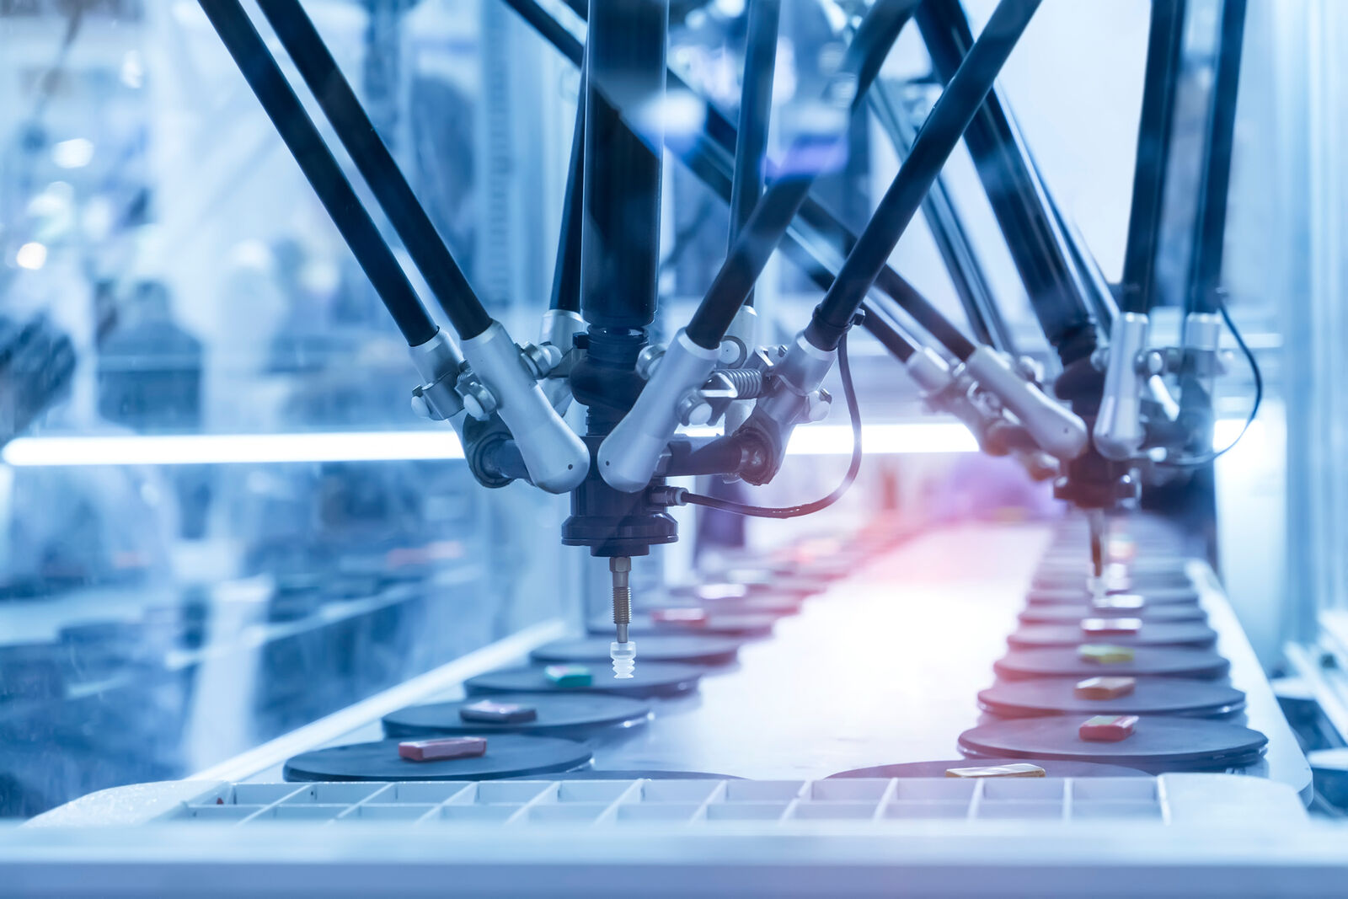
At ACHEMA (Booth A47, Hall 3.1) B&R presents AI-enhanced, IIoT-connected, adaptive solutions to get higher productivity from a smaller footprint. (Photo: B&R)

About B&R
B&R, a division of ABB Group, is a global leader in industrial automation headquartered in Austria. B&R combines state-of-the-art technology with advanced engineering to provide customers in virtually every industry with complete solutions for machine and factory automation, motion control, HMI and integrated safety technology. With Industrial IoT communication standards including OPC UA, POWERLINK and openSAFETY as well as its Automation Studio software, B&R is constantly redefining the future of automation engineering. The innovative spirit that keeps B&R at the forefront of industrial automation is driven by a commitment to simplifying processes and exceeding customer expectations.
For more information, visit www.br-automation.com.

