Energy transition: Accelerating the next wave
B&R presents solutions for a new generation of energy at Smarter E Europe 2024
At Smarter E Europe 2024 from June 19-21 in Munich, Germany, B&R is showing how intelligent automation can address the new challenges that come with widespread adoption of renewable energy. Visitors to Booth 490 in Hall B2 will see how B&R technology is helping to make green grids more reliable and deliver clean fuel to hard-to-electrify sectors.
"More than ever, society needs an energy supply that is reliable, affordable, efficient and sustainable," says B&R CEO Joerg Theis. "By making it faster and easier to incorporate and scale new solutions for power generation, transmission, distribution and storage, we're helping our customers drive the next wave of the energy transition."
New wave, new challenges
As the energy transition enters a new phase of widespread adoption, new challenges arise – from balancing dynamic supply fluctuations to integrating mixed energy sources into a cohesive grid. The energy industry is responding with a new generation of intelligent solutions: Battery systems store excess energy and release it when demand is high or production is low. Power-2-X systems convert surplus electricity for use in sectors that are hard to electrify directly. Fuel cells provide clean power for vehicles, portable power systems and even grid support using hydrogen produced with renewable energy.
Automating a new generation
Visitors to Booth 490 in Hall B2 will experience firsthand how B&R is helping lead the charge with this new generation of energy solutions – by optimizing performance, enabling rapid integration and scaling and ensuring secure and reliable operation. In addition to deep-dives into energy storage and Power-2-X, booth highlights include a demonstration of how B&R's patented diverter technology helps its ACOPOStrak product transport systems supercharge the production of battery cells.
B&R experts will be on site to introduce visitors to the latest evolutions in some of the company's flagship products: The new 4100 and 3200 series of its Automation PCs bring big steps in performance and scalability, while a major update to the B&R engineering environment, Automation Studio 6, offers a new level of collaborative, user-focused engineering across the full equipment lifecycle.
Long track record of powering progress
B&R's scalable automation and energy management systems are tailored for critical infrastructure and enhanced with the latest cybersecurity measures. From wind, solar, biogas and hydroelectric to conventional energy sources – they support the backbone of today's energy landscape as they drive progress toward a more sustainable future.
For more information on B&R's participation in Smarter E Europe 2024 and its solutions for the energy industry, please visit Smarter E Europe
Four events in one
Smarter E Europe comprises four parallel events dedicated to the future of energy:
• Intersolar Europe
• ees Europe
• Power2Drive Europe
• EM-Power Europe
B&R's booth in Hall B2 is part of ees Europe with a focus on energy storage. Stationary and mobile energy storage systems are a crucial component in establishing reliable and resilient energy supply chains.

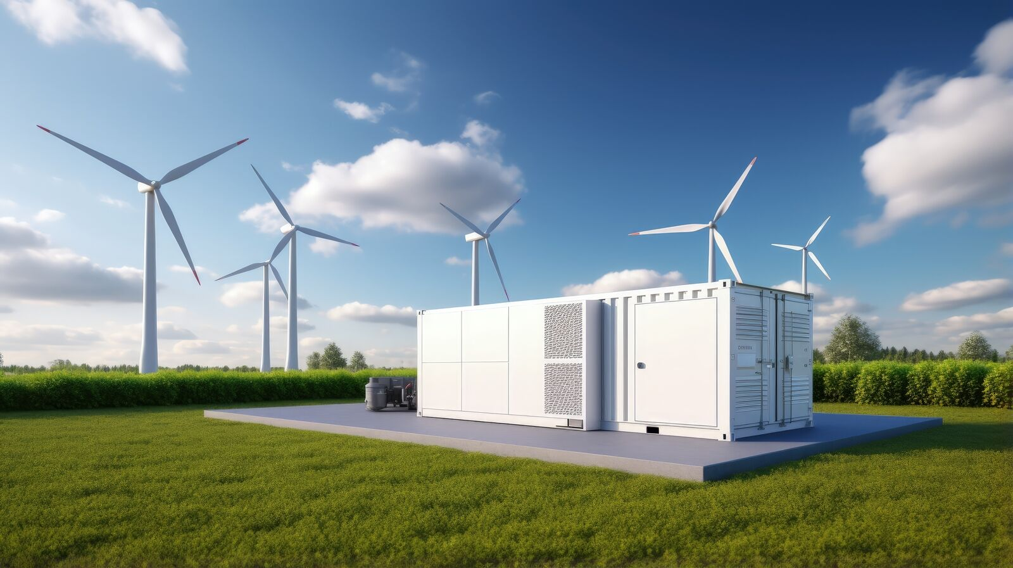
At Smarter E Europe 2024 (Booth 490, Hall B2) B&R presents solutions that make processes more productive, efficient and reliable while helping to drive the transition to clean and sustainable energy. (Photo: B&R)

About B&R
B&R, a division of ABB Group, is a global leader in industrial automation headquartered in Austria. B&R combines state-of-the-art technology with advanced engineering to provide customers in virtually every industry with complete solutions for machine and factory automation, motion control, HMI and integrated safety technology. With Industrial IoT communication standards including OPC UA, POWERLINK and openSAFETY as well as its Automation Studio software, B&R is constantly redefining the future of automation engineering. The innovative spirit that keeps B&R at the forefront of industrial automation is driven by a commitment to simplifying processes and exceeding customer expectations.
For more information, visit www.br-automation.com.

