How to build a battery production superhighway
B&R presents solutions to supercharge battery production at The Battery Show 2024
At The Battery Show Europe 2024 from June 18-20 in Stuttgart, Germany, B&R will show how eliminating stop-and-go traffic in battery production lines can transform them into perfectly orchestrated, ultra productive production networks. Visitors to Booth G67 in Hall 9 will learn how intelligent automation and track-based transport can help battery producers master the balancing act between high productivity, compact footprint and maximum availability.
"As electric vehicles come into their own, the race is on for battery producers to meet the sharp in-crease in production capacity while also managing the challenges of cost, quality and innovation," says B&R CEO Joerg Theis. "We're talking about orders-of-magnitude difference in cycle time com-pared to traditional automotive components – and to a large degree, the answer will come down to how intelligently battery production is automated."
The backbone of B&R's solutions for battery production is formed by its intelligent product transport systems. By moving each battery cell independently with variable speed, spacing and processing, it becomes possible to accelerate individual production steps by as much as 90%. Visitors can see live how B&R's product transport systems, Codian robot mechanics and machine vision cameras all work together seamlessly. Hard real-time synchronization enables high-precision processing while the products remain on track and in motion at up to 5 meters per second.
B&R experts are on hand to discuss how battery production can benefit from powerful new capabilities such as seamless interlinking between the track system and conventional conveyors, high-precision transport of larger payloads such as prismatic cells, and new deep learning capabilities in B&R's machine vision cameras. Visitors will also learn about the latest evolutions in some of B&R's flagship products: The new 4100 and 3200 series of its Automation PCs bring big steps in performance and scalability, while a major update to the B&R engineering environment, Automation Stu-dio 6, offers a new level of collaborative, user-focused engineering across the full machine lifecycle.
For more information on B&R's participation in The Battery Show 2024 and solutions for super-charged battery production, visit Battery Show 2024
100% inspection at 100% speed – With B&R and Exacom
The Open Tech Forum being held during the Battery Show features more than 20 panel discussions and live demonstrations. On Tuesday, June 18th B&R and Exacom will show how B&R's ACOPOStrak transport system helps Exacom integrate cutting-edge X-ray inspection into battery production at full speed. Read the full story here

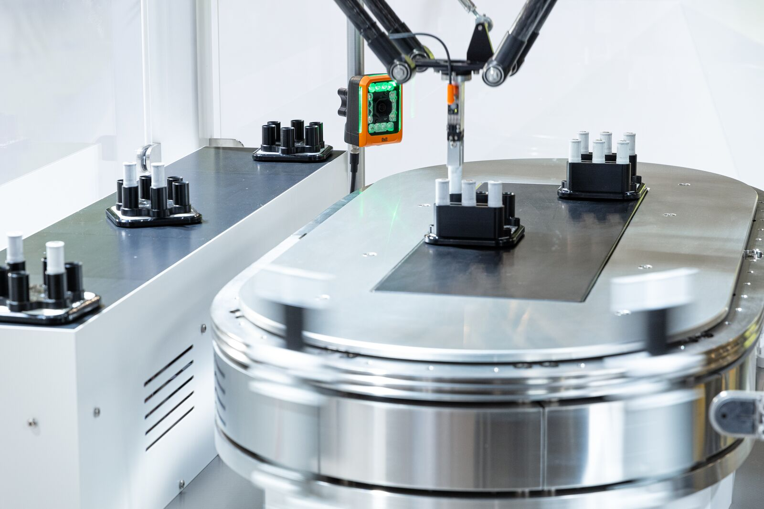
Hard real-time synchronization between tracks, robots, cameras and other equipment enables high-precision processing while battery cells remain on track and in motion at up to 5 meters per second. (Photo: B&R)

About B&R
B&R, a division of ABB Group, is a global leader in industrial automation headquartered in Austria. B&R combines state-of-the-art technology with advanced engineering to provide customers in virtually every industry with complete solutions for machine and factory automation, motion control, HMI and integrated safety technology. With Industrial IoT communication standards including OPC UA, POWERLINK and openSAFETY as well as its Automation Studio software, B&R is constantly redefining the future of automation engineering. The innovative spirit that keeps B&R at the forefront of industrial automation is driven by a commitment to simplifying processes and exceeding customer expectations.
For more information, visit www.br-automation.com.

