Upper Austria's young engineers on their way to the world finals
Students showcase pioneering solutions for sustainability at the World Robot Olympiad
On June 26, budding technologists aged 8 to 19 showcased their technical acumen and problem-solving prowess at the Austrian finals of the World Robot Olympiad. The competition was held for the second year in a row at B&R Headquarters in Eggelsberg, Upper Austria. Under the theme "Earth Allies", contestants illustrated how robots could serve as "allies of the earth", working in harmony with our planet. The triumphant teams, "MMG" from HTL Braunau and "Plasma Bots" from Riedau Middle School, are set to compete in the finals in Turkey this November.
The World Robot Olympiad (WRO) is a global robotics contest that seeks to expose children and young adults to computer science, robotics, and automation early on, while also promoting potential careers in engineering and IT. "Austria has been participating in this competition since 2018, and we are thrilled to be inspiring an increasing number of young talents," states Herbert Ibinger, organizer of WRO Austria and Managing Director of Techno-Z Braunau. For the national Olympiad, the students were challenged to reassemble and customize a robot that they had previously constructed and programmed themselves. The robot's mission was to successfully navigate through four laps of an obstacle course. Together with two graduates from the Austrian HTL (technical college), Herbert Ibinger assessed the participants' performance and selected the victorious teams.
Impressive performances and a tight decision
Both the younger and older students put forth their best efforts in each round, impressing the judges with their creativity and skills. Following a thrilling final round, the winning teams were chosen. Team "MMG" from HTL Braunau emerged victorious in the "Senior" category, "Plasma-Bots" from MS Riedau in the "Junior" category, and the "Robo-Hackers" from MS Riedau in the "Elementary" category. Teams "MMG" and "Plasma-Bots" will represent Austria at the three-day WRO World Final in Izmir, Turkey this November, where they will compete against 94 other countries for the title.
Fostering young talent for a sustainable future
WRO topics are often closely linked to sustainability. This year, participants will be challenged to leverage cutting-edge technologies to illustrate how robots, as "Earth Allies", can help us coexist with nature and mitigate the impact of environmental disasters.
"We are doubly proud to support the World Robot Olympiad this year," says Florian Schneeberger, Chief Technology Officer at B&R. "Not only because of its mission to inspire the next generation of much-needed technology specialists, but also because of this year's theme, which encourages them to think about how technology can be harnessed to address pressing sustainability issues. In a world where robotics and automation are instrumental in making industries more sustainable through more efficient use of energy and materials, it is both our vision and duty to support this trend."
B&R's innovation and training campus in Eggelsberg, where education is a top priority, was once again the perfect venue for the Austrian finals of the WRO. B&R's Automation Academy offers training and continuing education opportunities for up to 4,000 individuals annually, including students, apprentices, specialists, B&R employees and customers from around the globe. ABB's robust partner program, which collaborates with over 100 schools and universities, aids educational institutions in preparing future generations.
Responsibility and investment in the future
As a member of the ABB Group, B&R is committed to ambitious sustainability goals and is working towards achieving a Net Zero future by 2050. Educating and nurturing our younger generation in STEM (science, technology, engineering, and mathematics) disciplines and promoting diversity in technical professions are crucial to realizing this goal and addressing the challenges of climate change and resource scarcity. For B&R, supporting such sustainable initiatives is not just a part of its social responsibility, but also an investment in the future.

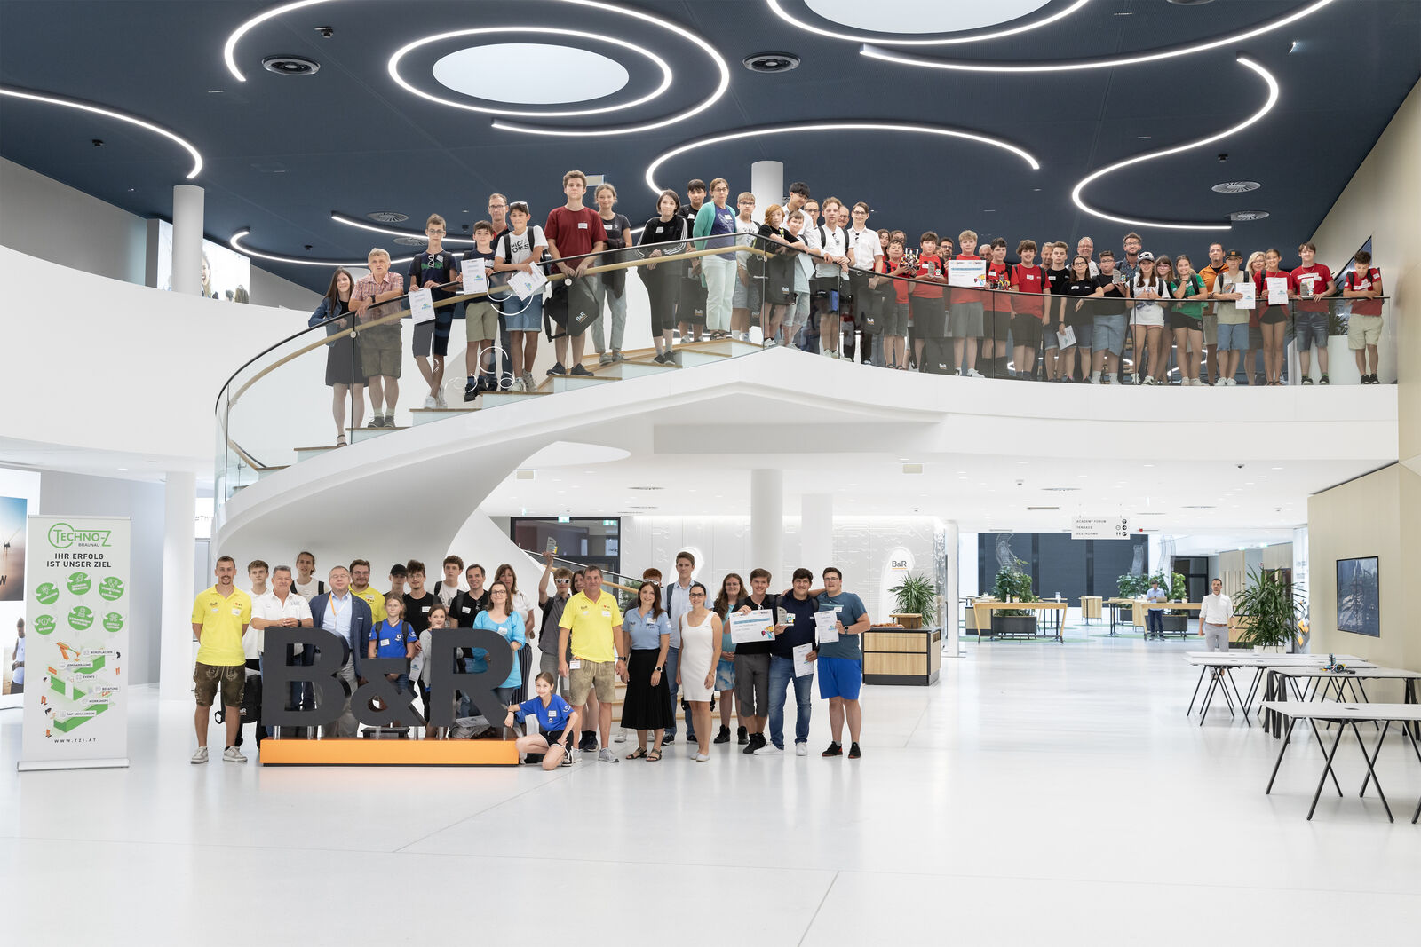
At the B&R Campus, 47 students from 9 schools engineered innovative robot solutions aimed at fostering a sustainable future. (Image: B&R)
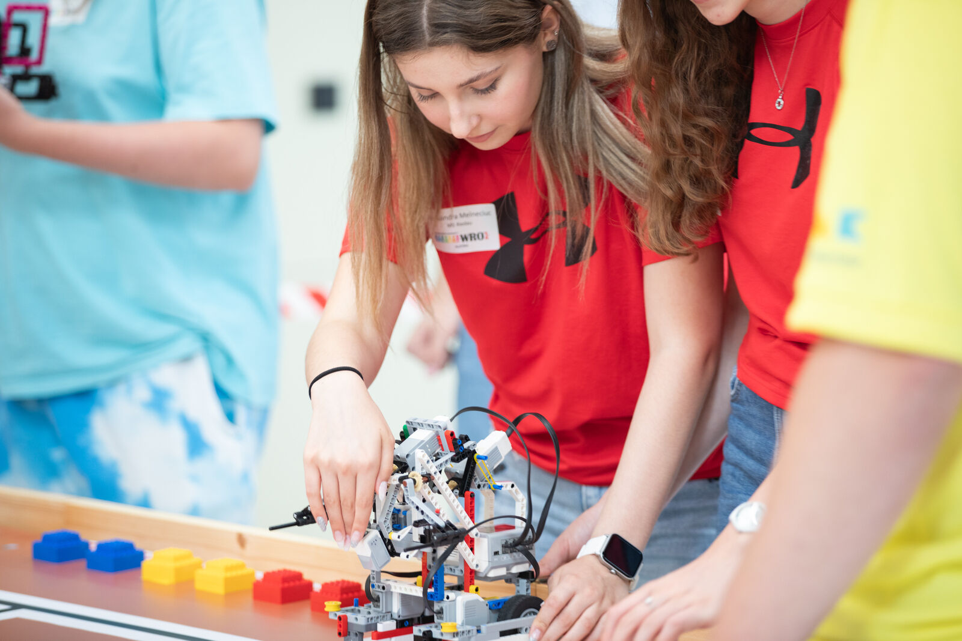
Participants were challenged to reassemble and customize a robot that they had previously constructed and programmed themselves. (Image: B&R)
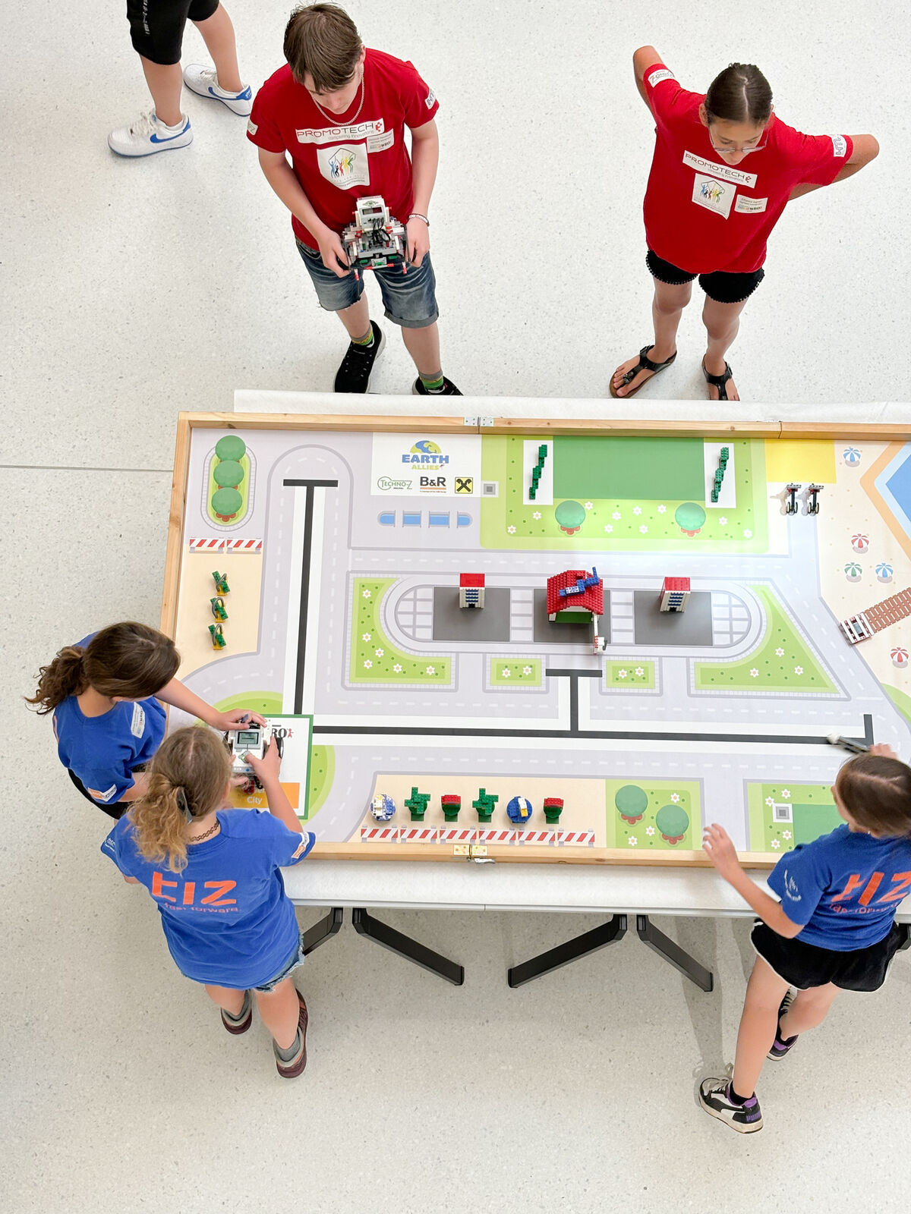
The robot's mission was to successfully navigate through four laps of an obstacle course. (Image: B&R)
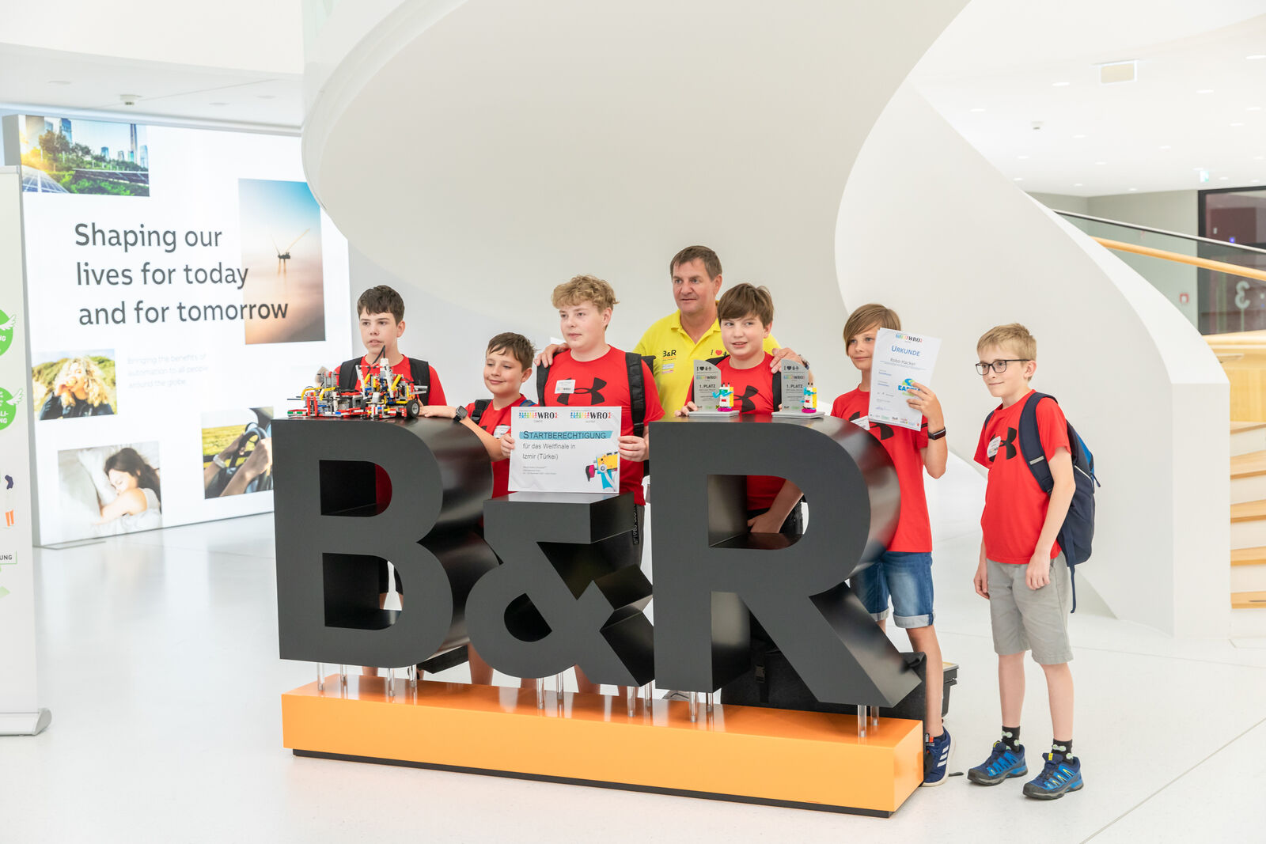
Together with two graduates from the Austrian HTL (technical college), Herbert Ibinger assessed the participants' performance and selected the victorious teams. (Image: B&R)

About B&R
B&R, a division of ABB Group, is a global leader in industrial automation headquartered in Austria. B&R combines state-of-the-art technology with advanced engineering to provide customers in virtually every industry with complete solutions for machine and factory automation, motion control, HMI and integrated safety technology. With Industrial IoT communication standards including OPC UA, POWERLINK and openSAFETY as well as its Automation Studio software, B&R is constantly redefining the future of automation engineering. The innovative spirit that keeps B&R at the forefront of industrial automation is driven by a commitment to simplifying processes and exceeding customer expectations.
For more information, visit www.br-automation.com.

