Open Automation Challenge 2024: Shaping engineers of the future

At a time when the global manufacturing landscape is more competitive than ever, industry and academia are collaborating to overcome complex new challenges in engineering and at the same time inspire future engineers. The B&R Education Network in India is continuously working as the interface between educational institutions and the automation industry. To help make the next generation of engineers ready for industry, the B&R Education Network partnered with the Dr. D. Y. Patil Institute of Technology in Pimpri-Pune to organize the Open Automation Challenge 2024. The event paired engineering students with B&R mentors to bring their ideas to reality using the state-of-the-art technologies in the field of automation engineering. The event started in June 2024 with over 50 teams across India registering their groundbreaking ideas. Fourteen teams were shortlisted based on their innovative approach and application. The selected teams completed training on B&R's Automation Studio engineering software and other B&R technologies to finally execute their projects and bring their ideas to life.
Understanding the gap
In a fast-paced world, technological transformation leads to better productivity. It is necessary that the engineers of today understand the industry challenges. Today, automation is considered a key element in all manufacturing operations, and the industry expects new recruits to have the required skills in this technology. Moreover, in the era of industrial IoT and Industry 4.0, the evolution of technology is growing rapidly, and the engineering curriculum often struggles to keep pace with it. B&R’s Education Network is a well-structured program of collaboration to improve the industry knowledge of engineering graduates and make them ready for the industrial world. Open Automation Challenge 2024 offered fresh inspiration for the engineering students' innovative minds, encouraging curiosity for creative solutions and courage for big ideas. The emerging engineers explored numerous possibilities, the way automation is changing the world and were intrigued by a presentation delivered by B&R's Regional Managing Director for Southern and Eastern Asia, Mr. Jhankar Dutta. During the presentation, he highlighted important topics like industry trends, the changing demands, sustainability and how the B&R Education Network is bridging the gap between industry and educational institutes.
Building the bridge of knowledge
Open Automation Challenge 2024 has seen remarkable milestones with new perspectives and a fresh outlook on the projects built by students along with their mentor assigned by B&R. The group of students participating in the challenge embarked on a two-week educational adventure that included project development and training on B&R Automation Studio and related technologies. Their dedication and creativity transformed innovative ideas into reality using advanced software and simulation tools. On the final day, each team stepped onto the stage, unveiling their meticulously crafted automation projects before a panel of esteemed judges. The students demonstrated not just technical prowess, but the potential to revolutionize sectors ranging from manufacturing to healthcare and agriculture. The top three teams were selected as winners. The right knowledge is a critically important first step and one of the most effective ways to bridge the gap is to mentor the right way. As the automation industry grows across India with rising expectations and demands, engineers are the pioneers of a bright tomorrow. Beyond competition, the Open Automation Challenge 2024 was a celebration of collaboration and learning.

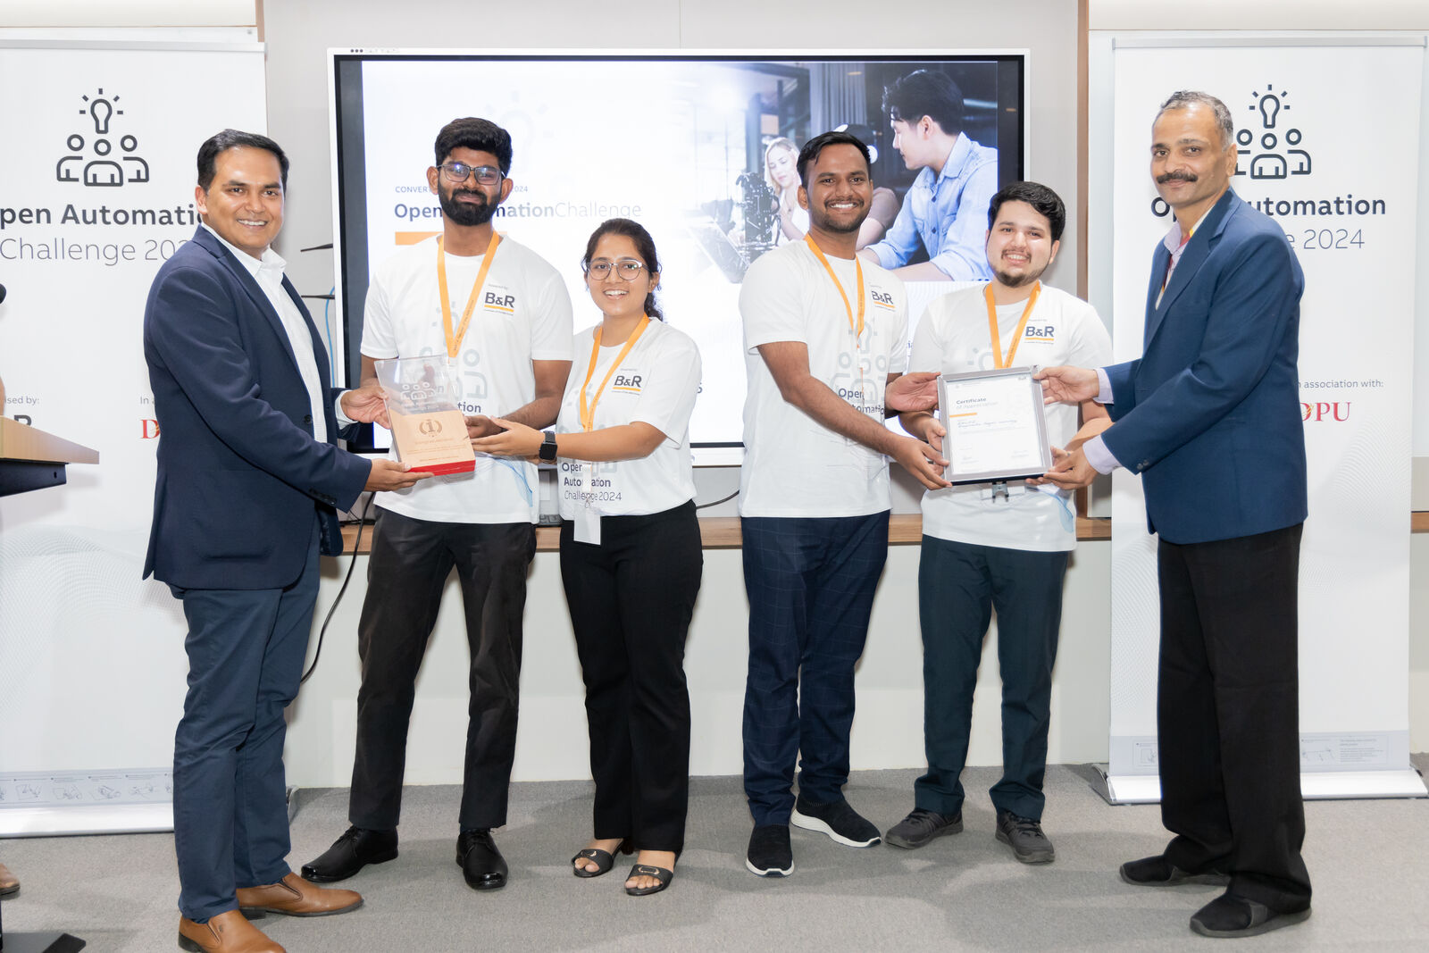
Winner: Team ‘DSU_ECE’ from Dayananda Sagar University, Bangalore for executing and presenting the best project idea. (Image - B&R)
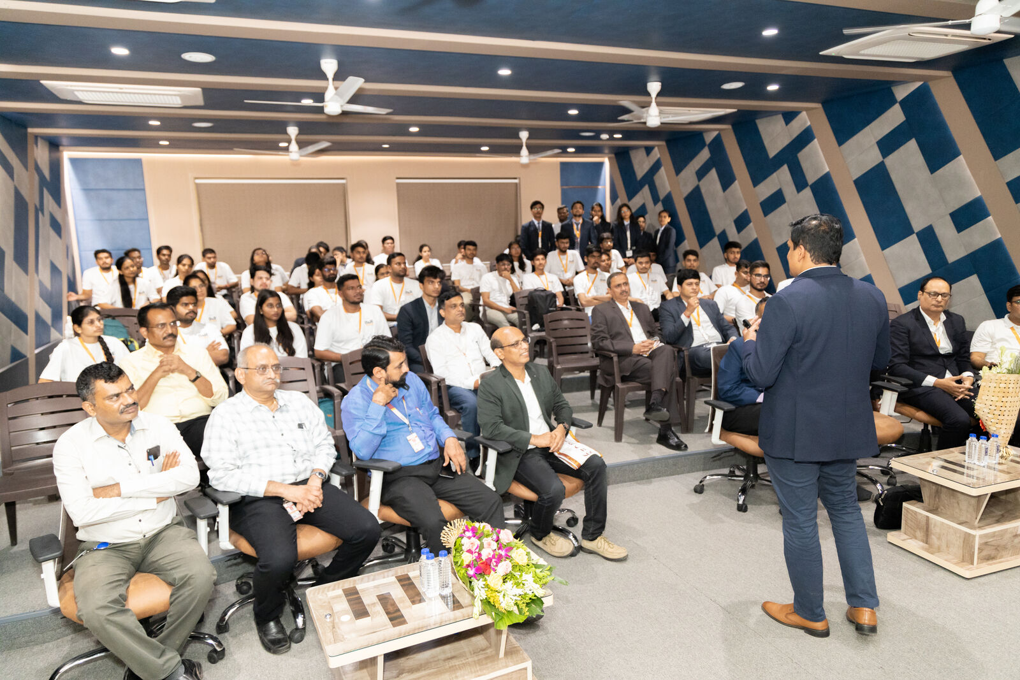
Mr. Jhankar Dutta presenting B&R's efforts for bridging the gap between industry and institutes with programs like Open Automation Challenge. (Image - B&R)
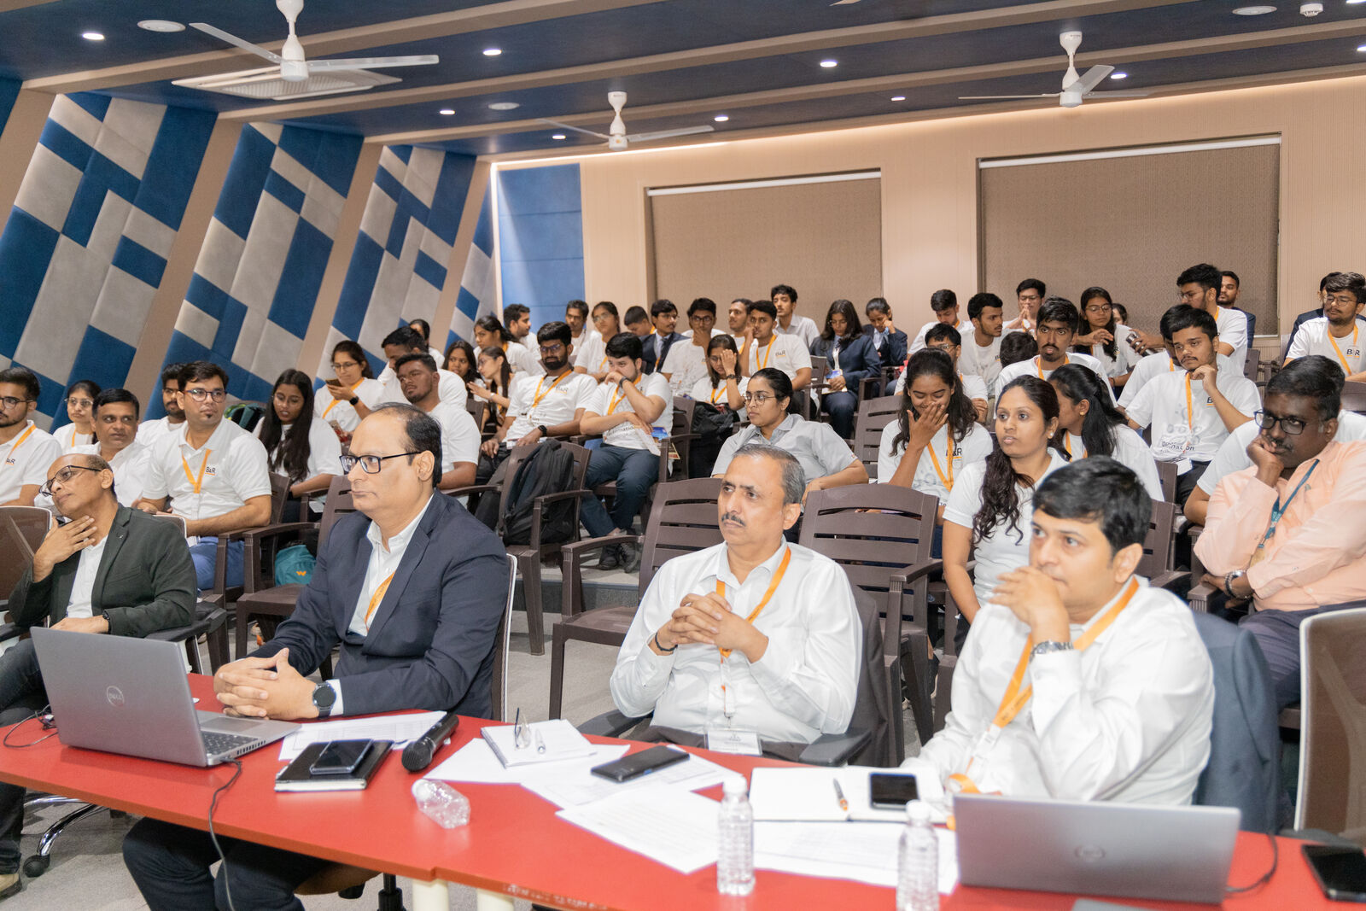
The B&R expert panelists listening to the interesting and groundbreaking project idea presented during the event. (Image - B&R)
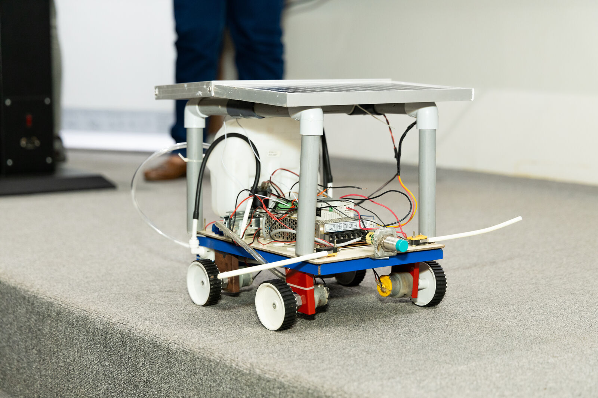
An autonomous spraying vehicle prototype for weed control in agricultural fields presented by Runner-up Team : ‘Vayuputhra’ from Karpagam college of engineering, Coimbatore. (Image - B&R)
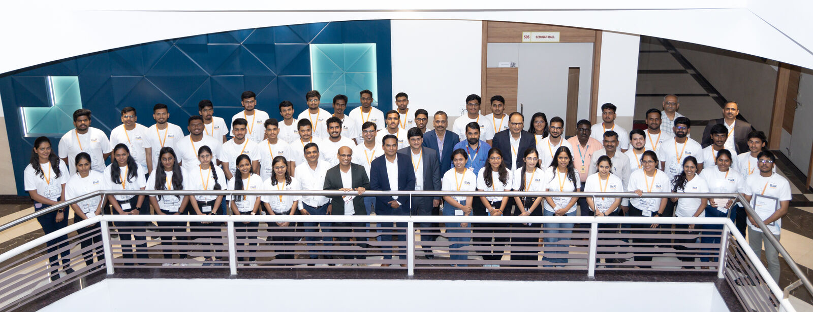
Open Automation Challenge 2024 event gathered engineering students from all over India: More than 50 teams registered and ultimately 14 teams selected to get the trainings and execute the projects. (Image - B&R)

About B&R
B&R, a division of ABB Group, is a global leader in industrial automation headquartered in Austria. B&R combines state-of-the-art technology with advanced engineering to provide customers in virtually every industry with complete solutions for machine and factory automation, motion control, HMI and integrated safety technology. With Industrial IoT communication standards including OPC UA, POWERLINK and openSAFETY as well as its Automation Studio software, B&R is constantly redefining the future of automation engineering. The innovative spirit that keeps B&R at the forefront of industrial automation is driven by a commitment to simplifying processes and exceeding customer expectations.
For more information, visit www.br-automation.com.

