B&R introduces new coding environment with cloud collaboration and AI assistant
Automation Studio Code and Copilot boost productivity and enhance teamwork in software development for industrial automation
• New coding environment delivers modern experience and advanced editing for faster development
• AI-assisted code generation and optimization accelerate time-to-market and boost code quality
• Cloud collaboration simplifies teamwork across devices and locations
At this year's SPS exhibition in Nuremberg, Germany, B&R announced a major update to its comprehensive suite of engineering and runtime software. With Automation Studio Code, B&R introduces an entirely new engineering experience. It incorporates an array of advanced editing functions, drawing from the latest the software industry has to offer. With flexible local or cloud-based access, it supports seamless collaborative engineering. Fully integrated in this new environment is Automation Studio Copilot, a generative AI coding assistant developed in cooperation with Microsoft. Among the numerous upgrades in the new release, these standout additions promise a dramatic impact on the software development experience for machine builders and system integrators.
Elevating the engineering experience in machine automation
"Bringing state-of-the-art software engineering into the world of machine automation is crucial to helping our customers stay a step ahead of rapid changes in today's markets," says B&R Chief Technology Officer Florian Schneeberger. "With a productivity boost from modern development tools and generative AI, together with the flexibility of cloud collaboration, we help them develop faster with more agile teamwork and get innovative machines to market fast."
In Version 6 of B&R's engineering software, Automation Studio Code adds powerful new engineering capabilities, while offering full flexibility to open the same projects in either the new environment or the familiar Automation Studio interface. Among the new capabilities are rich syntax highlighting, which makes code easier to read, and object-oriented programming in Structured Text, which helps engineers organize their code more logically and work more efficiently. Real-time error detection eliminates repetitive compiling and correction loops, and the ability to adapt the theme to dark mode helps prevent developer fatigue.
Productivity boost with generative AI
One of the most significant contributions to accelerated machine development comes in the form of Automation Studio Copilot, the AI companion embedded in the new coding environment. Copilot allows developers to generate executable machine code simply by entering prompts in natural language. It also helps optimize and annotate existing code, making it easier to share and reuse. Complex applications can be quickly summarized to facilitate discussions with non-technical stakeholders.
Describing what typical project workflow might look like, Software Strategy Manager Manuel Sanchez-Marchan says: "You might start by setting up a project in the familiar, feature-rich Automation Studio environment. Then you can jump over to Automation Studio Code to develop your application and share it with your team – using all the modern editing features and enjoying all the advantages of cloud collaboration and seamless source control. Every step of the way, you have Automation Studio Copilot at your side – whether you get stuck on a tricky problem or just want a faster way to get things done."
Seamless flexibility with cloud collaboration
Automation Studio Code offers a seamless experience for developers, whether they choose to open projects on their desktop or in a web browser. "It's a lot like the tools we all use to collaborate on documents, spreadsheets and presentations," explains Sanchez-Marchan. "Considering how dramatically those tools have transformed office work, it's easy to imagine what it means to bring the same level of collaboration to software development processes in the automation industry."
With teams collaborating in real-time from different locations, topics like source control become more important than ever. "B&R has always been a step ahead with easy source control thanks to the file-based nature of Automation Studio projects," notes Sanchez-Marchan. "With Automation Studio Code, we're now taking that a step further. By building source control tasks right into the development environment, we remove distractions and allow developers to focus on their creative work." Connection of git repositories enables integration of third-party tools like GitHub or Azure DevOps. These version control and collaboration tools make it easy to merge contributions from different team members, keep track of changes, and ensure that everyone is always working from the latest version.
Streamlined development with cloud-based engineering
A cloud-based engineering solution eliminates the need to install the development environment locally. This prevents challenges in version management and dependencies from becoming bottlenecks for team efficiency. Development teams frequently face long hardware lifecycles and multiple tool versions across different machines, adding complexity to their processes. Moreover, IT restrictions on local software management can further hinder productivity, requiring virtual machines or specialized development setups to support different versions of the environment. Cloud-based engineering eliminates these obstacles, streamlining setup and maintenance.
With a project dashboard offering a clear overview of their projects all in one place, engineers can easily see what is in progress and what needs attention. "You spend less time searching for files or trying to remember where you left off, and more time actually developing and refining your code," says Sanchez-Marchan. Projects can be shared by sending a link – which a teammate or client can open directly in their browser without needing to install any additional software.

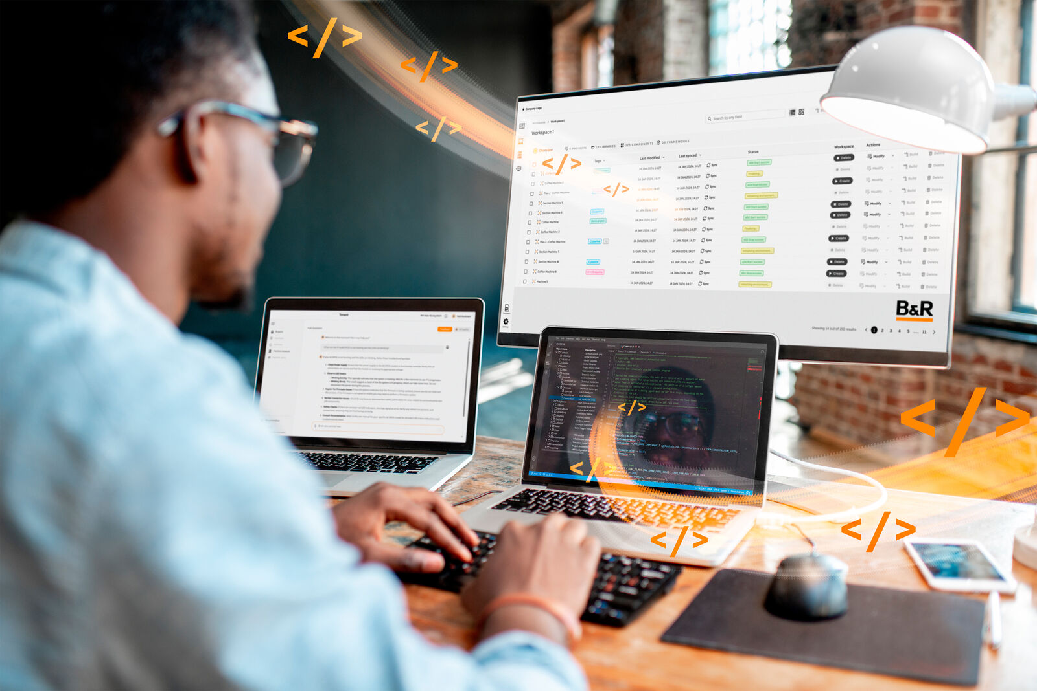
The new version of B&R's automation software delivers advanced engineering capabilities, enhanced collaboration and an AI productivity boost (Image: B&R)

About B&R
B&R, a division of ABB Group, is a global leader in industrial automation headquartered in Austria. B&R combines state-of-the-art technology with advanced engineering to provide customers in virtually every industry with complete solutions for machine and factory automation, motion control, HMI and integrated safety technology. With Industrial IoT communication standards including OPC UA, POWERLINK and openSAFETY as well as its Automation Studio software, B&R is constantly redefining the future of automation engineering. The innovative spirit that keeps B&R at the forefront of industrial automation is driven by a commitment to simplifying processes and exceeding customer expectations.
For more information, visit www.br-automation.com.

