Fast and flexible lab automation at scale
B&R shows adaptive solutions for laboratory operations at SLAS 2025
B&R Industrial Automation, a global leader in industrial automation solutions, is excited to announce its participation in the SLAS 2025 tradeshow, taking place from January 25-29, 2025, in San Diego, CA. As a first-time exhibitor, B&R will showcase a new ACOPOS 6D demo specifically designed for lab automation.
At SLAS 2025, B&R will demonstrate how its latest innovations are helping laboratories multiply throughput without adding floorspace. Visitors to Booth #2715 will learn how advanced automation can transform the efficiency of automated laboratory and screening processes.
Key highlights at B&R’s booth:
• Planar technology: Experience the revolutionary planar technology, ACOPOS 6D, that enhances flexibility and precision in lab automation.
• Integrated automation solutions: Discover how B&R’s integrated systems can streamline laboratory workflows, reduce manual intervention, and increase throughput.
• Precision control systems: Learn about B&R’s precision control technologies that ensure high accuracy and repeatability in laboratory processes.
“We are thrilled to participate in SLAS 2025 and showcase our latest advancements in laboratory automation,” said B&R segment expert Lazaros Patsakas. “We look forward to speaking with SLAS visitors about how our solutions target all three factors of OEE to help them achieve flexibility and quality at scale.”
B&R Industrial Automation invites all SLAS 2025 attendees to visit Booth #2715 to learn more about their innovative solutions and how they can transform laboratory operations.
For more information about B&R Industrial Automation, please visit https://www.br-automation.com/en-us/

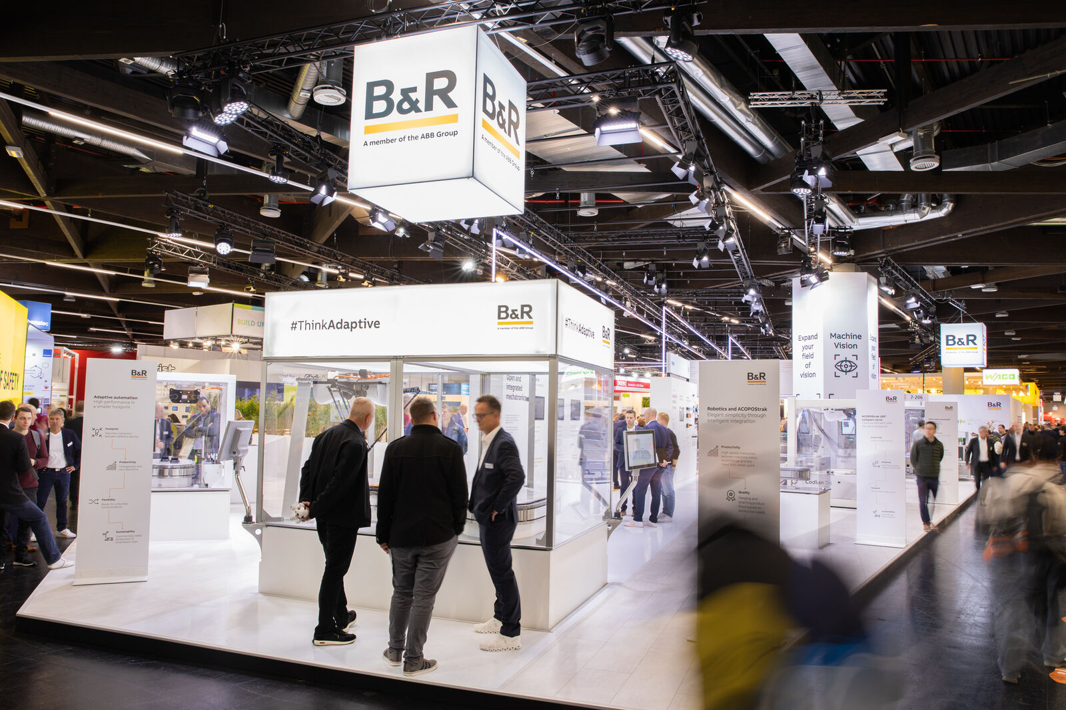
At SLAS 2025, B&R will demonstrate how its latest innovations are helping laboratories multiply throughput without adding floorspace. (Image: B&R)

Lazaros Patsakas is Global Segment Manager at B&R. "We are thrilled to participate in SLAS 2025 and showcase our latest advancements in laboratory automation." (Image: B&R)

About B&R
B&R, a division of ABB Group, is a global leader in industrial automation headquartered in Austria. B&R combines state-of-the-art technology with advanced engineering to provide customers in virtually every industry with complete solutions for machine and factory automation, motion control, HMI and integrated safety technology. With Industrial IoT communication standards including OPC UA, POWERLINK and openSAFETY as well as its Automation Studio software, B&R is constantly redefining the future of automation engineering. The innovative spirit that keeps B&R at the forefront of industrial automation is driven by a commitment to simplifying processes and exceeding customer expectations.
For more information, visit www.br-automation.com.

