ABB appoints Susana Gonzalez as Chief Sales Officer Machine Automation Division (B&R)
Seasoned leader with global experience to drive customer focus and innovation
ABB has appointed Susana Gonzalez as Chief Sales Officer Machine Automation Division, B&R (A Member of the ABB Group), effective February 2025. Gonzalez, who brings over 25 years of global experience in industrial automation and manufacturing, will lead B&R's global sales organization and serve as a member of the Division Management Team. She succeeds Luca Galluzzi who held the position for the past five years.
Gonzalez has extensive global expertise in developing and implementing strategies to drive sales growth and enhance customer experiences. She joins B&R from Rockwell Automation, where she led sales for the EMEA region. Gonzalez’s diverse background includes roles in customer support, product management, and sales across the USA, Asia, Europe, the Middle East, and Africa.
“Susana’s extensive international experience and strategic approach make her an excellent fit for this role,” said Joerg Theis, President of ABB’s Machine Automation Division. “Her leadership will strengthen our customer focus and ensure we continue to deliver innovative solutions that address the evolving needs of our customers while maintaining our commitment to quality and performance.”
“I am excited to join B&R at this pivotal moment in the division’s history,” said Gonzalez, Chief Sales Officer Machine Automation Division, B&R. “B&R has a strong tradition of providing exceptional support to customers and adapting to their evolving needs. By leveraging customer insights, we will drive growth and innovation, improve our sales processes, and work closely with our Research and Development team to deliver solutions that meet and exceed customer expectations.”
Gonzalez holds a degree in Business Administration from Asturias Business School and an MBA from San Francisco State University.

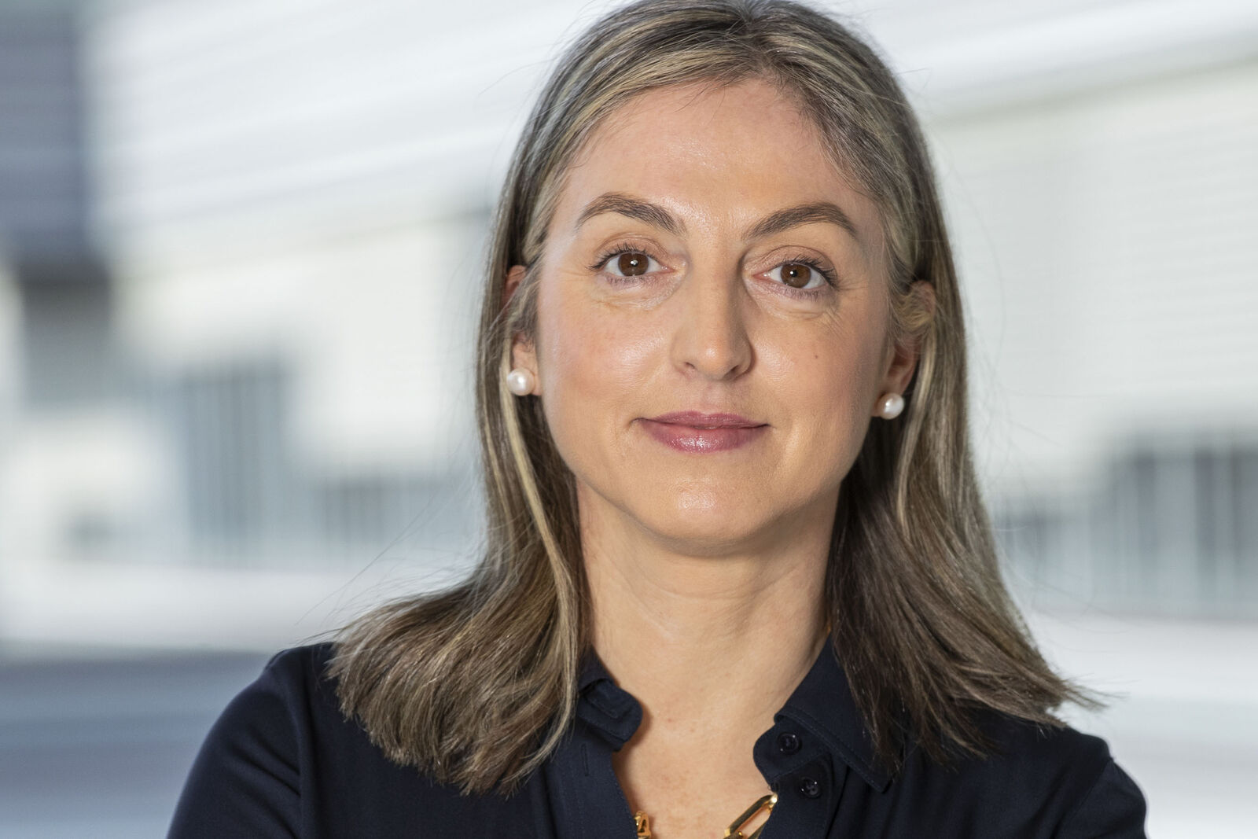
Gonzalez is the new Chief Sales Officer Machine Automation Division, B&R (A Member of the ABB Group) as of February 2025. (Credit: B&R)
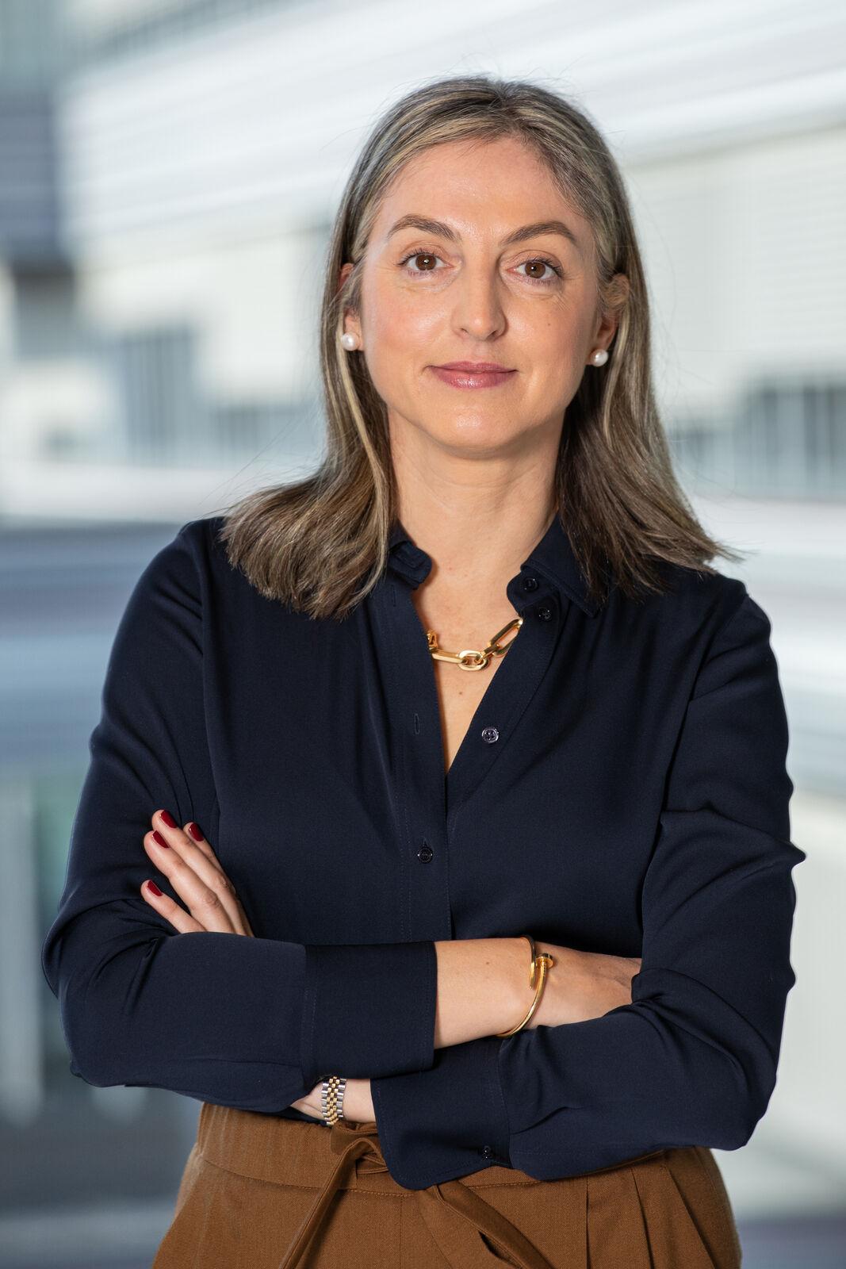
Gonzalez is the new Chief Sales Officer Machine Automation Division, B&R (A Member of the ABB Group) as of February 2025. (Credit: B&R)

About B&R
B&R, a division of ABB Group, is a global leader in industrial automation headquartered in Austria. B&R combines state-of-the-art technology with advanced engineering to provide customers in virtually every industry with complete solutions for machine and factory automation, motion control, HMI and integrated safety technology. With Industrial IoT communication standards including OPC UA, POWERLINK and openSAFETY as well as its Automation Studio software, B&R is constantly redefining the future of automation engineering. The innovative spirit that keeps B&R at the forefront of industrial automation is driven by a commitment to simplifying processes and exceeding customer expectations.
For more information, visit www.br-automation.com.

