B&R presents AI-enhanced fitness tracking for machines
Industrial IoT apps for machine health and performance
• AI-powered Industrial IoT apps support real-time optimization and predictive maintenance
• Containerized software enables open integration across edge and cloud environments
• Domain-specific AI analysis of machine data boosts availability, efficiency, and equipment lifespan
B&R launches two Industrial IoT apps that enable AI-powered optimization of machine health and performance. Designed for open integration into any platform, IIoT Connector serves as the core enabler of data-driven services, providing flexible access to B&R device data across edge and cloud environments. Building on this data, ACOPOStrak Monitor applies AI-based analysis to support real-time performance optimization and predictive maintenance of B&R's adaptive product transport solutions.
"Many of us use smartwatches and fitness apps to analyze data from our body—our pulse, steps, and breathing—so we can stay healthy and perform better," explains Sridharan Rangarajan, Vice President and Global Product Group Manager for Software at B&R. "What fitness tracking is to the athlete, Industrial IoT solutions are to the machine." What's special about B&R's approach, notes Rangarajan, is how easy it is to turn data from B&R products into measurable improvements in productivity, equipment lifespan, and efficient utilization of materials and energy. "We wanted a solution that really works for our customers, so we've designed our IIoT solutions to fit friction-free into any platform and any system architecture."
Connecting data to value
When digital transformation projects struggle to deliver meaningful value, it's rarely due to a lack of data. Most often, it’s due to the cost and complexity of accessing data and making sense of it. Or, as B&R IIoT expert Reinhard Achatz explains it: "Machines are already telling us everything we need to know, the key is finding the right way to listen and understand." That's the job of IIoT Connector, the new containerized app that gives users open and configurable access to data from B&R assets across any architecture—edge, cloud, or hybrid—in both new and brownfield installations.
With automatic asset discovery and selective data forwarding, IIoT Connector simplifies what were once complex, costly tasks. Built on open communication standards like OPC UA and MQTT, open edge orchestration frameworks like Margo, and with APIs to allow direct integration in third-party tools, IIoT Connector makes it easy to incorporate B&R device data wherever it is needed. More than simply providing access, IIoT Connector transforms complex, B&R-specific datasets into lightweight, standardized formats that are easy to manage within IT systems—making B&R data readily available for use in cloud environments and enterprise infrastructures. It also streamlines everyday operations with practical visibility into hardware configurations, software versions and available updates.
AI-enhanced health and performance
Building on the IIoT Connector, technology-specific software can apply contextualized analysis to help reduce downtime, improve asset utilization and extend equipment life. As the first such app from B&R, ACOPOStrak Monitor combines B&R's deep domain expertise in track technology with advanced AI algorithms to transform data from B&R track systems into clear insights—helping operators move from reactive maintenance to proactive optimization.
Live status, historical trends, and automatic notifications are presented in intuitive, user-friendly dashboards that can be viewed locally or remotely on HMI panels and mobile devices. "Like the dashboard in your car, ACOPOStrak Monitor tells you what you need to know at a glance—helping your track system run better and last longer," says Achatz.
The dashboards enable faster, more informed decisions throughout the life of the machine. Feedback during assembly and commissioning enables faster time to market. Condition monitoring and advanced diagnostics minimize downtime and extend component life. Like IIoT Connector, B&R's data-driven service apps are containerized and feature APIs to allow easy integration into any ecosystem. Importantly, ACOPOStrak Monitor derives everything it needs to know from existing shuttle data—no additional sensor hardware is needed.
Check out the B&R website to learn more about B&R's Industrial IoT solutions.


New Industrial IoT apps enable AI-powered optimization of machine health and performance—like fitness tracking for machines—by providing flexible access to B&R device data across edge and cloud environments.
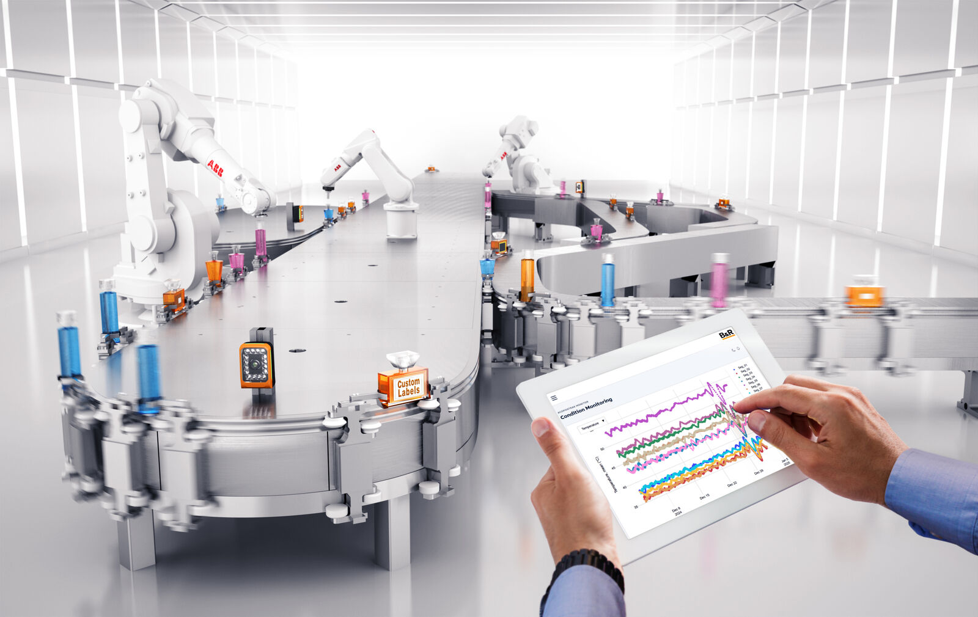
The intuitive ACOPOStrak Monitor dashboard gives operators AI-powered insights into the performance of B&R's adaptive product transport systems, enabling real-time optimization and predictive maintenance.

About B&R
B&R, a division of ABB Group, is a global leader in industrial automation headquartered in Austria. B&R combines state-of-the-art technology with advanced engineering to provide customers in virtually every industry with complete solutions for machine and factory automation, motion control, HMI and integrated safety technology. With Industrial IoT communication standards including OPC UA, POWERLINK and openSAFETY as well as its Automation Studio software, B&R is constantly redefining the future of automation engineering. The innovative spirit that keeps B&R at the forefront of industrial automation is driven by a commitment to simplifying processes and exceeding customer expectations.
For more information, visit www.br-automation.com.

