Future-proof PC performance
Automation PC 3200 provides ultimate solution for digital transformation
As manufacturers accelerate their digital transformation, the demands placed on industrial PCs are rising fast. From real-time data processing and AI workloads to preparing for evolving cybersecurity requirements, the pressure is on to combine computing power with long-term system adaptability. The new Automation PC 3200 delivers exactly that. As the latest generation of B&R's proven 3000 series, it brings 13th-generation Intel Core i processing, seamless system integration and a robust foundation for future updates – equipping manufacturers for the challenges of today and the opportunities of tomorrow.
Broad performance spectrum
B&R's latest automation PC is built to handle the most demanding industrial applications. Its modular and customizable design offers flexibility for machine-specific requirements, offering future-proof performance and advanced security features. Powered by the latest Intel Core i processors, it provides scalable computing power up to 64 GB DRAM, catering to a wide range of applications from simple HMI to data-intensive real-time analytics or complex AI-driven tasks. High processor performance ensures long-term software availability, updates that help meet future cyber-security demands, and system reliability, maximizing product lifecycle while keeping operations secure and efficient.
In addition to high performance, the Automation PC 3200 helps reduce total cost of ownership through long service life, minimal maintenance, and consistent software support. Its fanless design and robust industrial-grade components extend operating lifetime while lowering the risk of down-time. For machine builders, that translates to fewer service calls, easier lifecycle management, and greater customer satisfaction. End users benefit from reliable 24/7 operation, lower energy consumption, and a platform that is designed for longevity and adaptable to future requirements – contributing not only to operational efficiency but also to broader sustainability goals.
"The development of this new generation is an important step for B&R's PC/HMI portfolio and a clear signal to our customers that B&R takes the growing demands their applications in the areas of edge-based AI, advanced analytics and cybersecurity very seriously," says Stephan Hatheuer, B&R's product manager for industrial PCs. "At the same time, we're helping manufacturers stay future proof in terms of security, investment and having a platform built for long-term reliability in 24/7 use."
Seamless upgrades and enhanced features
Full compatibility with its predecessor, the Automation PC 3100, allows for easy upgrades without additional costs or re-engineering efforts, ensuring immediate benefits from enhanced performance and security features. The new mass storage device CFexpress offers about twice the performance compared to CFast. Other standard features include 2x 2.5 Gigabit Ethernet interfaces, ensuring fast and reliable communication with IT networks, which is crucial for data-intensive tasks.
Check out the B&R website to learn more about the Automation PC 3200 and B&R's full range of powerful, scalable, future-proof industrial PC and HMI solutions.

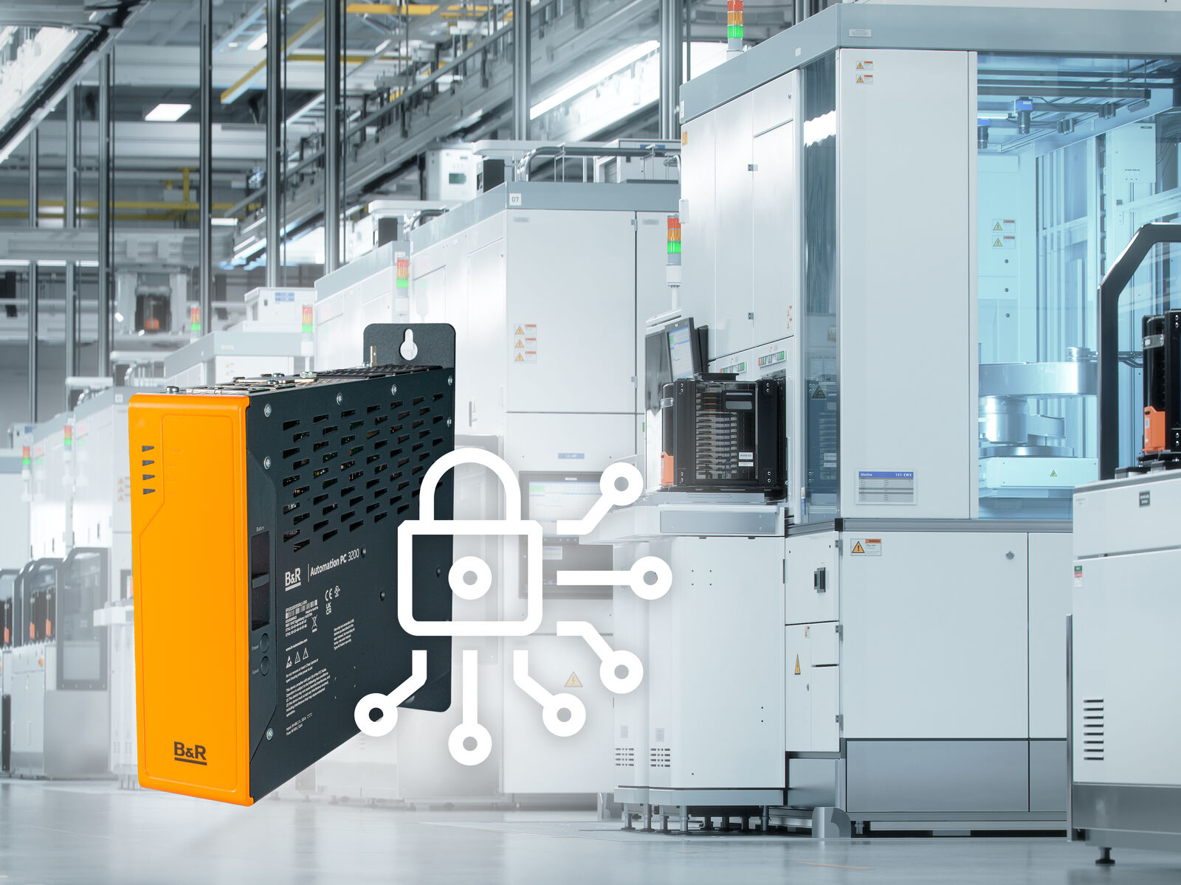
The Automation PC 3200 is designed for seamless integration, long-term availability and updates. (Image: B&R)

About B&R
B&R, a division of ABB Group, is a global leader in industrial automation headquartered in Austria. B&R combines state-of-the-art technology with advanced engineering to provide customers in virtually every industry with complete solutions for machine and factory automation, motion control, HMI and integrated safety technology. With Industrial IoT communication standards including OPC UA, POWERLINK and openSAFETY as well as its Automation Studio software, B&R is constantly redefining the future of automation engineering. The innovative spirit that keeps B&R at the forefront of industrial automation is driven by a commitment to simplifying processes and exceeding customer expectations.
For more information, visit www.br-automation.com.

