Plug-and-play SCARA robots join B&R Codian lineup
Machine-centric handling for speed and precision in a compact footprint
• New SCARA models enable easy and compact mounting, including under cleanroom conditions
• Availability as open robot mechanics allows full design flexibility for third-party integration
• Optional integration in machine control allows seamless engineering and tight synchronization

With the new Codian SR, B&R adds SCARA kinematics to its Codian portfolio of open robot mechanics and integrated Machine-Centric Robotics solutions. The new series offers high-speed articulated movement with four degrees of freedom – perfect for tasks like pick-and-place, loading and unloading, assembly and dispensing that demand both speed and repeatability on a compact footprint.
Complementing the existing Codian delta linup, the new SCARA models extend the range of applications to include high-speed handling with a lateral offset or overhead mounting restrictions. They are particularly easy to install on a small footprint alongside linear and planar product transport systems and handle payloads ranging from 3-65 kilograms with exceptionally high repeatability. The Codian SR lineup includes cleanroom-qualified models that provide compact high-performance handling with undisturbed airflow in sensitive environments like semiconductor or pharmaceutical production.
To ensure maximum flexibility, B&R Codian SR models – like their delta cousins – are available either as open robot mechanics or together with B&R controls and software as an integrated Machine-Centric Robotics (MCR) solution. "Our MCR solutions make robots a plug-and-play part of the machine – physically, logically, and operationally," explains Dario Rovelli, B&R's global product group manager for mechatronics. "That means no extra controllers, no engineering silos – just one seamless system from transport to handling. All thinking and acting as one, in tight synchronization with AI-enhanced machine vision and motion control."
Open software
The new SCARA models are also integrated in B&R's open software platform, mapp Robotics, making it easy to incorporate sophisticated robotic handling in the machine application without specialist knowledge in robotics programming. Users have as access to all the familiar machine programming languages like Ladder Diagram, Structured Text and C/C++ and ready-made software components needing only configuration and tuning, all in the familiar Automation Studio engineering environment.
"With mapp Robotics and our integrated approach, machine builders can implement robotics applications without needing robotics expertise," says Sebastian Brandstetter, B&R product manager for robotics. "It's about empowering engineers to focus on machine performance and product quality – not on bridging technical gaps between systems."
Unifying machine and robot control reduces complexity and setup time. With preconfigured templates, simulation tools, and standardized interfaces, commissioning is faster and easier. B&R's deep expertise in tuning, synchronization, and motion ensures that the robot performs at its best in the context of the entire machine. It's all part of a seamlessly integrated automation package – spanning software, hardware, and services – from a single source.
Learn more about B&R's open robot mechanics and software and its integrated Machine-Centric Robotics solutions at Machine-Centric Robotics.

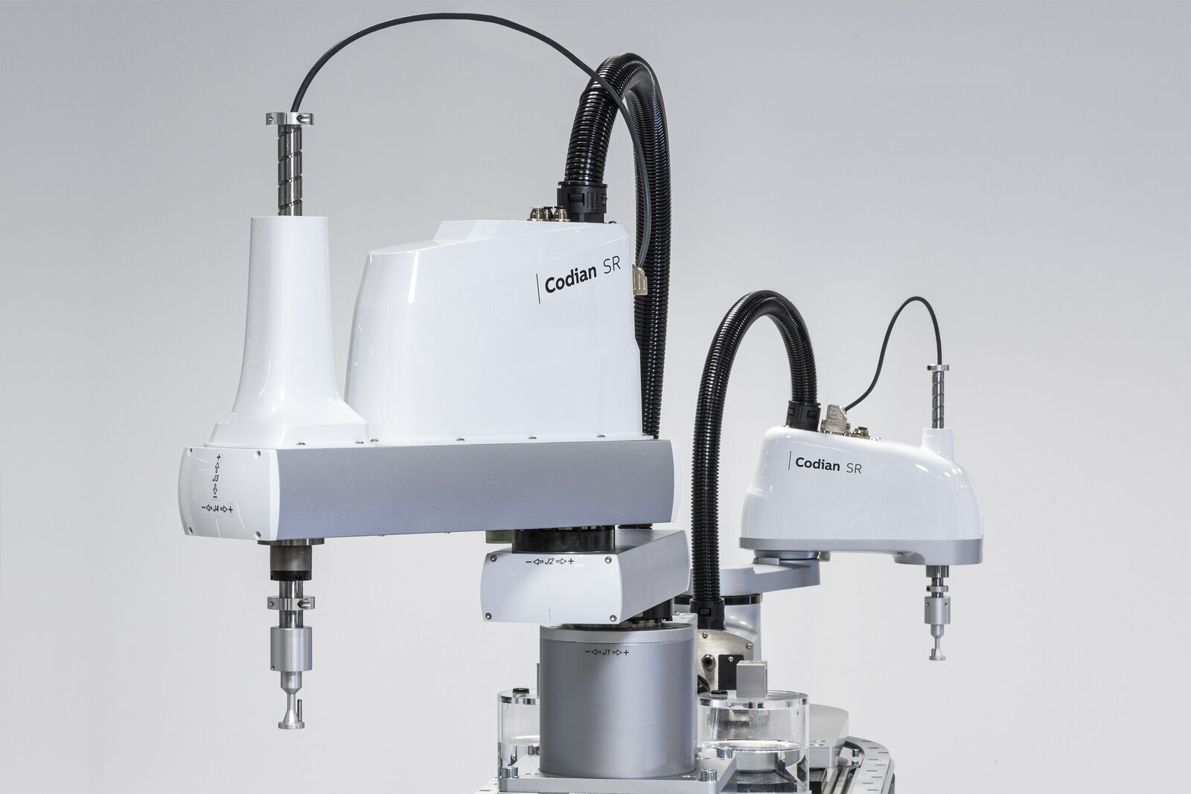
B&R's new Codian SR series offers fast and precise movement in a compact footprint – ideal for tasks like pick-and-place, loading and unloading, assembly and dispensing. (Image: B&R)
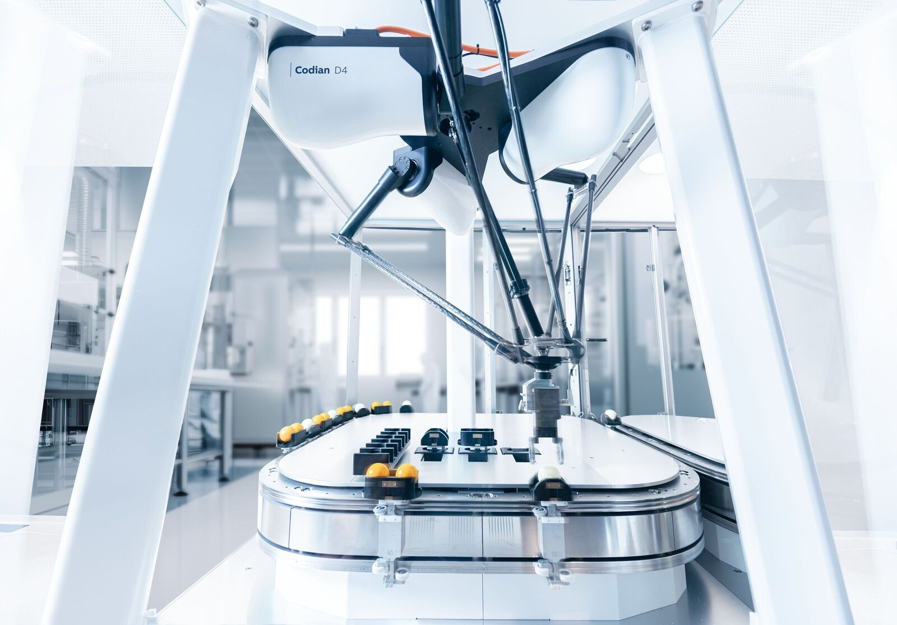
All B&R Codian models are available either as open robot mechanics or integrated with B&R controls for seamless engineering and tight synchronization with product transport systems. (Image: B&R)

About B&R
B&R, a division of ABB Group, is a global leader in industrial automation headquartered in Austria. B&R combines state-of-the-art technology with advanced engineering to provide customers in virtually every industry with complete solutions for machine and factory automation, motion control, HMI and integrated safety technology. With Industrial IoT communication standards including OPC UA, POWERLINK and openSAFETY as well as its Automation Studio software, B&R is constantly redefining the future of automation engineering. The innovative spirit that keeps B&R at the forefront of industrial automation is driven by a commitment to simplifying processes and exceeding customer expectations.
For more information, visit www.br-automation.com.

