B&R products now available through RS
Faster, easier access to automation technology for machine builders across Europe
B&R, the Machine Automation Division of ABB, and RS, a high-service global product and service solutions provider for industrial customers, have entered into a strategic cooperation agreement to distribute B&R products via RS online and offline channels, offering streamlined online ordering, enhanced order traceability, and trusted local support. This partnership marks a significant milestone in expanding access to B&R’s automation technology, initially across major European markets and with plans for progressive expansion to additional regions.
“This partnership with RS is key and complements our customer-focused servicing model,” said Susana Gonzalez, Chief Sales Officer, ABB Machine Automation (B&R). “We are making it easier than ever for machine builders and integrators to access B&R technology by working with one of the most reputable and digitally advanced distributors in the B2B market—ensuring streamlined procurement processes and first-class service.”
RS will make a comprehensive range of B&R automation products available through its online and offline channels where customers can easily browse and order B&R products, with the confidence of reliable delivery supported by RS’s robust logistics infrastructure. The partnership also brings full order traceability, allowing customers to track their purchases from checkout to delivery.
This collaboration reinforces RS Group’s existing strategic relationship with ABB Group and expands its footprint in the industrial automation sector. The move aligns with RS’s mission to deliver innovation, accessibility, and reliability to its growing industrial customer base. “This collaboration deepens our engagement with ABB Group and, by bringing B&R’s advanced automation solutions to our customers across Europe, it strengthens our presence in the industrial automation space,” said Pete Malpas, President EMEA at RS. “We are committed to helping engineers and industrial businesses innovate faster by offering technical and application support whilst simplifying access to the world’s best technology. Our ability to combine products, services and digital solutions adds true value to our partnerships and to our customers across the region.”
About RS:
RS is a high-service global product and service solutions provider for industrial customers, enabling them to operate efficiently and sustainably.
We operate in 36 markets, stock over 830,000 industrial and specialist products and list an additional five million relevant for our industrial customers, sourced from over 2,500 suppliers. This extensive range supports our customers across the industrial lifecycle of designing, building and maintaining equipment and operations. We enhance their experience through a tailored service model, leveraging our efficient physical, digital and process infrastructure sustainably. We combine a technically led and digitally enabled approach with an exceptional team of experts; ultimately, it’s our people that make the difference.
Our purpose, making amazing happen for a better world, reflects our focus on delivering results for people, planet and profit.
RS Group plc is listed on the London Stock Exchange with stock ticker RS1 and in the year ended 31 March 2025 reported revenue of £2,904 million.
For more information, please visit: https://uk.rs-online.com/web/

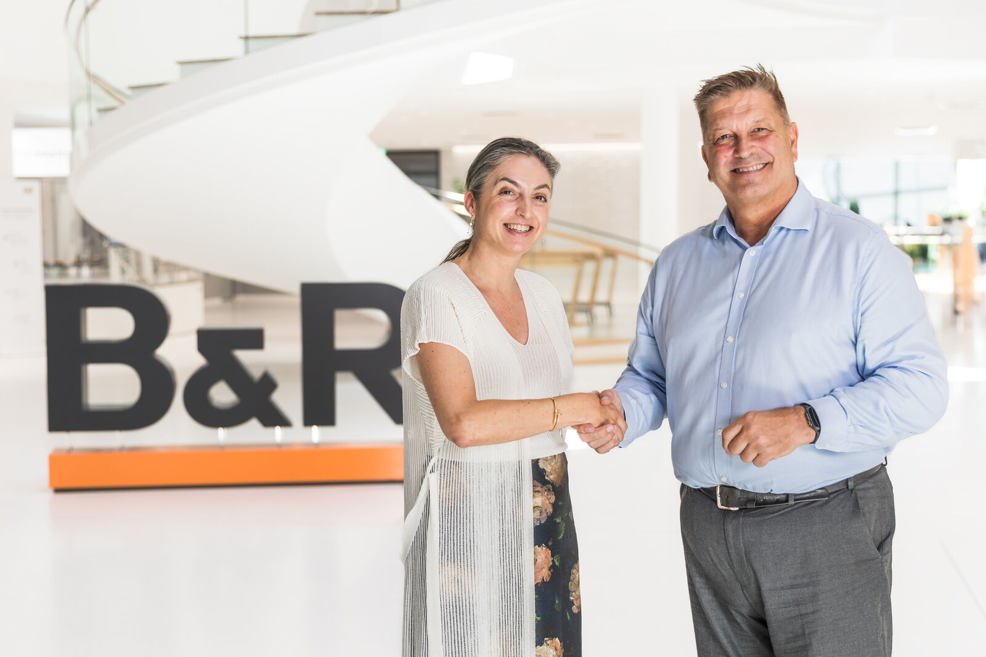
Susana Gonzalez, Chief Sales Officer of ABB Machine Automation (B&R), and Pete Malpas, President EMEA at RS, celebrate the launch of a strategic partnership designed to accelerate innovation and simplify access to advanced automation technology for customers across Europe. (Source: B&R/Thomas Oberascher)

About B&R
B&R, a division of ABB Group, is a global leader in industrial automation headquartered in Austria. B&R combines state-of-the-art technology with advanced engineering to provide customers in virtually every industry with complete solutions for machine and factory automation, motion control, HMI and integrated safety technology. With Industrial IoT communication standards including OPC UA, POWERLINK and openSAFETY as well as its Automation Studio software, B&R is constantly redefining the future of automation engineering. The innovative spirit that keeps B&R at the forefront of industrial automation is driven by a commitment to simplifying processes and exceeding customer expectations.
For more information, visit www.br-automation.com.

