Entire B&R product development certified according to IEC 62443-4-1
Security standard confirmed by TÜV Rheinland
B&R, the Machine Automation Division of ABB, has earned IEC 62443-4-1 certification across its entire product development process. This audit, conducted by TÜV Rheinland, validates that B&R's development practices align with global standards for secure product development in industrial automation. The certification covers all product groups and development teams at B&R, proving that cybersecurity is integrated throughout every stage in the development cycle – from specification and design to implementation, testing and maintenance.
Software as the key to secure automation
B&R is also raising the bar in software development: This highly security-critical area has been awarded "Maturity Level 3" – a top tier designation within the IEC 62443-4-1 standard. "Software is of strategic importance in automation today," says Florian Schneeberger, Chief Technology Officer at B&R. "Our customers benefit from solutions that are designed to be secure right from the start."
Certification according to IEC 62443-4-1 is a strategic milestone for B&R. "It shows how deeply cybersecurity is embedded in all our processes and how sustainably we implement it," Schneeberger continues. "Our customers are optimally prepared for upcoming requirements such as the EU Cyber Resilience Act starting in 2027 and benefit from certified processes that accelerate innovation."
The certification is a significant advantage for machine builders and plant operators, as it simplifies compliance and documentation, creates investment security and shortens time-to-market for new products. The audit by TÜV Rheinland confirms B&R's "Secure by Design" approach, in which security requirements are embedded from the beginning and across the entire product life cycle and all product groups.
Practical training for secure processes
B&R also provides practical support to companies in the field of cybersecurity. With targeted training courses, individual workshops with qualified cybersecurity experts and technical support, B&R helps to implement security measures effectively. Practical training courses such as “Cybersecurity Basics and System Hardening”, as well as providing security-related information in machine-readable CSAF format underscore B&R's commitment to proactively meeting the growing demands of the market.

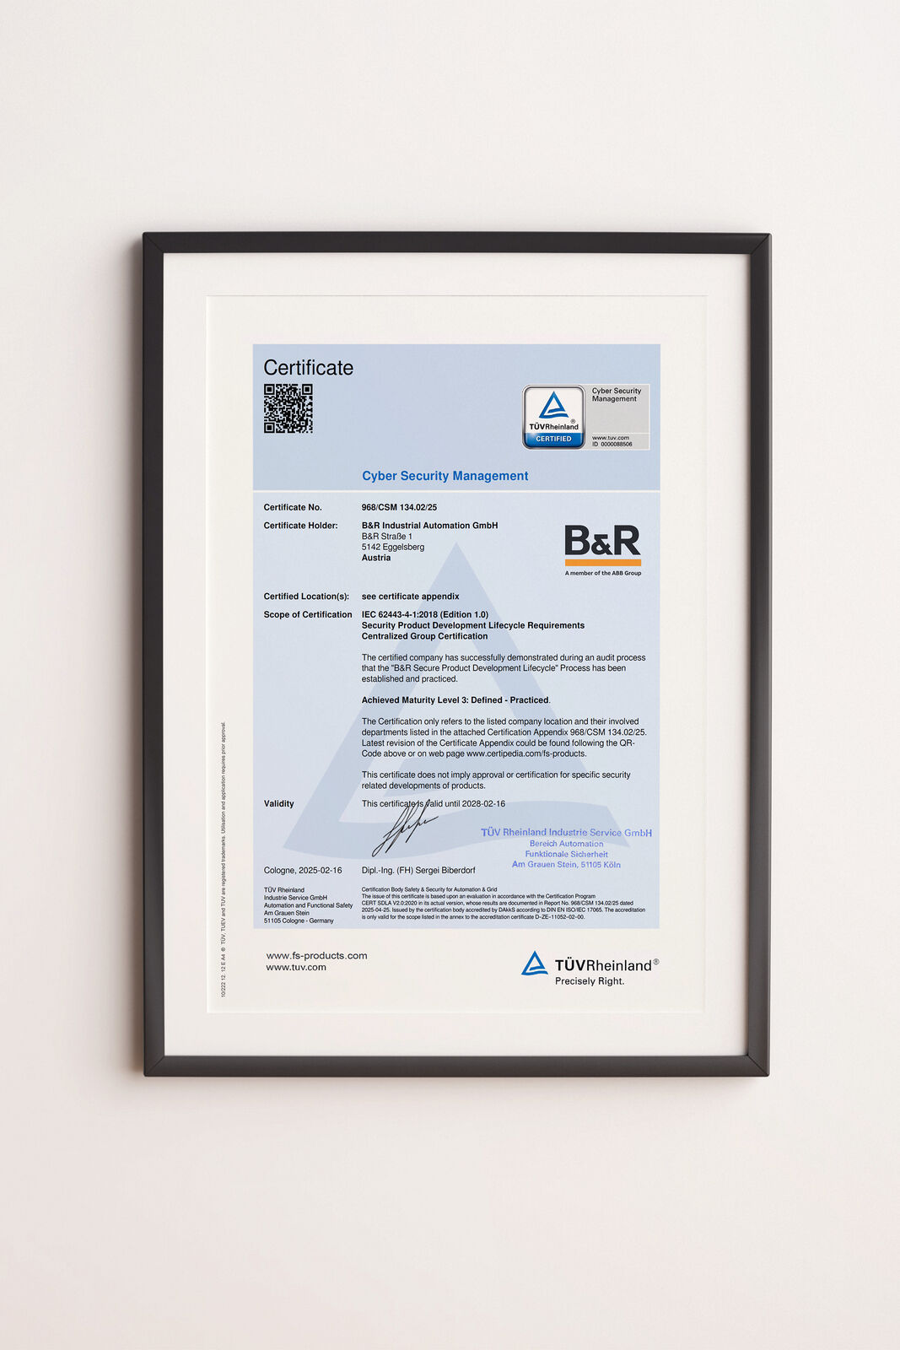
TÜV Rheinland has confirmed that B&R's development processes meet the highest security standards. The software development has even been awarded "Maturity Level 3" certification. (Image: B&R)
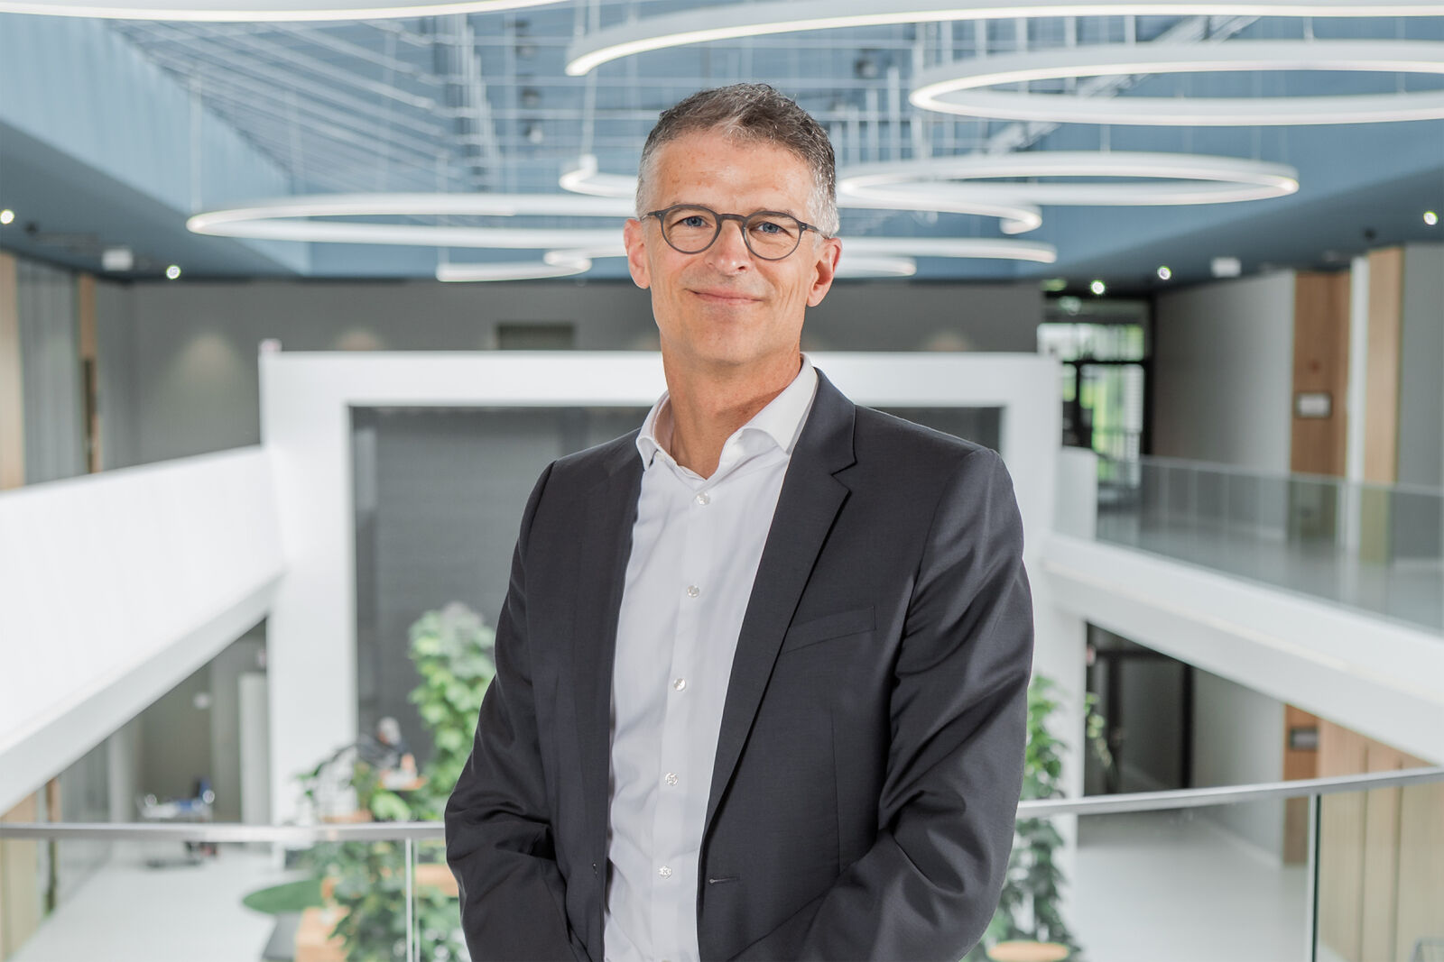
Florian Schneeberger, Chief Technology Officer of the Machine Automation Division (B&R), emphasizes the importance of IEC 62443-4-1 certification as a strategic milestone for the company's cybersecurity. (Image: B&R)

About B&R
B&R, a division of ABB Group, is a global leader in industrial automation headquartered in Austria. B&R combines state-of-the-art technology with advanced engineering to provide customers in virtually every industry with complete solutions for machine and factory automation, motion control, HMI and integrated safety technology. With Industrial IoT communication standards including OPC UA, POWERLINK and openSAFETY as well as its Automation Studio software, B&R is constantly redefining the future of automation engineering. The innovative spirit that keeps B&R at the forefront of industrial automation is driven by a commitment to simplifying processes and exceeding customer expectations.
For more information, visit www.br-automation.com.

