B&R welcomes FPE Automation as Value provider
Expanding Local Access to B&R Technology in Illinois, Iowa, and Missouri
B&R, the Machine Automation Division of ABB, today announced a new distribution partnership with FPE Automation to expand its local service and support capabilities in Illinois, Iowa, and Missouri. The collaboration, part of B&R’s Value Provider Program (VPP), is designed to bring advanced automation technologies and comprehensive support closer to regional machine builders and manufacturers, reinforcing B&R’s commitment to delivering cutting-edge solutions through a trusted network of partners.
FPE Automation is now offering B&R’s full portfolio including control, motion, robotics, mechatronics, safety, and visualization. Customers benefit from a single point of contact for their entire automation solution. This unified approach simplifies project execution and enhances system integration, helping customers reduce complexity and accelerate time to market.
Collaboration boosts efficiency and performance for regional manufacturers
With FPE Automation as a trusted regional partner, customers in Illinois, Iowa, and Missouri will benefit from faster, more responsive local support. They will gain access to B&R’s cutting-edge technologies, including adaptive machines and integrated robotics. The partnership enables streamlined engineering through a unified software platform, allowing for closer collaboration with application experts who can deliver tailored solutions. These advantages contribute to improved efficiency and performance across automation systems.
“For over 60 years, FPE Automation has built a reputation for delivering best-in-class automation solutions,” said Adrian Lovatt, Partner Manager at B&R Industrial Automation North America. “Their strong market presence and technical expertise make them an ideal partner to bring B&R’s innovations to more customers in the Midwest.”
“B&R’s broad portfolio, coupled with the most innovative solutions centered around a unified software platform, helps FPE Automation better serve the needs of our valued clients,” added Jomy Vadakumpadam, VP Sales & Engineering at FPE Automation.
Built on trust and technical excellence
FPE Automation’s team is fully equipped to support B&R’s technology and provide expert guidance throughout the automation lifecycle. This partnership reflects B&R’s ongoing commitment to delivering high-performance, scalable solutions with local support that meet the evolving needs of machine builders and manufacturers.
To learn more about how this partnership can benefit your business, please contact FPE Automation or visit our Value Provider Page.

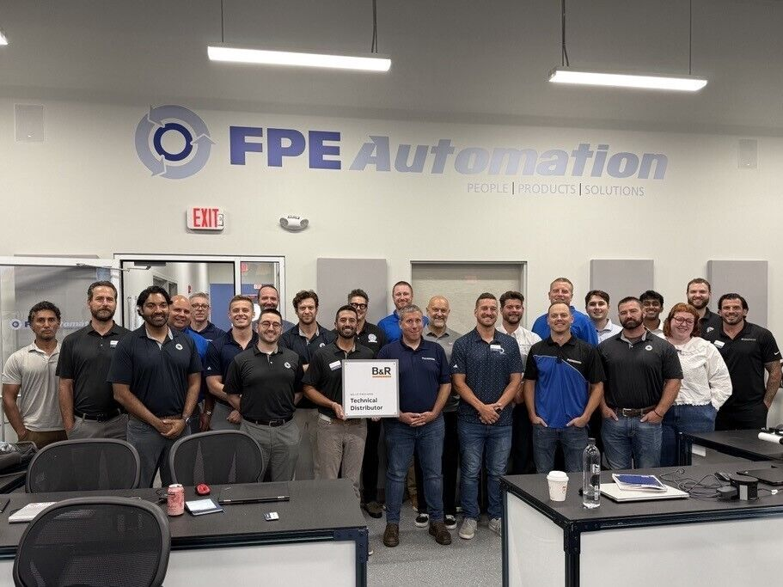
Shaun Kneller, Director of Global Accounts and End User Sales US at B&R, presents the official B&R Technical Distributor plaque to the FPE Automation team.

About B&R
B&R, a division of ABB Group, is a global leader in industrial automation headquartered in Austria. B&R combines state-of-the-art technology with advanced engineering to provide customers in virtually every industry with complete solutions for machine and factory automation, motion control, HMI and integrated safety technology. With Industrial IoT communication standards including OPC UA, POWERLINK and openSAFETY as well as its Automation Studio software, B&R is constantly redefining the future of automation engineering. The innovative spirit that keeps B&R at the forefront of industrial automation is driven by a commitment to simplifying processes and exceeding customer expectations.
For more information, visit www.br-automation.com.

