B&R high-performance automation for sustainable plastics at K 2025
Scalable, smart and sustainable automation for a circular economy in plastics processing
• The latest B&R technologies redefine plastics manufacturing by combining AI, robotics and high-performance motion control to enable smarter, more sustainable production.
• The new ACOPOS P3 2-axis servo drive delivers 60% more power and requires 50% less space, setting a new industry standard.
• Visitors can experience adaptive manufacturing with live demos, smart robotics and AI-powered engineering for compact, high-performance solutions.
B&R, the Machine Automation Division of ABB, will present its latest technologies, including the powerful new ACOPOS P3 2-axis servo drive for plastics processing at K 2025. From October 8–15 in Düsseldorf, booth A80 in hall 12 will be the destination for manufacturers seeking to future-proof their operations with intelligent, scalable and sustainable automation.
"The plastics industry is undergoing a transformation driven by rising sustainability demands, increasing production complexity and digitalization," says Magnus Jeppson, Global Industry Segment Manager at B&R. "B&R's unified and scalable automation portfolio enables our customers to develop everything from simple machines to highly complex systems – all within the same software ecosystem." With the 2-axis ACOPOS P3, B&R introduces a powerful servo drive tailored for plastics and injection molding applications. The 2-axis version delivers up to 60% more power and requires 50% less space. It offers the highest performance with maximum scalability and doubles the power density for use in the smallest spaces.
Top performance for demanding applications
B&R will present its enhanced ACOPOS P3 servo drive range for the first time at K 2025. The new 2-axis module is ideally suited to the requirements of the plastics industry with its unique ultra-fast internal cycle time of 50 µs and unmatched performance. It combines intelligent functions, optimized energy efficiency and simplified wiring to give machine builders a decisive competitive edge. Unlike fragmented solutions from other automation providers, B&R offers fully integrated automation – bringing to-gether machine control, robotics, vision systems and AI-powered analytics in a single ecosystem. This empowers manufacturers to meet the demands of smart manufacturing and the circular economy, while maintaining full operational control.
Smart technologies for a competitive advantage
B&R's advanced IoT solutions, real-time data analytics and AI-driven optimization enable manufacturers to remain competitive in a global market where digitalization is key. Predictive maintenance and adaptive control make machines more available, reduce energy use and ensure consistent product quality, even when the materials used change. Vision systems ensure real-time quality inspection, while robotics and conveyor systems streamline handling and packaging. These technologies are seamlessly integrated into machine control, supporting flexible, automated production and contributing to a sustainable plastics economy.
Innovation in action: Live and on the show floor
At the B&R booth, visitors will experience how adaptive manufacturing boosts flexibility and productivity within a compact footprint. Live demos showcase mechatronic systems such as ACOPOStrak and ACOPOS 6D working in precise, dynamic harmony with Codian robotics. Vision systems will demonstrate real-time anomaly detection and automated quality inspection. At interactive workstations, B&R offers hands-on software demos featuring AI-assisted coding and flexible, cloud-based engineering. In addition to B&R's own presentations, over multiple leading plastics manufacturers will showcase machines powered by B&R technology. Visit B&R and its customers' booths at K 2025 and discover how intelligent automation is transforming every stage of plastics manufacturing.

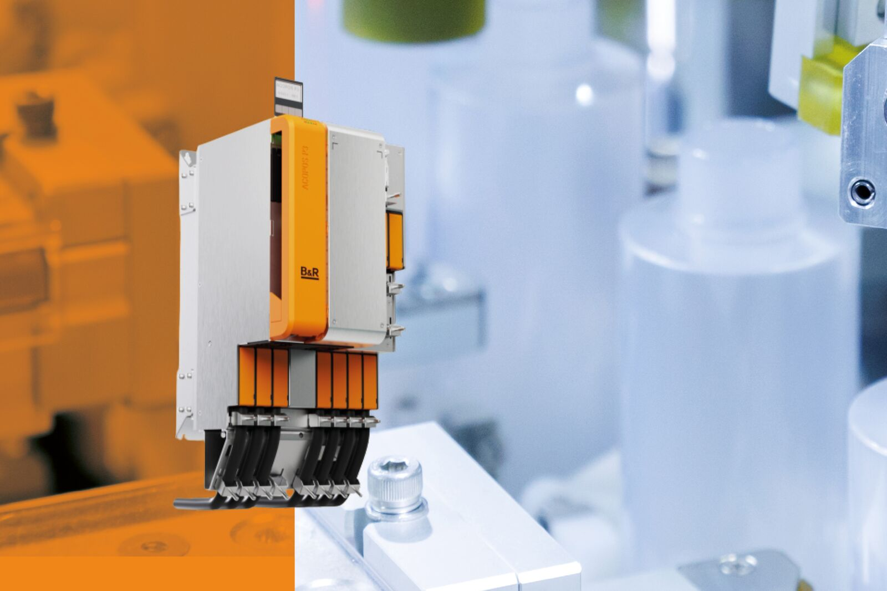
The ACOPOS P3 2-axis high-performance servo drive delivers up to 60% more power and requires 50% less space providing excellent speed and compact dimensions for plastics production.
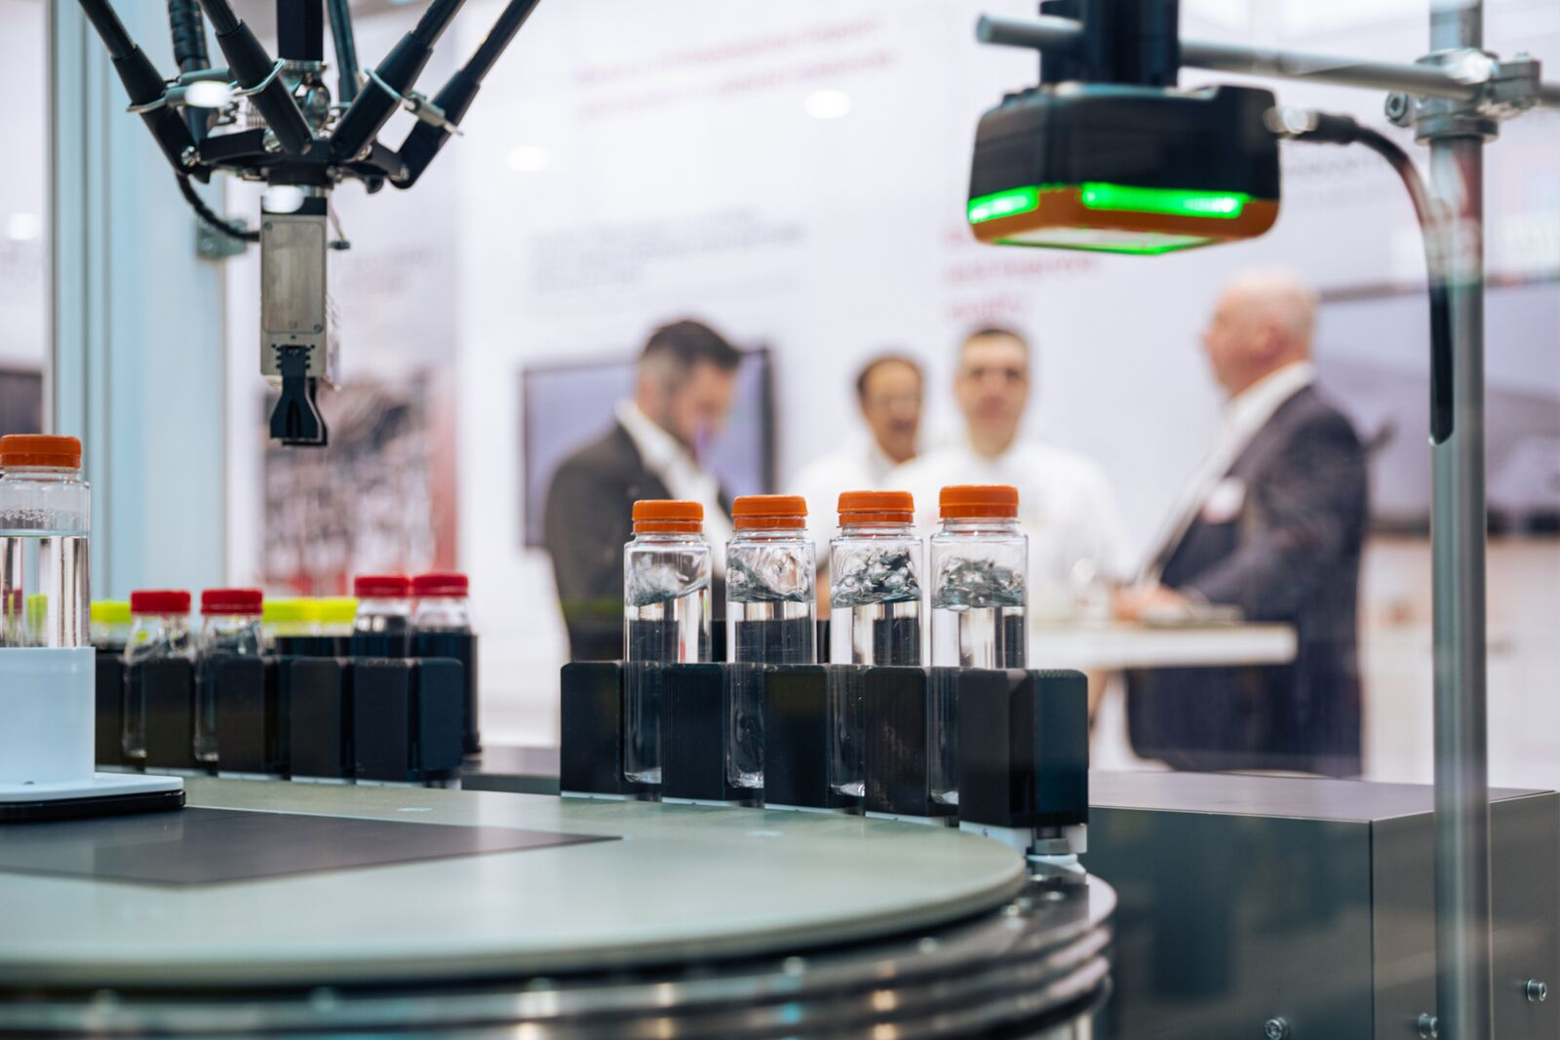
End-to-end integration: Discover scalable, smart and sustainable automation solutions from B&R that are shaping the future of plastics production at K 2025.

"The plastics industry is undergoing a transformation driven by rising demands for sustainability, increasing production complexity and digitalization," says Magnus Jeppson, Global Industry Segment Manager at B&R.

About B&R
B&R, a division of ABB Group, is a global leader in industrial automation headquartered in Austria. B&R combines state-of-the-art technology with advanced engineering to provide customers in virtually every industry with complete solutions for machine and factory automation, motion control, HMI and integrated safety technology. With Industrial IoT communication standards including OPC UA, POWERLINK and openSAFETY as well as its Automation Studio software, B&R is constantly redefining the future of automation engineering. The innovative spirit that keeps B&R at the forefront of industrial automation is driven by a commitment to simplifying processes and exceeding customer expectations.
For more information, visit www.br-automation.com.

