ABB integrates Machine Automation division into Process Automation business area

Following the announcement of the divestment of its Robotics division to SoftBank Group, ABB is transitioning the Machine Automation division – formerly part of the Robotics & Discrete Automation business area – into the Process Automation business area. The transition will take effect in the fourth quarter of 2025.
As the division transitions into the Process Automation business area, customers in process and hybrid industries will benefit from deeper technology synergies – spanning automation, electrification and digitalization – delivered through a unified and comprehensive portfolio.
In a leadership update, ABB announced that Florian Schneeberger, who served as Chief Technology Officer at Machine Automation since 2022, has been appointed Division President. He succeeds Joerg Theis, who has decided to leave the company to pursue opportunities outside ABB.
“Machine Automation brings deep expertise in machine and factory automation – capabilities that complement ABB’s strengths in process and hybrid industries,” said Florian Schneeberger, Division President, ABB’s Machine Automation division. “With pioneering technology innovated and produced here in Eggelsberg, we are committed to deliver a truly differentiated offering for customers across industrial sectors globally, helping them operate leaner and cleaner.”
This integration builds on Machine Automation’s legacy within ABB, including the 2017 acquisition of B&R – now the core of the division.
ABB is a global technology leader in electrification and automation, enabling a more sustainable and resource-efficient future. By connecting its engineering and digitalization expertise, ABB helps industries run at high performance, while becoming more efficient, productive and sustainable so they outperform. At ABB, we call this ‘Engineered to Outrun’. The company has over 140 years of history and around 110,000 employees worldwide. ABB’s shares are listed on the SIX Swiss Exchange (ABBN) and Nasdaq Stockholm (ABB).
B&R, a division of ABB Group, is a global leader in industrial automation headquartered in Austria. B&R combines state-of-the-art technology with advanced engineering to provide customers in virtually every industry with complete solutions for machine and factory automation, motion control, HMI and integrated safety technology. With Industrial IoT communication standards including OPC UA, POWERLINK and openSAFETY as well as its Automation Studio software, B&R is constantly redefining the future of automation engineering. The innovative spirit that keeps B&R at the forefront of industrial automation is driven by a commitment to simplifying processes and exceeding customer expectations.

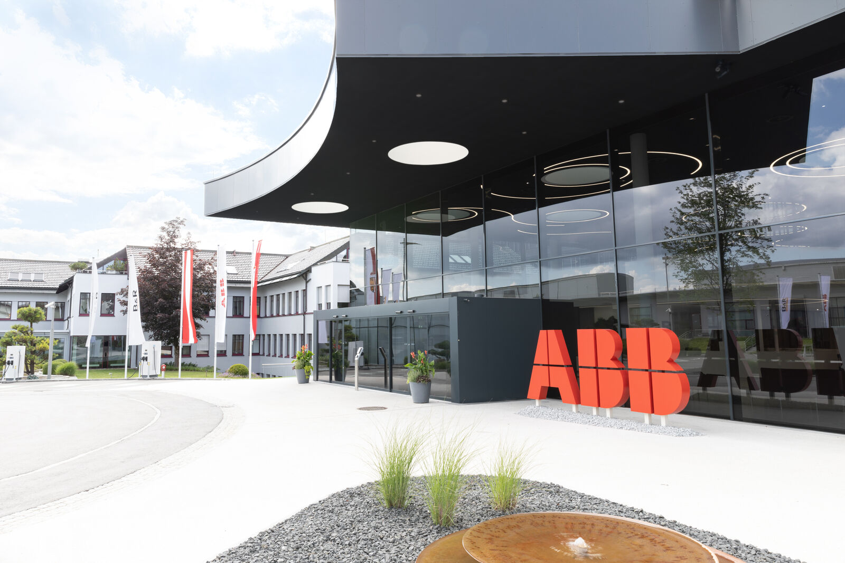
ABB integrates Machine Automation division into Process Automation business area. (Image: B&R)

About B&R
B&R, a division of ABB Group, is a global leader in industrial automation headquartered in Austria. B&R combines state-of-the-art technology with advanced engineering to provide customers in virtually every industry with complete solutions for machine and factory automation, motion control, HMI and integrated safety technology. With Industrial IoT communication standards including OPC UA, POWERLINK and openSAFETY as well as its Automation Studio software, B&R is constantly redefining the future of automation engineering. The innovative spirit that keeps B&R at the forefront of industrial automation is driven by a commitment to simplifying processes and exceeding customer expectations.
For more information, visit www.br-automation.com.

