Best-in-market small drives combine flexibility, safety, and powerful motor control in a compact design

Eggelsberg/Nuremberg – B&R, ABB’s Machine Automation Division welcomes two new modules to their ACOPOS family: the ACOPOS X2 and ACOPOS X4, providing machine builders with more options within a compact package. Both modules plug into the slice-based X20 system and increase the system’s versatility by providing support for different motor and encoder types from the same module.
ACOPOS X2 – Smart, safe, and versatile
The ACOPOS X2 can control two stepper motors, two brushless DC motors – or one of each - with a total power range up to 1 kW. This makes it suitable for different applications such as positioning applications on machines, as required in the packaging and metals industries for example. While the ACOPOS X2 includes integrated encoder support for various encoder types, it can also run encoder-less. On-board Safe Torque Off Safety Integrity Level 3 (STO SIL3) capability ensures guaranteed functional safety, while closed loop functionality ensures precision control along with high performance and accuracy.
ACOPOS X4 – Controls four servo motors from a single device
ACOPOS X4 offers improved precision control plus integrated SafeMotion technology. ACOPOS X4 can control up to four servo motors from a single module with a total power range up to 1 kW. A cycle time of 50 μs ensures a high degree of responsiveness and accuracy, while the compact foot-print provides an overload factor up to twice the nominal current in a smaller package that reduces cabinet footprint by up to 30% in an eight-motor configuration. In addition, ACOPOS X4 is equipped with SafeMotion, B&R’s integrated safety technology. It reduces the need for external wiring by transmitting safety data over a standard network and allows for faster reaction times and more compact machine designs.
“The new ACOPOS X family delivers powerful, precise motor control in a compact form, offering machine builders flexible, safe, and scalable solutions for low-power applications with maximum efficiency,” said Wilfried Guerry, Product Manager Motion at B&R Industrial Automation.
ACOPOS X2 and ACOPOS X4 provide both scalable motion control solutions for low to medium power ranges, combining integrated safety features with flexible motor support. Their compatibility with X20 systems and modern communication standards ensures precise positioning and efficient integration in diverse automation environments.

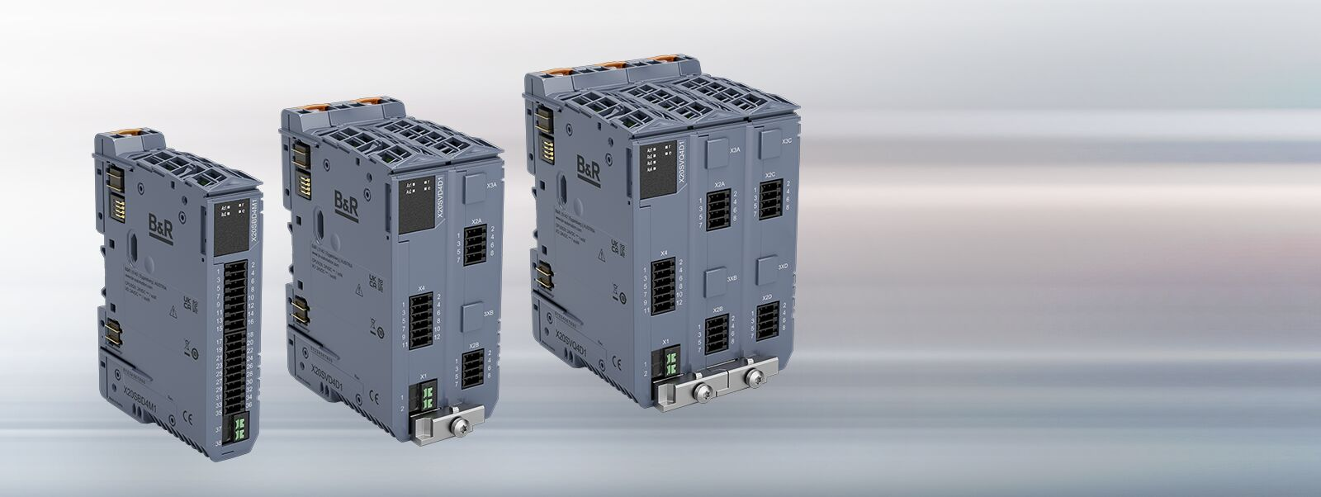
B&R, ABB’s Machine Automation Division introduces the ACOPOS X2 and ACOPOS X4, providing machine builders with more options within a compact package. Both modules plug into the slice-based X20 system.

About Machine Automation, ABB
ABB’s Machine Automation division delivers automation solutions and services for machine and factory applications across industries such as consumer packaged goods, printing, life sciences, plastics, energy and maritime. With its B&R’s product portfolio, the division delivers integrated control and software, motion control, mechatronics, and machine automation technologies designed to simplify processes and optimize factory operations.

