B&R advances ACOPOStrak technology for increased load and higher precision
ACOPOStrak from B&R, ABB’s Machine Automation Division, is a modular and flexible product transport system powered by shuttles on a long-stator linear motor. The new Metal-to-Metal (M2M) upgrade enables the system to handle heavier payloads, achieve faster acceleration and curve speeds, and reduce wear for fewer repairs and greater uptime.

Eggelsberg/Nuremberg - Moving shuttles with high payload or cantilevered loads leads to significant forces. The higher the speed and the dynamics of the movement, the higher the forces. This is where B&R’s ACOPOStrak Metal-to-Metal upgrade steps in.
This is particularly relevant for assembly automation, where items need to be placed quickly into the shuttles while maintaining consistency and accuracy. In addition, there is a growing demand in the consumer packaged goods (CPG) industry for space-saving transport solutions that also enable high dynamics and high throughput. This is the point where, the ACOPOStrak metal-to-metal approach, together with the ACOPOStrak compact curve, offers the most effective solution: Its metal-to-metal design allows to transport a potentially infinite number shuttles of up to 10 kg each at speeds of up to 5 m/s – with no spacing needed between shuttles.
Moving shuttles with high payload or cantilevered loads leads to significant forces. The higher the speed and the dynamics of the movement, the higher the forces. This is where B&R’s ACOPOStrak Metal-to-Metal upgrade with its Compact Curve steps in. The combination of these two extensions leads to a higher throughput per square metre – a special requirement from the CPG industry. The new metal guide and shuttle system significantly enhances ACOPOStrak’s payload capacity and precision. This mechanical extension enables higher movement dynamics and curve speeds, unlocking faster cycle times and greater throughput. The result is a measurable boost in profitability through optimized performance and reliability,” said Johannes Vitzthum, Product Manager ACOPOStrak at B&R Industrial Automation.
The Metal-to-Metal upgrade enhances ACOPOStrak’s ability to handle higher forces from heavy or canti-levered loads, ensuring reliable performance at increased speeds and dynamics – even in harshest environments. This results in greater throughput and space efficiency without compromising precision or flexibility.

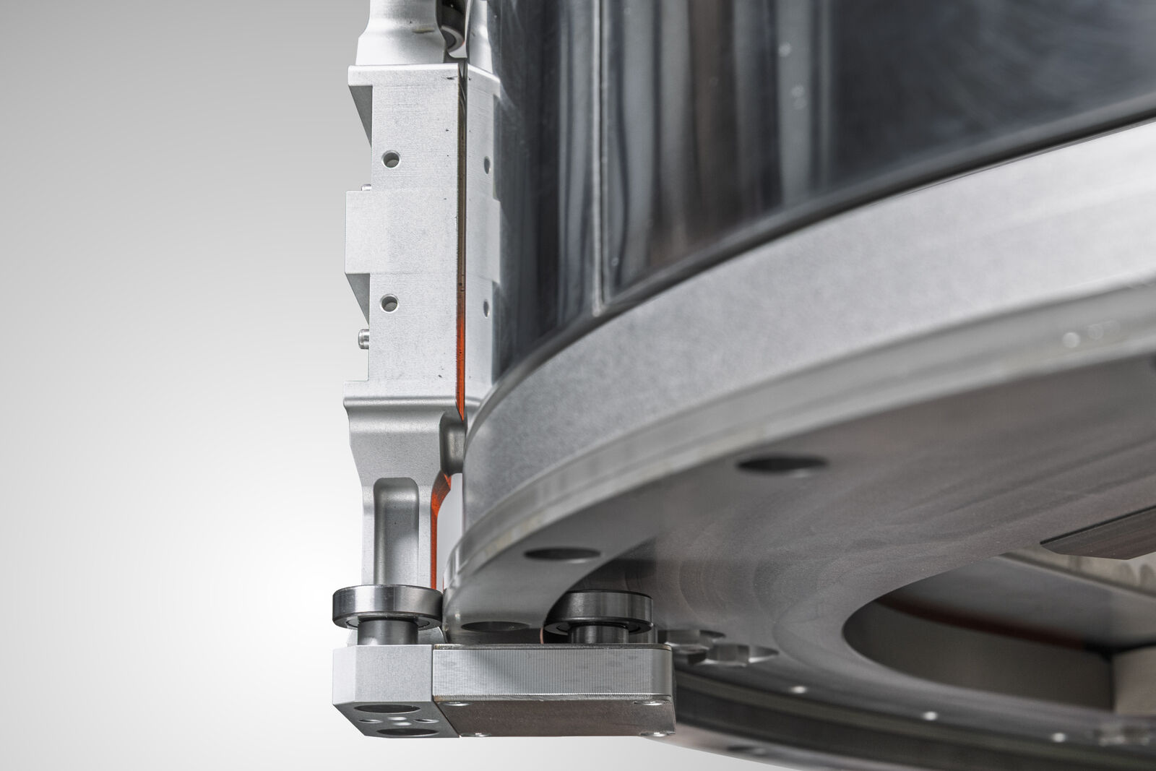
With the new Metal-to-Metal (M2M) upgrade, the system can handle heavier payloads, achieve faster acceleration and curve speeds, and reduce wear for fewer repairs and greater uptime.

About Machine Automation, ABB
ABB’s Machine Automation division delivers automation solutions and services for machine and factory applications across industries such as consumer packaged goods, printing, life sciences, plastics, energy and maritime. With its B&R’s product portfolio, the division delivers integrated control and software, motion control, mechatronics, and machine automation technologies designed to simplify processes and optimize factory operations.

