B&R adds flexibility to its Codian robotics offering with Codian AR
B&R, ABB’s Machine Automation Division, presented Codian SR, a kinematic variant in May 2025. In 2026, a kinematic six-axis variant will follow.
Eggelsberg/Nuremberg - With the Codian AR product variant, B&R adds flexibility to its Codian system offering. Having six degrees of freedom allows the Codian AR mechanics to perform complex 3D paths, multi-angle manipulation, and the flexibility to manoeuvre repeatedly in and out of the workspace. Areas of application range from handling operations and sorting to assembling tasks serving industries including plastics, pharmaceuticals, metals, electronics manufacturing and consumer packaged goods (CPG).
“Codian AR and SR deliver flexibility, precision, and performance, empowering machine builders with compact, integrated solutions for even the most complex automation tasks,” said Sebastian Brand-stetter, Product Manager Machine Centric Robotics at B&R Industrial Automation.
With working ranges from 1,400 mm down to 600 mm, the Codian AR is engineered for maximum adaptability. Even in the most confined environments, whether mounted on the wall, ceiling, or floor, it delivers consistent performance.
The Codian AR delivers dynamic performance thanks to a high-stiffness transmission design that maintains rigidity and precision even under high loads. This ensures stable operation, exact positioning, and fast response times in demanding applications. Precision-engineered gearboxes and bearings further enhance accuracy and durability. An advanced trajectory algorithm optimizes motion paths in real time. By combining model-based control with state-of-the-art optimization methods, the system enables smooth, efficient, and reliable movements, even in complex or fast-changing operating conditions. This guarantees consistently high throughput and accuracy.
Codian robots are designed to work seamlessly with B&R controls and software. This tight integration makes hardware and software work hand in hand with significantly less engineering effort. Machine builders need only one controller and one engineering platform for development, diagnostics and maintenance. Codian AR is, just as all Codian robots, available as open mechanics platform. Unlike traditional robotic systems tied to proprietary controllers, open mechanics give machine builders complete design freedom. Using the same ecosystem for both the robot and the machine control systems helps to streamline and simplify processes, reduces components, and increases overall efficiency. The integration of Codian is "plug-and-play", meaning no additional controller or com-plex programming is required. This significantly simplifies engineering and accelerates commissioning.
The Codian AR with six-axis kinematics delivers high precision, stiffness, and advanced trajectory control for complex tasks even in tight spaces. Seamless integration with B&R controls and software ensures simplified engineering and faster commissioning.
About B&R
B&R, a division of ABB Group, is a global leader in industrial automation headquartered in Austria. B&R combines state-of-the-art technology with advanced engineering to provide customers in virtually every industry with complete solutions for machine and factory automation, motion control, HMI and integrated safety technology. With Industrial IoT communication standards including OPC UA, POWERLINK and openSAFETY as well as its Automation Studio software, B&R is constantly redefining the future of automation engineering. The innovative spirit that keeps B&R at the forefront of industrial automation is driven by a commitment to simplifying processes and exceeding customer expectations.
For more information, visit www.br-automation.com

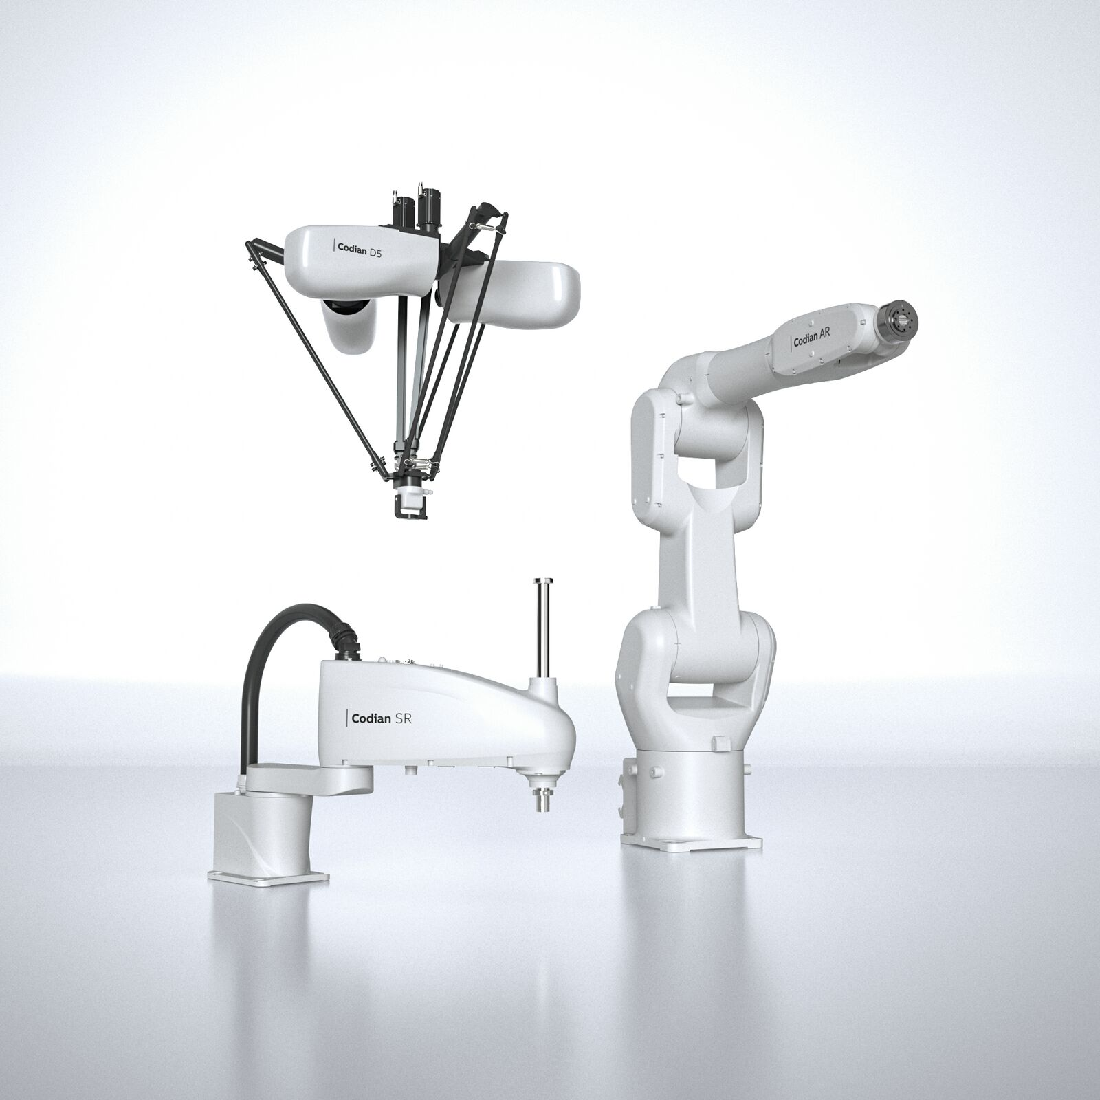
With the Codian AR product variant, B&R adds flexibility to its Codian system offering.

About Machine Automation, ABB
ABB’s Machine Automation division delivers automation solutions and services for machine and factory applications across industries such as consumer packaged goods, printing, life sciences, plastics, energy and maritime. With its B&R’s product portfolio, the division delivers integrated control and software, motion control, mechatronics, and machine automation technologies designed to simplify processes and optimize factory operations.

